https://doi.org/10.23913/ride.v14i28.1865
Artículos científicos
Water quality from common use springs, in a rural community: Las Ánimas, Tecoanapa, State of Guerrero, Mexico

Calidad del agua de manantiales de uso comun, en una comunidad rural: Las Ánimas, Tecoanapa, Estado de Guerrero, México

Qualidade da água de nascentes de uso comum, em uma comunidade rural: Las Ánimas, Tecoanapa, Estado de Guerrero, México

Sirilo Suastegui Cruz
Universidad Autónoma de Guerrero, México
sirilo_sc@uagro.mx
https://orcid.org/0000-0001-6795-6312

José Luis Rosas Acevedo*
Universidad Autónoma de Guerrero, México
jlrosas@uagro.mx
https://orcid.org/0000-0003-2744-7454
*Autor de correspondencia

Abstract
Macroinvertebrates as indicators, are an alternative that is adequate to measure the mountain springs water quality and, the environmental changes in ecosystems, product of the anthropogenic activities that impact on the ground. We determined the FBI-ANIMAS index of water quality through the biological index, taking into consideration aquatic insect communities like FBI-PR index, These new index combines the tolerance values with the abundance of each family and the total number of individuals. The Pearson correlation coefficient was calculated to measure the association between the families like indicators. It was observed that FBI-ANIMAS index was adjusted to the physicochemical characterization of the mountain springs and to Disolved Oxigen amounts present in them. The FBI-ANIMAS index for the mountain springs (M1, M2, M3, M4 and M6) was in the numeric parameters from 4 to 1, which indicates that they have regular to excellent quality waters, conversely, mountain spring M5, it remained in poor quality.
Keywords: anthropic activity, bioindicator, biological index.

Resumen
Los macroinvertebrados como indicadores, son una alternativa adecuada para medir la calidad del agua de los manantiales de montaña y, los cambios ambientales en los ecosistemas, producto de las actividades antropogénicas que impactan en el suelo. Determinamos el índice FBI-ANIMAS de calidad del agua a través del índice biológico, tomando en consideración comunidades de insectos acuáticos como el índice FBI-PR. Estos nuevos índices combinan los valores de tolerancia con la abundancia de cada familia y el número total de individuos. Se calculó el coeficiente de correlación de Pearson para medir la asociación entre las familias como indicadores. Se observó que el índice FBI-ANIMAS se ajustó a la caracterización fisicoquímica de los manantiales de montaña y a las cantidades de Oxígeno Disuelto presentes en ellos. El índice FBI-ANIMAS para los manantiales de montaña (M1, M2, M3, M4 y M6) se ubicó en los parámetros numéricos de 4 a 1, lo que indica que cuentan con aguas de calidad regular a excelente, por el contrario, el manantial de montaña M5 se mantuvo en mala calidad.
Palabras clave: actividad antrópica, bioindicador, índice biológico.

Resumo
Os macroinvertebrados, como indicadores, são uma alternativa adequada para medir a qualidade da água das nascentes das montanhas e as mudanças ambientais nos ecossistemas, produto das atividades antrópicas que impactam no solo. Determinamos o índice FBI-ANIMAS de qualidade da água através do índice biológico, levando em consideração comunidades de insetos aquáticos como o índice FBI-PR. Este novo índice combina os valores de tolerância com a abundância de cada família e o número total de indivíduos. O coeficiente de correlação de Pearson foi calculado para medir a associação entre os indicadores familiares. Observou-se que o índice FBI-ANIMAS foi ajustado à caracterização físico-química das nascentes montanhosas e às quantidades de Oxigênio Dissolvido nelas presentes. O índice FBI-ANIMAS para as nascentes de montanha (M1, M2, M3, M4 e M6) ficou nos parâmetros numéricos de 4 a 1, o que indica que possuem águas de regular a excelente qualidade, ao contrário, a nascente de montanha M5, permaneceu em má qualidade.
Palavras-chave: patrimonialização, socialização, transformação, identidade.
Fecha Recepción: Junio 2023 Fecha Aceptación: Diciembre 2023

Introducction
As society develops the demand for water resources increases, the quality and quantity of water decreases due to the anthropogenic impact on the basins, which affects the mountain springs and deep wells. This means that the resource is not in a sustainable manner exploited (Elosegi, 2009). In the same way, Damanik-Ambarita et al. 2016; Forero-Céspedes et al. 2013; Gómez-Tolosa et al. 2021, point out that water resource is vulnerable to conditioning factors such as population density, human settlements, productive activities and technological systems, among others, for which alternatives are sought that propitiate an approach to determine the deterioration of the ecosystems (Aguilar-González et al., 2022; Gallay et al., 2007; Suastegui Cruz et al., 2017, 2018). In this way, water quality assessing through routine and costly analyzes such as physical-chemical and microbiological, only provide timely and indirect information at the time of sampling and do not express the ecosystem deterioration over time. In addition, they are to requiring infrastructure and qualified personnel, which represents a limitation for places with very high marginalization, as is the area of study (National Institute of Statistics, Geography and Informatics [INEGI], 2010).
Certainly the macroinvertebrates as indicators alternative are adequate to measure the mountain springs water quality (Callisto et al., 2023; Galdean et al., 2001; Mimeche et al., 2019; Ramírez Villalobos et al., 2015). They are used today by the ease collecting of the samples (Gamboa et al., 2008; García-Barreras et al., 2023) and, adaptability of them to environmental changes in ecosystems (Mancilla-Villa et al., 2022; Terneus et al., 2012) product of the anthropogenic activities impacts on the ground (Hofstede, 2001; Patiño et al., 2021). The objective of this work was to determine the water quality of common use mountain springs through the biological index FBI-ANIMAS similar to FBI-PR, taking into account aquatic insect communities, but adjusting tolerance values.

Materials y methods
The study area is located in the rural community of Las Animas, Municipality of Tecoanapa Guerrero, Mexico (Figure 1), UTM coordinates - 99.318611°, -16.972778° it is located; at 660 meters above sea level (National Institute of Statistics, Geography and Informatics [Inegi], 2010). The warm Subhumid climate predominates (E. García, 1973) with an average annual temperature of 31 ° C; in the coldest months (January and February) it reaches up to 24.9 ° C. The rains appear from June to October, with average annual rainfall of 1200 mm.

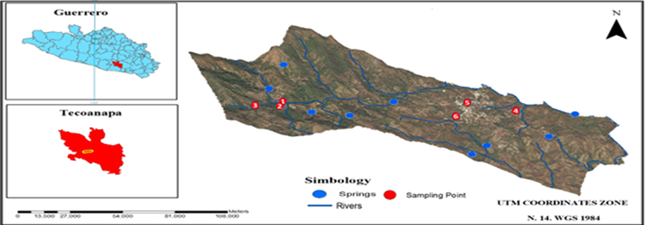
Figure 1. Geographical location of the mountain springs at Las Animas, Gro. In red, the mountain springs of common use (M1, 2, 3, 4, 5, 6) selected for sampled at the present study.
Source: Own design
The sampling sites (Figure 1), correspond to six mountain springs of continuous flow in times of rains and with little flow in dry weather. They are located in the upper and middle part of the polygon of the study, which were called M1 (Cold Water), M2 (Los Martínez), M3 (Avocados), M4 (The Tube), M5 (Los Cuartololotes) and M6 (The Flat land).
The springs selected for the sampling of macroinvertebrates and physicochemical analysis (Figure 1) are important for the inhabitants, since the first three feed the stream of the town and the last three, for human consumption they are used (drinking) in time of low water.

The samplings were standardize by unit of effort / time, in three trawls (with manual spoon network) during 30 minutes (Coayla-Peñaloza et al., 2023; Hurtado et al., 2005; Ruiz-Picos et al., 2016). Due to the size of the mountain springs, they were not divide by quadrants to carry out the collection, but the center and shores were taken into account, removing stones and leaf litter from the surface, as well as the bottom substrate by dragging.
The samples were stored in plastic bottles, labeled and fixed with alcohol, for the later separation of the organisms and their taxonomic identification. In order to the index calculation FBI, the organisms found were grouped by family, accounting for the total number in each of them and for the calculation of the index, assigning the tolerance score proposed by Gutiérrez-Fonseca & Ramírez, 2016, with parameters between 0 (sensitive taxa) to 10 (tolerant taxa).
The Family Biotic Index (FBI-PR) was use because it combines the values of tolerance with the abundance of each family and the total number of individuals in a sample. The value of the index is obtained from the sum of multiplying the tolerance values of each family (ti) by the abundance of organisms (ni) and, divided by the total number (N) of individuals collected (IBF= ∑ (ni*ti) / N).
To compare the scores obtained from the FBI, physicochemical analyzes were carry out based on the Mexican norm: NOM-001-SSA1-1994, of Public Health and the red light of the National Council of Water for surface water (National Water Commission [CONAGUA], 2017). The most important parameters for assessing water quality in freshwater ecosystems were temperature (T), dissolved oxygen (DO), Biochemical Oxygen Demand (BOD5), chemical oxygen demand (COD), nitrites (NO2) y nitrates (NO3).

Results and Discussion
In six studied springs, mountains were captured 140 individuals belonging to four orders and nine families. The most abundant families were Dytiscidae with 40 specimens, followed by Gerridae with 38, Gomphidae with 30, Hydrophilidae with 12, Pseudothelphusidae with five, Calopterydidae and Gyrinidae with four, Veliidae and Belostomatidae with three and Glossosomatidae, with one. Subsequently, we proceeded to the development of graphs for the visualization of the abundance, diversity and water quality for freshwater ecosystems (Pineda Pineda et al., 2018) which was adapted for the common use mountain springs.
Where G (V, E) is a weighted bipartite graph with the set of vertices V= {A, B}, where the set of mountain springs is denoted by A=Mi con i= 1, 2,…6 and set B are the macroinvertebrate families present. The sample number in each family is the weight of the edges (edge thickness). Where vi ϵ A, the degree of the vertex vi (d (vi)) is the number of families present in Mi., and the color represents the water quality according to the FBI (Figure 2, left in the dry season and right in the rainy season).

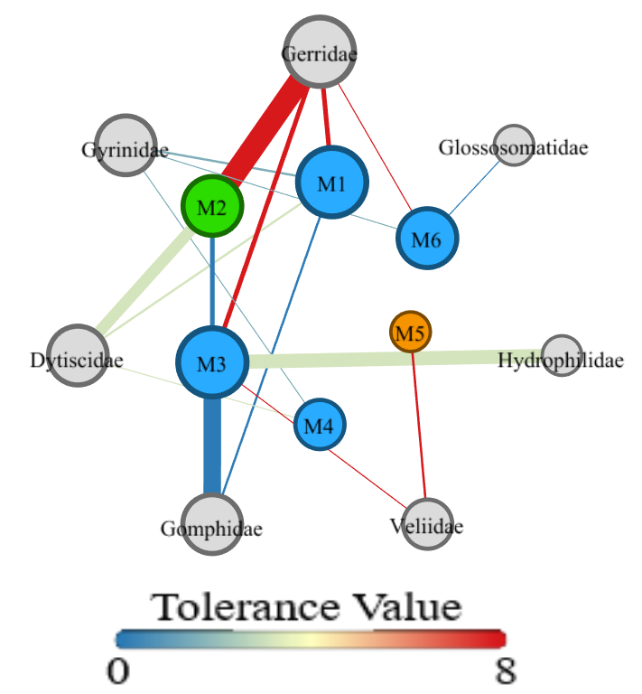
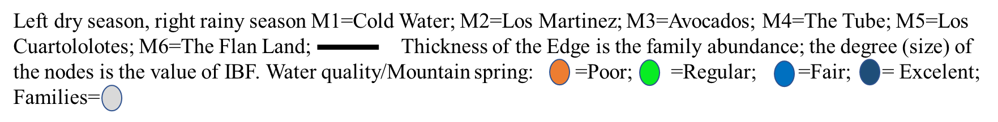
Figure 2. Richness, abundance and wáter quality of the six mountain springs in Las Animas, Guerrero, Mexico.
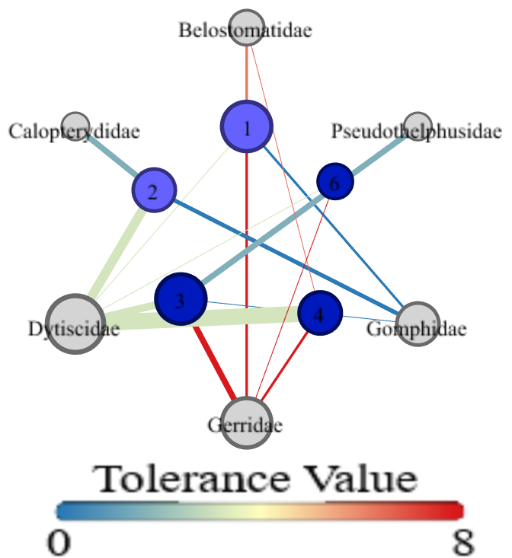

Source: Own design
In the dry season (Figure 2, left), it shows a greater number of families (seven) and the water quality fluctuates from poor to excellent, this is because the mountain springs do not have protection barriers, which causes the animals to make their physiological needs within the water bodies by altering the water quality conditions. While in the rainy season (right), it shows fewer families, because two mountain springs (Los Cuatolotes y The Flat land) have no continuous flow through concrete constructions that protect and store the water resource, which prevents the accumulation of natural organic matter, affecting the development of insect groups.
In this sense, The Tube mountain spring, despite not having a construction that protects it, the connection of a plastic hose at the point where it mountain springs, indirectly affects insects abundance and diversity. In the dry season, the water quality changes going from poor to excellent due to the increase in flow due to the dragging that occurs in this period, which does not happen with the mountain springs that have concrete construction.
Subsequently, the physicochemical parameters and the calculated FBI-PR in Las Animas common use mountain springs. The Pearson correlation coefficient was calculate to measure the association between the indicators. The correlation matrix shows a negative tendency of the DO with BOD5, COD, NO2 and NO3. In the case of the calculated FBI-PR it does not correlate with any measured parameter (Figure 3).

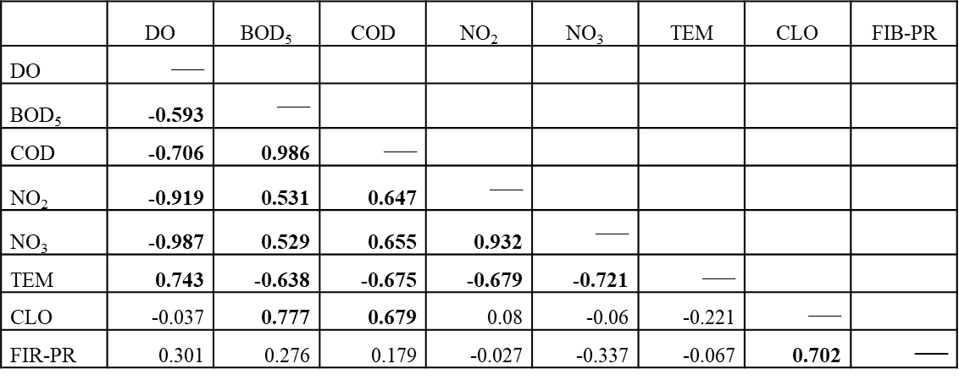
Figura 3. Physicochemical parameters and FBI-PR index correlation of Las Animas common-use mountain springs.
Source: Own design
In order to the correlation’s analysis, scores of 0.4 were taking due to the number of correlated indicators. In accordance with Alakananda et al. 2011; Du et al. 2017, who pointed out that the data can be treated differently, provided that it is taken into consideration that it is sought and that it is wanted to measure. In our case, it can be inferred that FIB-PR index is not adapted to the physicochemical parameters and their contextualization. Therefore, it was determined to make a correlation with the DO and the FBI-PR index, to start from an established criterion.

Based on the DO saturation criteria in water bodies, based on the temperature and established chlorides concentration (Barragán-Peña et al., 2021; Sawyer et al., 2001); DO saturation was calculated in the mountain springs of common use, in Las Animas Guerrero México, based on the Temperature and Chlorides recorded data. The maximum values of temperature (28.3°C), chlorides saturation (25.78 mg/L) and DO (7.28 mg/l) registered in mountain spring number 4 (The Tube) are observed.
Tafur et al. 2010; Vilca-Carhuapoma, 2022, point out that macroinvertebrates found in freshwater currents are molluscs (snails and bivalves), crustaceans (shrimps, crabs, others), mites and, above all, insects (ephemeroptera, plecoptera, trichoptera, coleoptera, diptera). This allows taxa to have a wide range of requirements to colonize the habitat. Whose difference is based on the tolerance degrees to various chemical factors (dissolved oxygen, pH and metal ions) and the wide range of food (Allan et al., 2021; Merritt & Cummins, 1996).
DO and FBI-PR values are inversely related, that is, if DO tends to 0, the water quality is characterized as strongly contaminated (National Water Commission [CONAGUA], in the opposite case of the FIB-PR index, if its value tends to 0, the water quality is excellent. Figure 4 shows the maximum value of DO, obtained in the mountain springs and, the values of the FBI-PR index retained of Gutiérrez-Fonseca & Ramírez, (2016).

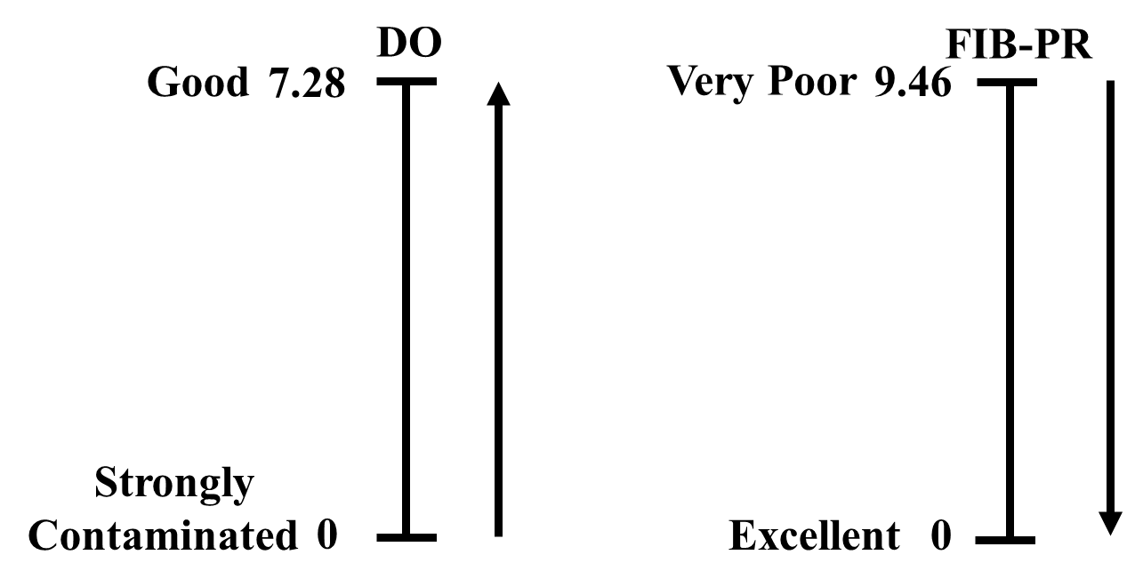
Figure 4. DO values of the mountain springs and FIB-PR index established by Gutiérrez-Fonseca and Ramírez, (2016) for different families and their relationship with water quality.

Source: Own design
Based on this hypothesis, an approximation of water quality was give among these indicators, through the correlation between them. For this study, the seven classes of the FIB-PR index was take into consideration in order to classify the DO values (Figure 5).

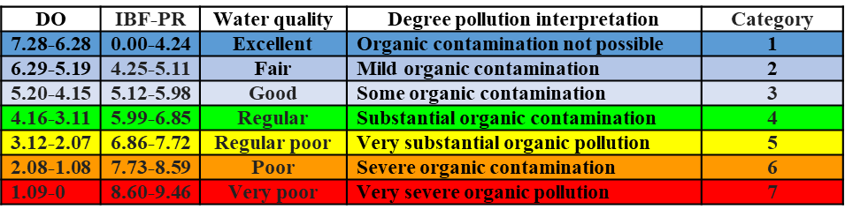
Figure 5. DO intervals, FBI-PR index and contamination interpretation of common use mountain springs in Las Ánimas, Gro., México.
Source: Own design
Afterward, a graphic representation of the relationship between DO and index FIB-PR of the mountain springs was made. The Pearson correlation coefficient was calculate to measure the linear representation between these indicators. Dispersion diagram with negative correlation (-0.945) between the DO and the FIB-PR index obtained in the mountain springs of Las Animas, Gro., Mexico, considering the numerical parameters of indication (P = 0.01).
Subsequently, taking into consideration the families present in the mountain springs, the FIB-PR index Gutiérrez-Fonseca & Ramírez, (2016) was calculated. Furthermore, the Pearson correlation coefficient was calculate to measure the degree of association of the DO and the FIB-PR index. A value of 0.301 was obtain, which indicates positive correlation.
Due to the above, it is considered that the FBI-PR index Gutiérrez-Fonseca & Ramírez, (2016), may be suitable for this type of water bodies, due to the parameters involved such as temperature, climate, or ecosystem. On the other hand, the FBI-PR index has been implemented for urban areas and fast flowing rivers, the study area is located in a rural area with slow flows, based on that perspective, the FBI-PR index was adjusted and FBI-ANIMAS index was constructed (Table 3), to give a first approximation for water quality evaluations from slow-flow springs.
The adjustments made were in the location of the tolerance levels for the families, in the sense that at low levels of contamination, it reduces the dominant populations, or its increase is less frequent (Perkins, 1983; Pontasch et al., 1989). In some Latin American countries, these types of adjustments have been made (Carrera Reyes & Fierro Peralbo, 2001; E. N. García & Rosas, 2010; Muñoz & de Andrés García, 2020; Tafur et al., 2010). The Gerridae and Veliidae families were adjusted to level 7, Belostomatidae to 6, Dytiscidae and Hydrophilidae to 4, Calopterydidae and Gyrinidae to 3 (Table 3).
Table 3. Scores assigned to aquatic macroinvertebrates families to obtain FBI-PR index.
Families * | Score
Blephariceridae | 0
Lestidae, Calamoceratidae, Hydrobiosidae, Leptoceridae, Psephenidae, Ptilodactylidae, Corethrellidae | 1
Xiphocentronidae, Haliplidae, Lampyridae, Ptiliidae, Hydraenidae, Noteridae, Ancylidae, Sphaeridae, Blaberidae | 2
Aeshnidae, Protoneuridae, Glossosomatidae, Helicopsychidae, Hydroptilidae, Polycentropodidae, Scarabaeidae, Scirtidae, Limnichidae, Sciomyzidae, Gomphidae | 3
Baetidae, Caenidae, Elmidae, Gyrinidae, Ceratopogonidae, Chaoboridae, Hydrachnidia, Atyidae, Palaemonidae, Xiphocarididae, Pseudothelphusidae, Neritidae, Calopterydidae | 4
Leptophlebiidae, Coenagrionidae, Libellulidae, Nepidae, Notonectidae, Pleidae, Hydropsychidae, Philopotamidae, Crambidae, Dytiscidae, Hydrophilidae, Staphylinidae, Turbellaria, Hydrobiidae | 5
Corixidae, Hydrometridae, Hebridae, Mesoveliidae, Naucoridae, Dolichopodidae, Empididae, Amphipoda, Hirudinea, Ampullaridae, Lymnaedidae, Limacidae, Corbiculidae | 6
Belostomatidae, Saldidae, Sarcophagidae, Stratiomyidae, Tabanidae, Thaumelidae, Tipulidae | 7
Gerridae, Veliidae, Dixidae, Simuliidae, Planorbiidae | 8
Chironomidae, Culicidae, Ephydridae, Muscidae, Psychodidae, Syrphidae, Thiaridae, Physidae | 9
Oligochaeta | 10
* Families in bold are those found in the mountain springs commonly used in Las Animas. Values of FBI-ANIMAS index were adjusted according to the tolerance level value of FBI-PR index (Gutiérrez-Fonseca and Ramírez, 2016): Families Gerridae and Veliidae to 7, Belostomatidae to 6, Dytiscidae and Hydrophilidae to 4, Calopterydidae and Gyrinidae to 3.
Source: Own design
From the FBI-ANIMAS index, the Pearson correlation coefficient was calculate to measure the level of correspondence between the DO and the FBI-ANIMAS index. A value of R = -.965 (P = 0.01) was obtained, which implies a negative correlation. It was observe that FBI-ANIMAS index was adjusted to the physicochemical characterization of the mountain springs and to DO amounts present in them. The FBI-ANIMAS index for the mountain springs was in the parameters from 4 to 1, which indicates that they are regular to excellent waters.

Conclusions
Dytiscidae family was the most abundant (40%) in the M2 (Los Martínez) monuntain spring, in the springs M1 (Cold water) and M3 (Avocados), were Gerridae with 38% and Gomphidae with 30% respectively.
According to the FBI-PR index, the greatest diversity was 8.0 for the M5 mountain spring (Los Cuartolotes) and those with the lowest diversity were M3 (avocados) and, M4 (The Tube) with 4.5.
The high percentages registered with the FBI-PR index and to match the physicochemical context registered in the mountain springs commonly used in Las Animas, the FBI-ANIMAS index is adjusted and developed.
The FBI-PR index interpreted the water quality for the mountain springs M1, M2, M3, M4 and M6 have good quality, in contrast, M5 springs was registered like poor quality.
FBI-PR index interpreted the water quality for the mountain springs M1, M2, M3, M4, and M6 have good quality, in contrast, the spring mountain M5 was like poor quality.
Evaluating the water quality of the mountain springs with to FBI-ANIMAS index, the springs M1, M2, M3, M4 and, M6 were from particularly good to excellent quality, in the case of M5 spring, it remained in poor quality.
Taking into consideration DO, the water quality was particularly good to excellent in the six mountain springs.
During rainy season, the water quality varied from poor to excellent, due to the increase in flow and the dragging that occurs, which does not happen with the springs sheltered with concrete constructions.
Future lines of research
This study is a reference for future research related to formal and non-formal education for the monitoring of natural resources in rural areas, where there will be an exchange of empirical and scientific knowledge, which will allow the practice of sustainability governance, where resources Natural resources are an essential part of the development of a society. Similar research has been carried out in Latin American countries and few studies have been carried out in Mexico. This would set the standard for understanding from a local perspective what are the forms of organization, participation and conservation that rural localities have.

References
Aguilar-González, X., Ronquillo-Cedillo, I., & Ávila-Nájera, D. M. (2022). Riesgos a la salud por el uso de herbicidas. http://18.235.180.106:8080/jspui/handle/unicaes/468
Alakananda, B., Mahesh, M. K., Supriya, G., Boominathan, M., Balachandran, C., & Ramachandra, T. V. (2011). Monitoring Tropical Urban Wetlands through Biotic Indices. Journal of Biodiversity, 2(2), 91-106. https://doi.org/10.1080/09766901.2011.11884730
Allan, J. D., Castillo, M. M., & Capps, K. A. (2021). Stream ecology: Structure and function of running waters. Springer Nature. https://books.google.com.mx/books?hl=es&lr=&id=SYokEAAAQBAJ&oi=fnd&pg=PR8&ots=bEzM2AkguK&sig=CST-Mp4sDTHI11agpFPxo0gTKE0
Barragán-Peña, P., Macedo-Miranda, Ma. G., & Olguin, M. T. (2021). Cadmium removal from wastewater in a fixed-bed column system with modified-natural clinoptilolite-rich tuff. Chemical Papers, 75(2), 485-491. https://doi.org/10.1007/s11696-020-01314-y
Callisto, M., Castro, D. M., Linares, M. S., Carvalho, L. K., Barbosa, J. E., & Hughes, R. M. (2023). Which metrics drive macroinvertebrate drift in neotropical sky island streams? Water Biology and Security, 2(1), 100077. https://www.sciencedirect.com/science/article/pii/S2772735122001007
Carrera Reyes, C., & Fierro Peralbo, K. (2001). Manual de monitoreo los macroinvertebrados acuáticos como indicadores de la calidad del agua. EcoCiencia.
Coayla-Peñaloza, P., Cheneaux-Díaz, A. A., Moreno-Salazar, C. V., Cruz-Remache, C. E., Colque-Rondón, E. W., & Damborenea, C. (2023). Benthic macroinvertebrate communities and water quality assessment in high Andean wetlands Callali-Oscollo, Arequipa-Cusco, Peru. Revista mexicana de biodiversidad, 94. https://www.scielo.org.mx/scielo.php?pid=S1870-34532023000100302&script=sci_arttext
CONAGUA. (2017). Comisión Nacional del Agua. México. Red Nacional de Monitoreo de la Calidad de las Aguas Nacionales. Base de datos. 20 pp.
Damanik-Ambarita, M. N., Lock, K., Boets, P., Everaert, G., Nguyen, T. H. T., Forio, M. A. E., Musonge, P. L. S., Suhareva, N., Bennetsen, E., & Landuyt, D. (2016). Ecological water quality analysis of the Guayas river basin (Ecuador) based on macroinvertebrates indices. Limnologica, 57, 27-59. https://www.sciencedirect.com/science/article/pii/S0075951116000050
Du, L.-N., Jiang, Y.-E., Chen, X.-Y., Yang, J.-X., & Aldridge, D. (2017). A family-level macroinvertebrate biotic index for ecological assessment of lakes in Yunnan, China. Water Resources, 44(6), 864-874. https://doi.org/10.1134/S0097807817090020
Elosegi, A. (2009). Conceptos y técnicas en ecología fluvial. Fundación BBVa. https://books.google.com.mx/books?hl=es&lr=&id=OfOUggC20_UC&oi=fnd&pg=PA11&dq=Elosegi,+A.,+and++Sabater,+S.(2009).++Conceptos+y+t%C3%A9cnicas+en+ecolog%C3%ADa+fluvial.+Primera+edici%C3%B3n.+Edici%C3%B3n+en+espa%C3%B1ol+Fundaci%C3%B3n+BBVA.+pp.+424.&ots=9kEbGTrfBB&sig=4F2sReyGgzQb5p6fsYqLqnQr4ew
FORERO-CÉSPEDES, A., Reinoso-Florez, G., & Gutierrez, C. (2013). Water quality assessment of the Opia River (Tolima-Colombia), using macroinvertebrates and physicochemical parameters. Caldasia, 35(2), 371-387. http://www.scielo.org.co/scielo.php?pid=S0366-52322013000200012&script=sci_abstract&tlng=pt
Galdean, N., Callisto, M., & Barbosa, F. A. R. (2001). Biodiversity assessment of benthic macroinvertebrates in altitudinal lotic ecosystems of Serra do Cipó (MG, Brazil). Revista Brasileira de Biologia, 61, 239-248. https://www.scielo.br/j/rbbio/a/QwTWbKk4K3D4rpkCycBRsqv/?lang=en&format=html
Gallay, R., Mendoza, C., & Benítez, V. N. B. (2007). Oxidación fotocatalítica de los herbicidas 2, 4-D, Diurón y Ametrina en agua a escala de laboratorio. Santiago de Cali: Facultad de Ingeniería de la Universidad del Valle. http://biosolar. univalle. edu. co/reports/raphaelGallayDoc. pdf. http://biosolar.univalle.edu.co/reports/raphaelGallayDoc.pdf
Gamboa, M., Reyes, R., & Arrivillaga, J. (2008). Macroinvertebrados bentónicos como bioindicadores de salud ambiental. Boletín de malariología y salud ambiental, 48(2), 109-120. http://ve.scielo.org/scielo.php?pid=S1690-46482008000200001&script=sci_arttext
García, E. (1973). Modificaciones al sistema de clasificación climática de Köppen. Instituto de Geografia. UNAM. Serie Libros No. 6.
García, E. N., & Rosas, K. G. (2010). Biodiversidad de insectos acuáticos asociados a la Cuenca del Río Grande Manatí. Puerto Rico: Departamento de Recursos Naturales y Ambientales (DRNA).
García-Barreras, E., Martínez-Fernández, V., & de Jalón, D. G. (2023). Long-term Macrobentos Responses to Environmental Flows and Water Quality improvement along River Jarama. Ecohydrology & Hydrobiology, 23(2), 304-315. https://www.sciencedirect.com/science/article/pii/S164235932200088X
Gómez-Tolosa, M., Rivera-Velázquez, G., Rioja-Paradela, T. M., Mendoza-Cuenca, L. F., Tejeda-Cruz, C., & López, S. (2021). The use of Odonata species for environmental assessment: A meta-analysis for the Neotropical region. Environmental Science and Pollution Research, 28(2), 1381-1396. https://doi.org/10.1007/s11356-020-11137-9
Gutiérrez-Fonseca, P. E., & Ramírez, A. (2016). Evaluación de la calidad ecológica de los ríos en Puerto Rico: Principales amenazas y herramientas de evaluación. Hidrobiológica, 26(3), 433-441. https://scielo.org.mx/scielo.php?pid=S0188-88972016000300433&script=sci_arttext
Hofstede, R. (2001). El impacto de las actividades humanas sobre el páramo. Los Páramos del Ecuador. Particularidades, Problemas y Perspectivas; Mena, P., Medina, G., Hofstede, R., Eds, 161-185.
Hurtado, S., Trejo, F. G., & Yurrita, P. J. G. (2005). Importancia ecológica de los macroinvertebrados bentónicos de la subcuenca del río San Juan, Querétaro, México. Folia Entomológica Mexicana, 44(3), 271-286. https://www.redalyc.org/pdf/424/42444301.pdf
INEGI. (2010). Instituto Nacional de Estadística, Geografía e Informática. Censo general de población y vivienda 2010. México. Pp.1-10.
Mancilla-Villa, O. R., Gómez-Villaseñor, L., Olguín-Lopez, J. L., Guevara-Gutiérrez, R. D., Hernández-Vargas, O., Ortega-Escobar, H. M., Flores-Magdaleno, H., Can-Chulim, Á., Sánchez-Bernal, E. I., & Cruz-Crespo, E. (2022). Contaminación orgánica por coliformes, Nitrógeno y Fósforo en los ecosistemas acuáticos de la cuenca Ayuquila-Armería, Jalisco, México. Biotecnia, 24(1), 5-14. https://www.scielo.org.mx/scielo.php?pid=S1665-14562022000100005&script=sci_arttext
Merritt, R. W., & Cummins, K. W. (1996). An introduction to the aquatic insects of North America. Kendall Hunt.
Mimeche, F., Nouidjem, Y., Djamai, S., Alouani, R., & Bensaci, E. (2019). Studies on the benthic macroinvertebrate community from K’sob Wadi (M’Sila, Algeria). International Biodiverstiy & Ecology Sciences Symposium. https://www.researchgate.net/profile/Tahir-Ozcan/publication/336737322_International_Biodiverstiy_Ecology_Sciences_Symposium_Proceeding_Bioeco2019_26-28_September_2019_IstanbulTurkey_Palas_Academic_Organization_and_Trade_Corporation_Publication_number_1_Iskenderun-Hatay_/links/5dafed5e4585155e27f7f173/International-Biodiverstiy-Ecology-Sciences-Symposium-Proceeding-Bioeco2019-26-28-September-2019-Istanbul-Turkey-Palas-Academic-Organization-and-Trade-Corporation-Publication-number-1-Iskenderun.pdf#page=386
Muñoz, J. M. B., & de Andrés García, M. (2020). La gestión de los sistemas socio-ecológicos de la Bahía de Cádiz:?` nuevas políticas públicas con viejos instrumentos? Boletín de la Asociación de Geógrafos Españoles, 85.
Patiño, S., Hernández, Y., Plata, C., Domínguez, I., Daza, M., Oviedo-Ocaña, R., Buytaert, W., & Ochoa-Tocachi, B. F. (2021). Influence of land use on hydro-physical soil properties of Andean páramos and its effect on streamflow buffering. Catena, 202, 105227. https://www.sciencedirect.com/science/article/pii/S0341816221000862
Perkins, J. L. (1983). Bioassay evaluation of diversity and community comparison indexes. Journal (Water Pollution Control Federation), 522-530. https://www.jstor.org/stable/25041913
Pineda Pineda, J. de J., Rosas Acevedo, J. L., Hernández Gómez, J. C., Rosario Cayetano, O., & Sigarreta Almira, J. M. (2018). Approximation to the study of water quality. http://ri.uagro.mx/handle/uagro/822
Pontasch, K. W., Smith, E. P., & Cairns Jr, J. (1989). Diversity indices, community comparison indices and canonical discriminant analysis: Interpreting the results of multispecies toxicity tests. Water Research, 23(10), 1229-1238. https://www.sciencedirect.com/science/article/pii/0043135489901851
Ramírez Villalobos, E., Rosas Acevedo, J. L., González González, J., & Ávila Pérez, H. (2015). Insectos acuáticos como bioindicadores de la calidad del agua de manantial en Platanillo, Guerrero, México. http://ri.uagro.mx/handle/uagro/686
Ruiz-Picos, R. A., Sedeño-Díaz, J. E., & López-López, E. (2016). Ensambles de macroinvertebrados acuáticos relacionados con diversos usos del suelo en los ríos Apatlaco y Chalma-Tembembe (cuenca del Río Balsas), México. Hidrobiológica, 26(3), 443-458. https://www.scielo.org.mx/scielo.php?pid=S0188-88972016000300443&script=sci_abstract&tlng=pt
Sawyer, C. N., McCarty, P. L., & Parkin, G. F. (2001). Química para ingeniería ambiental.
Suastegui Cruz, S., Rosas Acevedo, J. L., Hernandez Castro, E., Rodríguez Herrera, A. L., & Reyes Umana, M. (2017). Caracterización del uso actual del suelo en Las Ánimas, municipio de Tecoanapa, Guerrero. Revista Iberoamericana de Ciencias, 4(6), 132-143.
Suastegui Cruz, S., Rosas Acevedo, J. L., Reyes Umaña, M., Rodríguez Herrera, A. L., Hernández Castro, E., Gallardo López, F., & Leyva Zúñiga, A. P. (2018). Water Scarcity Index Calculation, Atlas Animas, Tecoanapa Municipality, Guerrero, Mexico.
Tafur, C. M., Revilla, M. H., Ruiz, W. P., Aguilar, R. G., & Guzmán, I. A. (2010). El índice Biological Monitoring Working Party (BMWP), modificado y adaptado a tres microcuencas del Alto Chicama. La Libertad. Perú. 2008. Sciéndo, 13(1-2). https://revistas.unitru.edu.pe/index.php/SCIENDO/article/view/280
Terneus, E., Hernández, K., & José Racines, M. (2012). Evaluación ecológica del río Lliquino a través de macroinvertebrados acuáticos, Pastaza-Ecuador. Revista de Ciencias, 16. https://pdfs.semanticscholar.org/a543/9809d2111eb2bfea99d61a84154e24e6e7f4.pdf
Vilca-Carhuapoma, E. (2022). Uso de los macroinvertebrados como indicadores de la calidad de agua en ecosistemas lóticos en el Perú: Una revisión. South Sustainability, 3(2), e060-e060. https://revistas.cientifica.edu.pe/index.php/southsustainability/article/view/1088

