https://doi.org/10.23913/ride.v14i28.1920
Articles scientists
La importancia de la educación financiera en los jóvenes universitarios frente al retiro por vejez
The importance of financial education in youth in the face of retirement due to old age
A importância da educação financeira dos jovens diante da aposentadoria por velhice

Elizabeth García Espinoza
Universidad Autónoma del Estado de Baja California, México
eligarcia@uabc.edu.mx
https://orcid.org/0000-0001-8932-1502

Gloria Araceli Navejas Juárez
Universidad Autónoma del Estado de Baja California, México
gloria.navejas@uabc.edu.mx
https://orcid.org/0000-0002-6763-5057

Antonio Rosalío Rodríguez Berrelleza
Universidad Autónoma del Estado de Baja California, México
antonio.rodriguez30@uabc.edu.mx
https://orcid.org/0000-0003-1816-7346

Resumen
Este artículo tiene como objetivo identificar la importancia de incluir la educación financiera (EF) en el proceso de formación de los estudiantes de nivel universitario frente al retiro por vejez, ya que las pensiones que se obtendrán conforme al sistema de cuentas individuales resultan en una menor cuantía respecto a las del régimen anterior. Para ello, el diseño de esta investigación fue cualitativo, puesto que se consideró la comprensión de los fenómenos a partir de la experiencia de los sujetos que la viven. Además, se efectúo una revisión documental que incluyó tanto a autores en la materia como información oficial, y se aplicaron encuestas a estudiantes universitarios para identificar su nivel de conocimiento sobre este tema y qué tan conscientes son de la importancia de planear su retiro para reducir el impacto financiero al momento de su vejez. Los resultados muestran que la mayoría de ellos no están debidamente informados al respecto, por lo que se concluye que es importante ahorrar a temprana edad o buscar alternativas financieras para atender las necesidades económicas en la etapa de la vejez. Además, se propone que las universidades se conviertan en promotoras de educación financiera en las unidades de aprendizaje de los planes de estudio.
Palabras clave: afore, finanzas personales, pensiones, seguridad social.

Abstract

This article aims to identify the importance of including financial education (FE) in the process of training university students regarding retirement due to the fact that pensions obtained through individual accounts result in lower amounts compared to those under the previous system. The approach of this research is qualitative because it considers the understanding of phenomena based on the experience of the subjects who live it, in addition to documentary review, which includes both authors in the field and official information. Surveys were conducted with university students to identify their level of knowledge on this topic and how aware they consider themselves of the importance of planning their retirement to reduce the financial impact at the time of old age.

The results of this research show that the majority of students are not properly informed about aspects of personal finances regarding retirement, thus it is concluded that it is important to save at an early age or seek financial alternatives to meet economic needs in old age. It is proposed that universities become promoters of financial education, including such topics in the learning units of the curriculum.
Key words: Afore, personal finances, pensions, social security

Resumo

Este artigo tem como objetivo identificar a importância de incluir a educação financeira (EF) no processo de formação dos estudantes universitários em relação à aposentadoria por idade avançada, uma vez que as pensões que serão obtidas conforme o sistema de contas individuais resultam em quantias menores em comparação com as do regime anterior. O enfoque desta pesquisa é qualitativo, pois considera a compreensão dos fenômenos a partir da experiência dos sujeitos que os vivenciam. Além da revisão documental, que inclui tanto autores na área quanto informações oficiais, foram aplicadas pesquisas com estudantes universitários para identificar seu nível de conhecimento sobre este tema e quão conscientes consideram ser sobre a importância de planejar sua aposentadoria para reduzir o impacto financeiro no momento da velhice.

Os resultados desta pesquisa mostram que a maioria dos estudantes não está devidamente informada sobre aspectos das finanças pessoais relacionadas à aposentadoria, concluindo-se que é importante economizar desde cedo ou buscar alternativas financeiras para atender às necessidades econômicas na velhice. Propõe-se que as universidades se tornem promotoras da educação financeira, incluindo tais temas nas unidades de aprendizagem dos planos de estudo.
Palavras-chave: Afore, finanças pessoais, pensões, segurança social
Reception date: October 2023 Acceptance date: May 2024

Introduction
According to data from the National Council for the Evaluation of Social Development Policy (Coneval), few older adults have had access to a contributory pension, since “only a third of the total number of people aged 65 or over (33.1%) had access to a contributory pension in 2020 and the average monetary value of this perception per person per month was $7,362 pesos” (Coneval, 2022, p. 29).
The requirements to obtain contributory social security pensions in Mexico are provided for in the Social Security Law (LSS) (Congress of the Union, December 21, 1995), although it is important to highlight that, as of July 1, 1997, we moved from a pay-as-you-go or defined benefit system to one of individual capitalization, also called defined contribution, based on individual accounts (Pelton, 2019). With this modification, workers who were registered after July 1, 1997 are covered by this new system; however, according to the Organization for Economic Cooperation and Development (OECD) (2016), it does not guarantee pension benefits of more than 50% of the final salary.
As Vásquez (2012) states, in Mexico there is a marked trend towards aging thanks to the reduction in mortality rates and a longer life expectancy due to technological advances and biomedical sciences. Consequently, the estimates of the National Population Council (Conapo) for Mexico consider that by the year 2050 there will be 148 million inhabitants, of which the majority will be an aged population (Conapo, 2019).
Given the growing number of older adults, it is imperative that their needs be met, hence "they should be adequately funded throughout their working life so that they are sufficient" (Atlatenco et al., 2020, p. 2). This problem has worried both governments and scholars on the subject, which is why Villagómez (2014) points out the following:
There has long been concern among academics and authorities in many countries about whether individuals are making the necessary savings to maintain an adequate level of consumption and well-being during the retirement phase. This is a fundamental issue for any individual and various empirical works have shown that savings levels are often insufficient (p. 550).
However, according to the National Commission for the Protection and Defense of Users of Financial Services (Condusef), Mexican youth have not considered planning their retirement, even though it is estimated that by 2025 the youth workforce will constitute almost 50% of the work in the world (Condusef, 2017). In other words, it can be seen that this age group has not taken into account that aging and the limitations it implies “end up imposing retirement from work, creating the need for income substitutes for remuneration” (Ham -Chande, 2014, p. 16).
To this idea we can add the opinion of Mendizábal and Ruiz (2012), who warn that "the social security that is granted in our country through social insurance has two vital functions for its insured: health care and protecting the means." of subsistence of workers and their families” (p. 95). In this last point, old-age pensions constitute an economic benefit at the time of retirement, that is, a substitute for labor income at this stage of life.
Currently, there is a transition regime between the previous system of the Social Security Law (LSS) of 1973 (Congress of the Union, March 12, 1973) and the new one. According to an OECD report, generations of workers pensioned by the 1973 LSS defined benefit scheme can receive at least 40% of their salary as a pension, and in some cases up to 100% (OECD, 2016). On the other hand, the Inter-American Development Bank (IDB) estimates only 23% for pensions with the individual account system, that is, for workers insured as of July 1, 1997 (Azuara et al., 2019).
Based on this reality, the following questions can be formulated: What is the level of knowledge that young university students have on this topic and how aware do they consider themselves to be of the importance of planning their retirement to reduce the financial impact at the time of their old age? How do young university students currently consider financing their old age in the face of a longer life expectancy?
The basic function of pensions “consists of protecting the standard of living of elderly people against the fall or loss of labor income at the end of their productive life, as well as avoiding poverty in old age” (Scott, 2008, p. 81), so another question arises: do young people know which pension scheme they belong to, as well as its requirements?
From the point of view of Villagómez and González (2014), the reforms to pension systems require greater financial knowledge on the part of workers, since the change was radical and they explain it as follows:
The replacement of pay-as-you-go and defined benefit programs with fully funded, defined contributions and individual accounts has important consequences on workers, transferring to them an important part of the responsibility for achieving adequate levels of savings for retirement (p. 2).
Given these new responsibilities regarding retirement, it is necessary for people to know the most convenient options to achieve an adequate standard of living in their old age. On the topic of financial education, Quezada (2022) explains:
[This] allows individuals to improve their understanding of financial concepts and products, prevent fraud, make decisions appropriate to their circumstances and needs, and avoid undesirable situations arising either from excessive debt or from inappropriate risk positions (p. 3).
Taking into account that, according to the OECD (2012), financial education implies the process through which people obtain a greater understanding of economic principles, as well as develop the skills required to make informed decisions, evaluate risks and economic opportunities to increase their financial well-being, doing so at an early age to avoid the risk of poverty in old age would be desirable.
In this sense, Brutes and Seibert, cited by Valenzuela et al. (2022), emphasize that young people lack financial knowledge in their environment, whether at home or at school, resulting in a lack of understanding on the subject. In this context, financial education becomes important, given that its integration into decision-making can improve the living conditions of young people and prepare them to face future situations and emergencies, regardless of the career they choose.
Consequently, one must be aware that, in terms of retirement due to old age, the problem that currently arises forces workers to make financial decisions to ensure that they will obtain an adequate pension, although in Mexico this problem is becoming more acute. by the following:
Less than half of the Economically Active Population (EAP) is covered by a public pension program; For those who are covered, a good part will not have the right to a pension or a guaranteed minimum pension and public transfer programs currently mean income for less than half of a minimum wage (Villagómez and González, 2014, p. 1).
According to the above, a significant lack of protection is observed for older adults because they will lack resources to meet their basic needs:
From a public policy point of view, this situation is undesirable, so […] one of these alternatives is to promote the financial capabilities of individuals, which consists of providing a set of tools related to knowledge, attitudes and financial behavior that allow them to make appropriate savings, consumption and investment decisions (Villagómez and González, 2014, p. 1).
In accordance with this idea, Villagómez (2014) adds:
Saving for retirement is a topic of great importance for practically all countries in the world. Not only for those whose demographic structure has been aging for some time, but also for those whose demographic transition is moving rapidly towards increasing aging, as would be the case of Mexico (pp. 570-571).
Unfortunately, people are not saving enough to face the future and it is necessary to raise awareness about the importance of saving for retirement.
[This issue] has several aspects, but the most relevant point is that there are serious doubts that a good part of Mexicans is acting as suggested by the standard life cycle model in which there is savings during the active work phase that will serve to finance a desirable (or optimal) level of consumption during the retirement phase (Villagómez, 2014, p. 571).
On this matter, the aforementioned author explains that the problem is exacerbated because the majority of people “do not accumulate the wealth necessary for retirement and the existing pension programs only partially solve the problem” (Villagómez, 2014, p. 571).
As is known, reforms to pension systems arose to ensure their sustainability. However, it cannot be overlooked that these are complex for workers:
[Although] they have allowed them to be given financial viability in the long term and have corrected existing design problems in previous systems; […], these reforms have not managed to solve the coverage problem and have transferred to individuals a set of decisions and risks that they did not previously consider in order to be able to retire (Villagómez, 2014, p. 571).
On the other hand, Colmenares (2015) assures that the perception that the insured have is that “they do not perceive an economic benefit with the current pension system, and they think that there is no transparency in the way their Afore invests their savings in the stock market.” (p. 1). To the above, add the following:
The worker also does not feel qualified to understand the information provided in his account statement, so he then becomes a client of private financial institutions, who manage his resources throughout his working life, charging a commission for management, and investment of their funds (Colmenares, 2015, p. 1)
Given this reality, it is necessary to highlight that the National Commission of the Retirement Savings System (Consar) has carried out important work by creating informative content on financial education with the aim of making this problem visible and raising workers' awareness about the importance of making plans for the future, saving as soon as possible and ensuring an old age without economic problems (Consar, May 20, 2018).
However, Atlatenco et al. (2020) state that the majority of young people have considered living off their pension upon retirement. The results offered by these authors are significant, since they make the problem known and encourage the search for different alternatives to have sources of income that cover the expenses of old age.
Finally, it should be noted that people who entered the social security system provided for by the Social Security Law (LSS) after July 1, 1997 will obtain their pensions based on the individual account regime administered by the Afore, that is why it is required to be informed for better decision-making regarding retirement.
To this end, some questions that should be raised in this regard are the following: What are Afores and what are they for? What returns do they offer? What are the Afore's resources invested in? How much are the commissions they charge? What are the Afores charged? How to achieve an adequate replacement rate to cover expenses in old age? How to improve the expectation of the pension in the face of retirement? What are the Siefores? What is better: a life annuity? or a scheduled withdrawal charged to the individual account of the Afore? What other investment alternatives in addition to the Afore could be considered with a view to retirement? What risks exist when investing? Are there tax benefits of voluntary contributions? and complementary for retirement? How to start saving? How to make a personal budget? How convenient are personal loans?
These questions can be addressed with financial education, hence each person should be informed, since at some point they will reach old age and it will be necessary to cover the expenses that this stage demands.

Materials and methods
This qualitative research was divided into two parts. The first was analytical, since it was based on the analysis of official documents from organizations such as Consar, Condusef, Coneval, OECD, IDB, World Bank (WB), National Banking and Securities Commission of Mexico (CNBV), Latin American Federation of Banks (Felaban) and National Council for Financial Inclusion (Conaif); then, this information collected was contrasted with the documentary review of several specialists in the field.
The second part consisted of the application of a survey carried out in the month of April 2023 to a sample of 500 students from the Autonomous University of Baja California (UABC) with the purpose of knowing how informed they were about the options for retirement in their old age and what financial measures they have taken into account to face that stage of life.
The topic of this research focuses on financial education in youth, particularly university students, and how the university, in this case the UABC, can include this type of topics in its learning units to promote comprehensive training.

Results
Through documentary analysis, it was found that having financial education and knowing how to manage personal finances “is of vital importance today, especially for the younger generations, due to the guarantees that are required for an old age that integrates a good quality of life and optimal financial well-being” (Meza et al., 2023, p. 2).
Numerous governments and international entities have worked on the evaluation of financial inclusion and, therefore, financial education, using a variety of tools aimed at collecting information and creating metrics on the accessibility, use and excellence of products and services. Their contributions have been very valuable in dictating public policies on this matter in different financial countries (Burgueño et al., 2023).
For example, The Global Findex, carried out by the WB, measures access to financial services, which is vital for the global development of countries. Through The Global Findex, it is possible to identify that until 2021, 71% of adults in developing countries have an account at a financial institution or mobile money provider, which corresponds to an increase of more than 50% for a decade now. This constitutes significant progress on the issue of financial inclusion (Demirgüç-Kunt et al., 2022).
However, there is still more to be done, since, according to Demirgüç-Kunt et al. (2022), The Global Findex study finds that traditional classroom financial education has had mixed results, while evidence suggests that financial training structured as learning by doing can lead to regular use of accounts and help users to become more financially savvy clients.
Evidence also demonstrates the importance of real-time information in increasing trust and usage, for example through functionalities that allow users to check balances using a card, phone or internet (Demirgüç-Kunt et al., 2022).
On the other hand, the Latin American Federation of Banks (Felaban) (2017) has considered financial education as a crucial life skill that should begin in school and be part of citizen practice, since this topic is not only valued its influence on behavior and individual well-being, but also highlights its benefits in work environments, in business administration, in the stability of the financial system and for the economic development of nations. Even so, Felaban's I Regional Report: Initiatives in Financial Education in Latin America highlights that there is still much to be done so that people are educated about financial matters at the earliest in their lives (Felaban, 2017).
For its part, the National Banking and Securities Commission (CNBV) (2023), in its study from July of that year, highlights that among adults who have savings accounts, more than half carry out their transactions using mobile devices, a trend that is increasing significantly in the younger segments of the population. In fact, this same organization highlights that a connection has been observed between the population's level of financial literacy and its success in the economic system. For example, financial education programs implemented in Mexico City—which cover topics such as savings, retirement, and credit management—have raised both the level of financial knowledge and savings outcomes among participants.
However, as the National Council for Financial Inclusion of Mexico (Conaif) points out (March 11, 2020), there is still a need to promote the financial inclusion of people in vulnerable situations, such as women, migrants, older adults, indigenous people and the rural population. through the formulation, implementation and control of public policies in this matter. In this regard, this organization highlights important advances, but there are still challenges.
The depth of financial inclusion in Mexico, measured through the possession of more than one financial product or service, indicates that almost 19 million have only one financial product, however, this implies that the degree of financial vulnerability of the population is high, even though they are financially included, since many do so with only one product (Conaif, 2020, p. 37)
Additionally, Conaif (2020) emphasizes the recommendation made in 2005 by the OECD on suggestions to include financial education from an early age and within the educational system. In this sense, he argues that younger generations will face a series of risks derived from various circumstances, including the following:
- An increase in life expectancy, forcing greater savings to be accumulated for longer retirement periods.
- The increase in life expectancy also brings with it a greater financial burden to cover possible medical expenses.
- Social security systems have evolved from defined benefit schemes to defined contribution schemes, where the individual is primarily responsible for generating assets that allow them to cover their expenses during old age (Conaif, 2020, p. 59).
Therefore, it is important to know how the pension system works and its characteristics, given that social security contributions are the contributions of the worker, employer and, where appropriate, the government, and are intended to form capital for the individual pension, which “are deposited in an individual account and the amount that accumulates in said account, plus the returns that are generated, is the resource that the worker will have at his or her disposal” (Pérez, 2015, p. 27).
In accordance with the above, what does old-age insurance protect? Orrico, cited by Mendizábal (2019), considers that the continence protected by this insurance is “the transition from the worker's active situation, regarding his or her working life, to a situation of work inactivity that implies the cessation of economic remuneration” (p. 293). On this topic, Mendizábal (2019) states that in terms of social security, the following is taken into account:

This inactivity is caused by the natural aging of people and the progressive wear and tear of their work capacity, so as a protected risk, benefits will be granted aimed at replacing labor income and protecting the health of retired workers and their beneficiaries (p. 293).

Consequently, it can be noted that the risk of old age accredits its inclusion in social security, in terms of protection of livelihoods:

[This] justifies its permanence within the core of contingencies object of social security, since those who suffer from it are due to its origin and strengthen the financial system by virtue of fulfilling a life of regular work, whose contributions allow the payment of a benefit. life (Mendizábal, 2019, p. 293).
Now, how does the defined contribution system work? According to Morales (2012), the savings from individual contributions, as well as the returns that the managing entities (Afore) manage to obtain, “are invested in various financial instruments, within the limits authorized by the government” (p. 21), which, once the commissions from the administrators have been subtracted, will constitute the basis for determining the pension.
However, it is worth mentioning that the individual capitalization system has provoked various criticisms from specialists in the field, such as Ruiz (2017), who considers that the State decides to abandon its natural responsibilities "leaving each insured person to save for buy his pension himself from a private insurer authorized to manage pensions” (p. 14). In other words, “in this system, each working person will obtain their pension based on what they have saved throughout their working life” (Martínez, 2023, p. 212).
Based on the above, Morales (2012) considers that this system includes “the displacement of a good part of the pension responsibility to a set of new institutions specialized in the administration of pension funds” (p. 21). Hence the importance of having financial education for proper decision-making.
On the other hand, it is important to note that, in the opinion of Ruiz (2017), the individual capitalization system has turned out to be a lucrative business because private institutions “with profit motives and financial intermediaries […] that do not share the risks” participate. in the investments of the savings funds of the insured made by their Investment Companies Specialized in Retirement Funds (Siefore)” (p. 125).
The above constitutes an important reason why each individual must be attentive to the behavior of their investments, so that they can evaluate whether they are in the Afore that offers the highest return through their Siefore. In this sense, Morales (2012) highlights that each worker has the right to choose precisely the institution that will manage their funds, so they can change the administrator periodically as suits their interests, although they must take into consideration that the total balance of funds will be transferred. your account to the new financial institution.
As can be seen, defined contribution plans operate under the principle of the value of each person's money. “This means that the benefits the member will receive are equivalent to the money they accumulated in their account. In this way, it is ensured that the resources of each member will not be used to finance the pensions of others” (Pérez, 2015, p. 27).
This situation seems to demonstrate an advantage; However, it must be taken into account that in this system, if compared to the pay-as-you-go system, “there is no certainty of the amount of benefits that each member will receive” (Pérez, 2015, p. 27), since—as explains Morales (2012)—the pension cannot be quantified in advance.

Workers do not know how much it will amount to in monetary terms, in real terms or in relation to their previous work income, that is, there is no guarantee that this income will last a lifetime and keep benefits up to date with current wage trends. and prices (Morales, 2012, p. 22).
On the other hand, it will be the worker who decides the way in which he will obtain his pension, whether through “life annuities acquired from insurance companies with the balance of accumulated savings, scheduled periodic payments or other combinations” (Morales, 2012, p. 21). Thus, as can be seen, the system of individual accounts administered by the Afores “encourages greater individual responsibility” (Morales, 2012, p. 22).
Likewise, it should be noted that it may be the case that the worker does not have sufficient resources for his pension, so there is a protection measure in this situation:

If the insured at the time of retirement is not enough with his or her own resources to acquire a life annuity or contract a scheduled withdrawal that provides at least the guaranteed minimum pension, the State must cover the shortfall in a single payment to guarantee at least the amount established minimum. Likewise, given that through scheduled withdrawals the resources of the individual account can be exhausted before the worker dies, the State is committed to paying the pensioner, from the date on which the resources have been exhausted, the pension. guaranteed minimum (Contreras, 2012, p. 39).
Certainly, as of July 1, 1997, “all workers who already contributed to the IMSS went to the individual account regime” (Contreras, 2012, p. 40). However, in order not to affect them with the entry into force of the new law, the previous treatment for obtaining a pension according to the LSS of 1973 was respected for those who were registered prior to that date. That is, to obtain unemployment pensions at advanced age, at least 500 weeks of contributions and 60 years of age were required, and for old age, at least 500 weeks of contributions and 65 years of age were required. Therefore, an important point to consider is the following:

At the time of meeting these conditions, they are allowed to choose between the pension that can be financed with the resources accumulated in their individual account, or the one that would correspond to them in Law 73, whose financing was based on collective capitalization in its premium form. staggered (Contreras, 2012, p. 40).
Although it is true that the Social Security Law contemplates a minimum pension, it is important to highlight that this has been decreasing significantly over time. This is another reason to establish financial measures for old age:

With the 1973 law, the minimum was the general minimum wage. As of the entry into force of the law on July 1, 1997, it began as a general minimum wage in force at that time, but as of 2017 it began to be updated according to inflation due to the application of the UMA, which It has caused what the pensioner receives to be less and less (Martínez, 2023, p. 217).
The weeks originally required to be entitled to a pension for unemployment at advanced age or old age, in accordance with the Social Security Law (LSS) that came into force on July 1, 1997, were one thousand two hundred and fifty weeks (Congress of the Union, December 21, 1995, p. 43). However, this requirement was modified by the “Decree that reforms, adds and repeals various provisions of the Social Security Law and the Retirement Savings Systems Law” (Congress of the Union, December 16 of 2020, p. 26), published in the Official Gazette of the Federation on December 16, 2020.
The aforementioned decree, which began its validity on January 1, 2021, establishes, in accordance with article 154 of the LSS for unemployment at advanced age, that “to enjoy the benefits of this branch, the insured is required to have recognized before the Institute a minimum of one thousand weekly contributions” (Union Congress, December 16, 2020, p. 26). Furthermore, for the purposes of article 162 of the LSS, that is, “to be entitled to enjoy old-age insurance benefits, the insured must have reached sixty-five years of age and have a minimum of thousand weekly contributions” (Union Congress, December 16, 2020, p. 27).
The reduction in the number of weeks necessary to access a pension for unemployment at advanced age or old age, from one thousand two hundred and fifty weeks to one thousand weeks, as a result of the reform, represents a benefit for workers. However, Meza et al. (2023) point out that this reform continues to have a direct impact on new generations, as they face a system that demands stricter requirements compared to previous generations.
In another aspect, once the documents from various authors and organizations had been reviewed, for the purposes of this research, a survey was carried out on 500 students from the eight semesters of the 2015-2 curriculum of the degree in Law in the Faculty of Law of the UABC (UABC University Council, 2015). The results are shown below:

Figure 1. Perception of young people about the importance of planning their retirement
Do you consider it important that young people should plan their retirement?
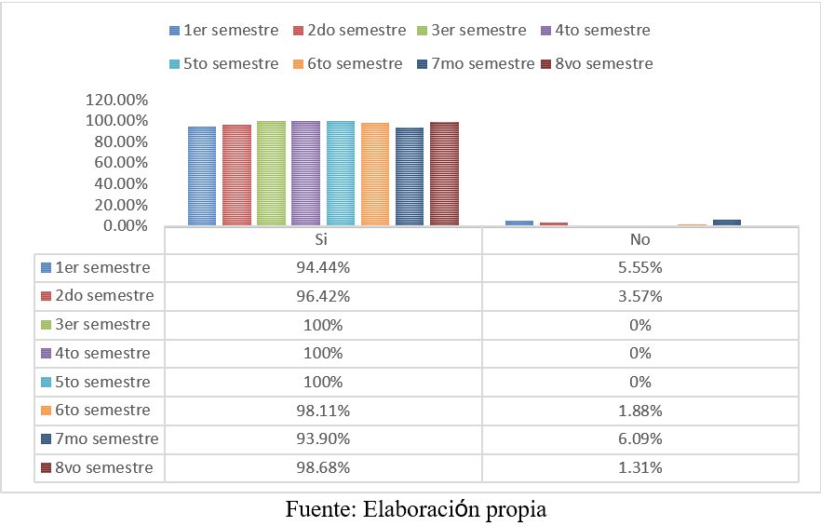
The majority of young people surveyed at the UABC Law School consider it important to plan their retirement (figure 1). This point is relevant, given that, as mentioned above, only one third of people over 65 years of age in Mexico have a contributory pension in the old age stage, which leaves two thirds (66.6%) of the population in a state of vulnerability and at risk of falling into poverty.

Figure 2. Retirement savings plan
Have you considered any savings plan for your retirement (Afore, insurance company, etc.)?
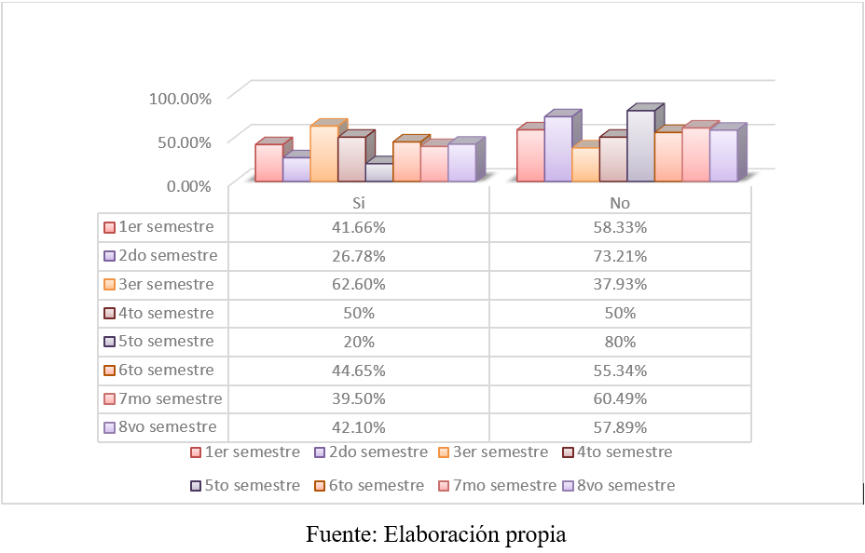

Figure 2 indicates that the majority of respondents have not considered any retirement savings plan; However, a significant percentage does have it contemplated, although it should be noted that if a pension is achieved, it will be low, as reported by the OECD (2016). Given this insufficiency, it is important that young people ensure that they reach the required weeks to obtain a pension or, where appropriate, provide for an alternative way to cover their old age through voluntary contributions, a personal plan for private retirement before some insurance company, or invest in the stock markets.

Figure 3. Identification of the pension scheme
Do you know which pension scheme you belong to?
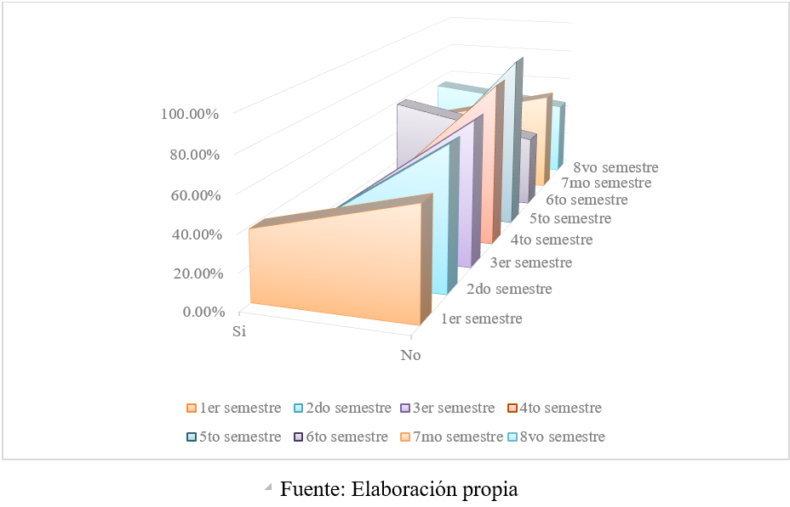
In figure 3 it can be identified that the majority of students are unaware that there are two pension regimes in terms of social security, that is, pensions based on the LSS of 1973, which are those of the pay-as-you-go scheme or also known as defined benefit, and those contemplated by the LSS that came into force on July 1, 1997 based on the resources of its Afore. Hence the importance of offering this information through financial education.

Figure 4. Pension information media
Do you know the various means of information to obtain advice regarding the current issue of pensions versus retirement?
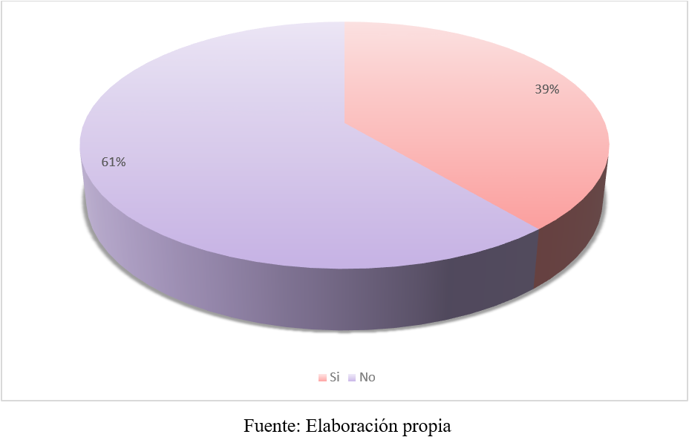
Figure 4 reveals that a significant percentage of students (39%) do not know the means through which they can obtain more information about pensions and other ways of providing resources to face the stage of old age. Although Consar has made a great effort to disseminate information through its portal, it can be said that it has not been enough to make itself known as a means of information.

Figure 5. Information on the subject of pensions
Do you think there is misinformation about the issue of pensions and their future vision?
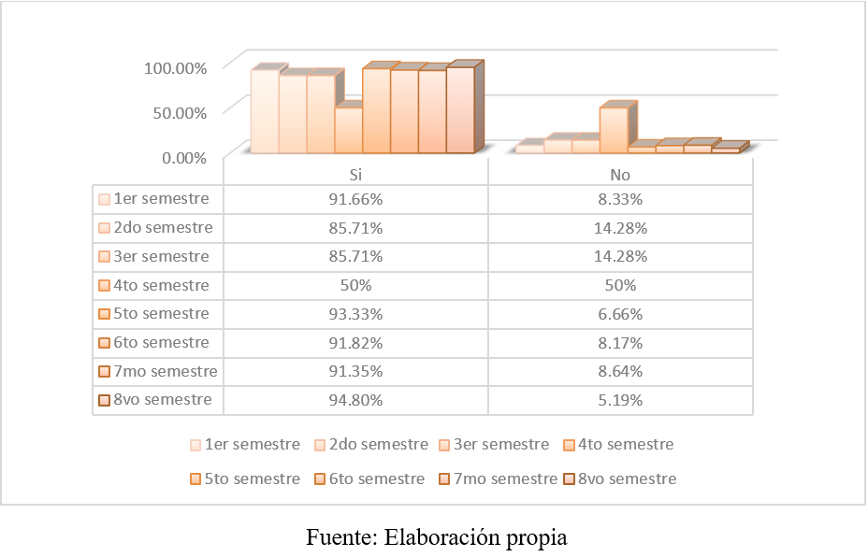
Figure 5 shows that the majority of students lack information regarding such important topics regarding savings and pensions, which they should definitely know.

Figure 6. Pension expectation
Do you know how much your pension will be at the time of your retirement?
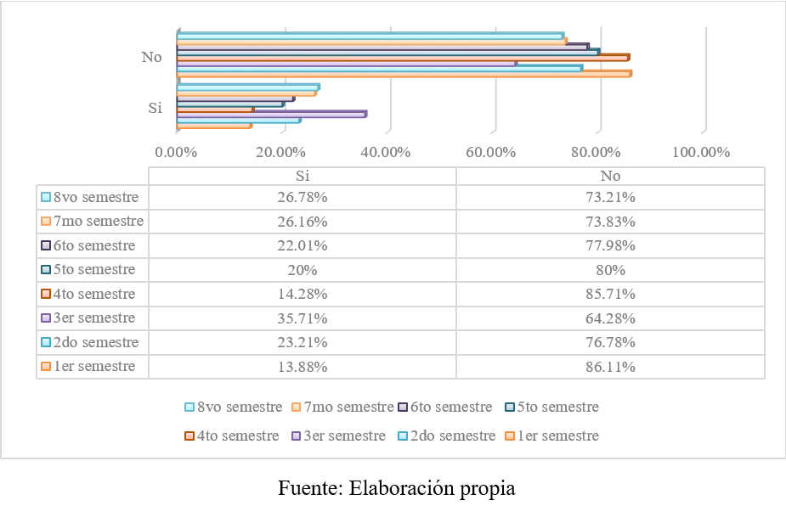
Figure 6 indicates the lack of knowledge about how much their pension will be upon retirement, since the majority do not have information about the amount their pension could be or, if applicable, the proportion it would represent of their salary (replacement rate). That is, they are unaware that it could be approximately a quarter of their salary.

Figure 7. Financial education in the Law degree curriculum
Would you like this topic to be included as an optional subject in our study plan?
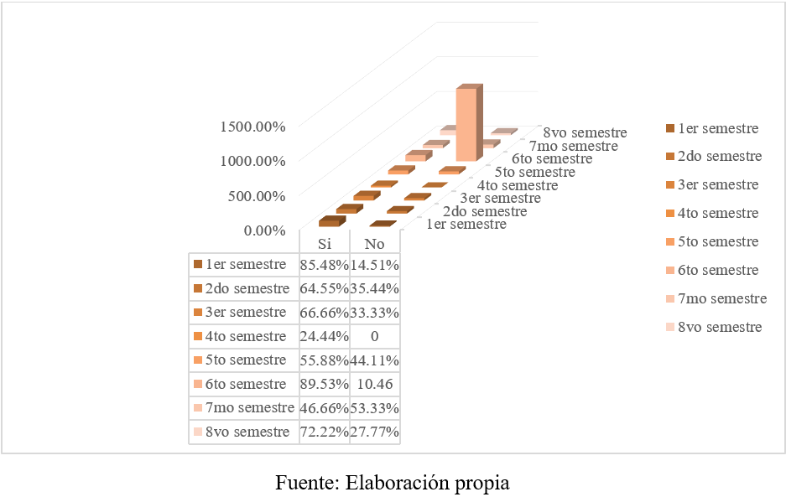
Figure 7 shows that the majority of students consider it important to include financial education as an optional subject in the law degree program (UABC University Council, 2015), although a lack of interest is also perceived on the part of the students. of the minority.

Discussion
The results of this research coincide with what other authors have stated in that, despite the importance of financial education regarding social security retirement pensions as a source of income in old age, there is great misinformation among young people in general. Paraphrasing Valenzuela et al. (2022), young people lack financial knowledge in their environment, whether at home or at school, which is evidenced in this research, which —as Atlatenco mentions et al. (2020)—also applies to old-age retirement.
Financial education, therefore, should be promoted from childhood with the objective that children and adolescents develop their knowledge and skills to make economic decisions with a vision for the future (Felaban, 2017). The data from this research coincide with Villagómez (2014) regarding the importance of planning for retirement; however, this should not be just an assessment, but rather the identification of alternatives for adequate awareness about the future of pensions that today's young people will obtain, which, in the case of this study, would be university students.
In accordance with the above, it is important to know the measures that should be implemented to counteract the negative effects of this financial ignorance, since the current pension system transfers to individuals a series of decisions regarding retirement that they did not have before (Villagómez and González, 2014). Furthermore, the exact amount of pensions that the current system offers is unknown, although, according to the literature consulted, it is known that they are low compared to the previous system called the pay-as-you-go or defined benefit system.
Therefore, it is proposed that universities consider financial education as part of their curricula to ensure a good quality of life and optimal financial well-being in the future (Meza et al., 2023). Likewise, for future work, it is relevant to look for alternatives to raise awareness about the importance of this pension issue and identify how technology can be used in the digital era with the aim of achieving quality of life in old age.

Conclusions
The findings of this study reveal that the majority of UABC university students lack adequate knowledge on topics related to financial planning for old-age retirement. It is therefore suggested to start saving from an early age or consider alternative financial options to ensure financial stability during old age. In addition to this, it is important to include financial education in the training process of university students to face the last stage of life.
In this regard, keep in mind that due to the incorporation of individual accounts into the retirement pension system in the social security legislation in Mexico, people will obtain pensions in smaller amounts than with the pension regime of the previous system. Therefore, young university students must know financial alternatives to reduce the risk of falling into poverty in old age, hence universities must include this type of topics in the learning units of their study plans.

Future lines of research
Based on this research, 26 years after the entry into force of the LSS of 1997, there is still misinformation about pensions and retirement savings. Therefore, it is important to develop detailed studies and analyzes on the fiscal and financial benefits of voluntary savings and personal retirement plans, as well as have options that allow people to expand their income to cover the stage of old age. Likewise, financial education, which allows savings to meet financial needs in old age, should be studied from childhood and by the entire young population.

References

Atlatenco, Q., De la Garza, M. T. y López, J. A. (2020). Pensiones contributivas como fuente de ingresos en la vejez prevista por los jóvenes mexicanos. Entreciencias: Diálogos en la Sociedad del Conocimiento, 8(22), 1-18. https://doi.org/10.22201/enesl.20078064e.2020.22.76243

Azuara, O., Bosch, M., García, M., Kaplan, D. y Silva, M. T. (2019). Diagnóstico del sistema de pensiones mexicano y opciones para reformarlo. Banco Interamericano de Desarrollo. http://dx.doi.org/10.18235/0001681

Burgueño, R., Bernardino, S. y Meza, F. (2023). Análisis de las características de la inclusión financiera en México. En L. F. Zamudio y B. A. Ramos (coords.), Una introducción a las políticas públicas en la inclusión financiera en México (pp. 205-224). Universidad Autónoma de Baja California y Editorial CENID. https://www.cenid.org.mx/libros/libros23/libro016/#p=1

Colmenares, E. (2015). Evaluación del conocimiento que cuentan los trabajadores sobre los fondos para su retiro. Revista Iberoamericana de Contaduría, Economía y Administración, 4(8), 1-14. https://dialnet.unirioja.es/servlet/articulo?codigo=5263328

Comisión Nacional Bancaria y de Valores (CNBV) (2023). Estudios Económicos, Vol.5. Educación Financiera y Riesgo Crediticio en México. https://www.gob.mx/cms/uploads/attachment/file/846234/3._Educaci_n_Financiera_-_Estudios_Econ_micos_CNBV_-_Vol._5.pdf

Comisión Nacional del Sistema de Ahorro para el Retiro (Consar) (20 de mayo de 2018). Ahorro y futuro: la aventura de mi vida. https://laaventurademivida.gob.mx/

Comisión Nacional para la Protección y Defensa de los Usuarios de Servicios Financieros (Condusef) (2017). Ahorro para el retiro en tiempo de millenials. Revista Proteja su Dinero, (210), 40-42. https://revista.condusef.gob.mx/2017/08/ahorro-para-el-retiro/

Congreso de la Unión (12 de marzo de 1973). Ley del Seguro Social [LSS]. Diario Oficial de la Federación, 10-38. https://legislacion.scjn.gob.mx/Buscador/Paginas/wfOrdenamientoDetalle.aspx?q=VzNC+MslnhhIDEEjByD59ZjF57yl5pC99hpoDzQ/dkTnhZ6U313zolbiDcQb33hh

Congreso de la Unión (21 de diciembre de 1995). Ley del Seguro Social [LSS]. Diario Oficial de la Federación, 25-63. https://legislacion.scjn.gob.mx/Buscador/Paginas/wfOrdenamientoDetalle.aspx?q=0JmX86OPHpb2N3AAc4v1rsXNeenSeDtEv+6waDB13OpzeU8tMaMqdFNopB+OI03Y
Congreso de la Unión (16 de diciembre de 2020). Decreto por el que se reforman, adicionan y derogan diversas disposiciones de la Ley del Seguro Social y de la Ley de los Sistemas de Ahorro para el Retiro. Diario Oficial de la Federación, 26-34. https://legislacion.scjn.gob.mx/Buscador/Paginas/wfOrdenamientoDetalle.aspx?q=0JmX86OPHpb2N3AAc4v1rsXNeenSeDtEv+6waDB13OpzeU8tMaMqdFNopB+OI03Y
Consejo Nacional de Evaluación de la Política de Desarrollo Social (Coneval) (2022). Pobreza y personas mayores en México 2020. https://www.Coneval.org.mx/Medicion/MP/Paginas/Pobreza_Personas_Mayores.aspx#:~:text=Un%20tercio%20del%20total%20de,al%20mes%20era%20de%20%247%2C362

Consejo Nacional de Inclusión Financiera de México (Conaif) (11 de marzo de 2020). Política nacional de inclusión financiera. https://www.gob.mx/cms/uploads/attachment/file/643214/PNIF__2020.pdf

Consejo Nacional de Población (Conapo) (2019). Proyecciones de la población de México y de las entidades federativas 2016-2050. http://www.conapo.gob.mx/work/models/CONAPO/Cuadernillos/33_Republica_Mexicana/33_RMEX.pdf

Consejo Universitario UABC (2015). Plan de estudios. Licenciatura en Derecho 2015-2. http://derecho.mxl.uabc.mx/derecho/doc/documentos/plan_estudios_20152.pdf

Contreras, C. (2012). Pensiones y jubilaciones en los sistemas públicos nacionales. En G. Mendizábal (coord.), El trabajo y las pensiones de los académicos en las universidades del siglo XXI (pp. 35-52). Universidad Autónoma del Estado de Morelos.

Demirgüç-Kunt, A., Klapper, L., Singer, D. and Ansar, S. (2022). The Global Findex Database 2021: Financial Inclusion, Digital Payments, and Resilience in the Age of COVID-19. World Bank. doi:10.1596/978-1-4648-1897-4

Federación Latinoamericana de Bancos (Felaban) (2017). I Informe regional. Iniciativas en educación financiera en América Latina. https://felaban.s3-us-west-2.amazonaws.com/publicaciones/archivo20180111220048PM.pdf

Ham-Chande, R. (2014). El envejecimiento en México: El siguiente reto de la transición demográfica. El Colegio de la Frontera Norte.

Martínez, G. (2023). Retiro, cesantía en edad avanzada y vejez. En S. Calvillo (coord.), Introducción al derecho de la seguridad social en México. Contenido y alcance (pp. 193-224). Tirant Lo Blanch.

Mendizábal, G. (2019). La seguridad social en México (3.ª ed.). Porrúa.

Mendizábal, G. y Ruiz, I. (2012). Las pensiones y jubilaciones para los trabajadores académicos de la Universidad Autónoma de Morelos. En G. Mendizábal (coords.), El trabajo y las pensiones de los académicos en las universidades del siglo XXI (pp. 95-120). Universidad Autónoma del Estado de Morelos.

Meza, B. J., Portal, M. y Feitó, D. (2023). El ahorro para el retiro en México. Un análisis generacional y de género. Región y Sociedad, (35), 1-31. https://doi.org/10.22198/rys2023/35/1715

Morales, M. A. (2012). Generalidades de los sistemas de pensiones. En G. Mendizábal (coords.), El trabajo y las pensiones de los académicos en las universidades del siglo XXI (pp. 13-33). Universidad Autónoma del Estado de Morelos.

Organización para la Cooperación y Desarrollo Económico (OCDE) (2005). Improving Financial Literacy: Analysis of Issues and Policies. OECD Publishing https://doi.org/10.1787/9789264012578-en

Organización para la Cooperación y Desarrollo Económico (OCDE) (2012). Recomendación sobre los principios y buenas prácticas de educación y concienciación financiera. Centro OCDE/CVM de Educación y Alfabetización Financiera para América Latina y el Caribe. https://www.oecd.org/daf/fin/financial-education/%5BES%5D%20Recomendaci%C3%B3n%20Principios%20de%20Educaci%C3%B3n%20Financiera%202005.pdf

Organización para la Cooperación y Desarrollo Económico (OCDE) (2016). Estudios de la OCDE sobre los sistemas de pensiones: México. https://www.oecd.org/pensions/private-pensions/OECD-Review-Pension-Systems-Mexico-Highlights-ESP.pdf

Pelton, A. (2019). Sistema de ahorro para el retiro. Kindle Amazon.

Pérez, F. (2015). La administración de los fondos de pensiones de capitalización individual en el contexto mexicano. Fontamara.

Quezada, E. (2022). Educación financiera para todos. Kindle Amazon.

Ruiz, A. G. (2017). Las Afore, el sistema de ahorro y pensiones mexicano. Porrúa.

Scott, J. (2008). Hacia la universalidad de la seguridad social en México: Pensión básica no contributiva. En R. Ham, B. Ramírez, y A. Valencia, (coords.) Evaluación y tendencias de los sistemas de pensiones en México (pp. 73-92). El Colegio de la Frontera Norte, la Universidad Nacional Autónoma de México, Instituto de Investigaciones Económicas.

Valenzuela, M., López, V. G. y Aguilar, K. G. (2022). Endeudamiento y educación financiera en estudiantes universitarios. Revista Venezolana de Gerencia, 27(97), 198-211. https://doi.org/10.52080/rvgluz.27.97.14

Vásquez, P. (2012). Pensiones en México, la próxima crisis. Siglo XXI Editores.

Villagómez, A. (2014). El ahorro para el retiro. Una reflexión para México. El Trimestre Económico, 81(323), 549-576. https://doi.org/10.20430/ete.v81i323.122

Villagómez, A. y González, A. (2014). El efecto del alfabetismo financiero en el ahorro para el retiro en México. Documento de Trabajo. Centro de Investigación y Docencia Económicas, A.C. http://repositorio-digital.cide.edu//handle/11651/935

Contribution Role | Author(s)
Conceptualization | Elizabeth García Espinoza (principal)  Gloria Araceli Navejas Juárez (same)  Antonio Rosalío Rodríguez Berrelleza (same)
Methodology | Elizabeth García Espinoza (principal)  Gloria Araceli Navejas Juárez (supporting)
Software | Elizabeth García Espinoza (principal)  Gloria Araceli Navejas Juárez (supporting)  Antonio Rosalío Rodríguez Berrelleza (who supports)
Validation | Elizabeth García Espinoza (principal)  Gloria Araceli Navejas Juárez (same)  Antonio Rosalío Rodríguez Berrelleza (same)
Formal Analysis | Elizabeth García Espinoza (principal)
Investigation | Elizabeth García Espinoza (principal)  Gloria Araceli Navejas Juárez (supporting)  Antonio Rosalío Rodríguez Berrelleza (who supports)
Resources | Elizabeth García Espinoza (principal)  Gloria Araceli Navejas Juárez (supporting)
Data curation | Elizabeth García Espinoza (principal)  Gloria Araceli Navejas Juárez (supporting)
Writing - Preparation of the original draft | Elizabeth García Espinoza (principal)
Writing - Review and editing | Elizabeth García Espinoza (principal)  Gloria Araceli Navejas Juárez (same)  Antonio Rosalío Rodríguez Berrelleza (same)
Display | Elizabeth García Espinoza (principal)  Gloria Araceli Navejas Juárez (same)  Antonio Rosalío Rodríguez Berrelleza (same)
Supervision | Elizabeth García Espinoza (principal)
Project management | Elizabeth García Espinoza (principal)
Fund acquisition | Elizabeth García Espinoza (principal)

