https://doi.org/10.23913/ride.v14i28.1950
Scientific articles
El rol docente entre el ethos y las virtudes del profesorado. Reflexiones y saberes
The teaching role between the ethos and virtues of the teacher. Reflections and teaching wisdom
O papel docente entre o ethos e as virtudes do corpo docente. Reflexões e conhecimento

Gabriela Ruiz de la Torre
Universidad Pedagógica Nacional, Unidad 161 Morelia, México.
gruiz@upn161morelia.edu.mx
https://orcid.org/0009-0003-4295-1488
Perla Araceli Barbosa Muñoz
Universidad Michoacana de San Nicolás de Hidalgo, México.
perla.barbosa@umich.mx
https://orcid.org/0000-0003-2613-0738
María Luisa Sáenz Gallegos
Universidad Michoacana de San Nicolás de Hidalgo, México.
maria.saenz@umich.mx
https://orcid.org/0009-0007-6440-5129

Resumen
El propósito de este artículo es presentar una variedad de recomendaciones y conocimientos docentes, junto con estrategias de trabajo, que buscan mejorar la dinámica escolar a través de la reflexión sobre el ethos y la ética docente con el objetivo de promover una práctica docente pertinente y adaptada a las necesidades educativas actuales. Para ello, la metodología se fundamentó en un estudio cuantitativo, no experimental, transversal y descriptivo, utilizando una muestra conveniente de 60 docentes de Morelia, Michoacán (México), que abarcó los niveles básico, medio superior y superior. En concreto, se administró una encuesta estructurada basada en los elementos encontrados en la literatura actual sobre el ethos docente, y se empleó estadística descriptiva para analizar los datos, utilizando Excel y el paquete estadístico SPSS, versión 25. El estudio reveló que la población encuestada reconoce ampliamente la importancia del ethos y la ética en su práctica docente, así como el papel crucial de la enseñanza en valores, la empatía, la mediación y la escucha activa en la formación integral de los estudiantes.
Palabras clave: clima del aula, ética docente, ethos, diálogo, práctica docente.

Abstract
The aim of this article is to present a variety of recommendations and pedagogical insights, along with work strategies, that seek to enhance school dynamics through reflection on teaching ethos and ethics, aiming to foster a teaching practice that is both relevant and consistent with current educational needs. The methodology employed was based on a quantitative, non-experimental, cross-sectional, and descriptive study, utilizing a convenience sample of 60 teachers from Morelia, Michoacán, Mexico, across Elementary, High School, and Higher Education levels. A structured survey was administered, incorporating elements identified in the current literature on teaching ethos, and descriptive statistics were used to analyze the data, employing Excel and the IBM SPSS Statistics software, version 25. The study made it possible to identify in the surveyed population a marked recognition of the importance of ethos and ethics in their teaching practice, as well as the determining role of teaching values, empathy, mediation, and active listening in the comprehensive training of students.
Key words: classroom climate, teaching ethics, ethos, dialogue, teaching practice.

Resumo
O objetivo deste artigo é apresentar uma variedade de recomendações e conhecimentos docentes, junto com estratégias de trabalho, que buscam melhorar a dinâmica escolar por meio da reflexão sobre o ethos e a ética docente, com o objetivo de promover práticas docentes relevantes e adaptadas às necessidades educacionais atuais. Para isso, a metodologia baseou-se em um estudo quantitativo, não experimental, transversal e descritivo, utilizando uma amostra apropriada de 60 professores de Morelia, Michoacán (México), que abrangeu o ensino básico, médio e superior. Especificamente, foi aplicada uma pesquisa estruturada com base nos elementos encontrados na literatura atual sobre o ethos docente, e a estatística descritiva foi utilizada para analisar os dados, utilizando o Excel e o pacote estatístico SPSS, versão 25. O estudo revelou que a população pesquisada reconhece amplamente a importância do ethos e da ética na sua prática docente, bem como o papel crucial do ensino de valores, da empatia, da mediação e da escuta ativa na formação integral dos alunos.
Palavras-chave: clima de sala de aula, ética docente, ethos, diálogo, prática docente.
Reception Date: October 2023 Acceptance Date: April 2024

Introduction
The COVID-19 pandemic has had a significant impact across various fields, including economic, political, and social sectors. Specifically, in the field of education, it has presented major challenges, especially concerning the role of teachers amidst crisis and uncertainty. This situation has necessitated a complete restructuring of teaching dynamics to adapt to the academic and technological demands imposed by the health emergency.
In the virtual environment, for example, teachers must prioritize dialogue, attention, and presentation, as well as remain vigilant to prevent potential conflicts and other unexpected events that may arise. Therefore, it is crucial to strengthen the teaching ethos, which involves avoiding improvisation and maintaining a consistent and well-prepared performance.
This article focuses on the narrative of recent studies on teaching ethos and ethics, starting with an analysis of these concepts and their axiological basis. Subsequently, proposals are explored to implement a teaching practice founded on ethical principles aimed at building a robust ethos that enhances the teaching profession and revalues its role. For this, key elements such as active listening, empathy, and mediation are considered fundamental in this process.
After conducting the theoretical study, the foundation of the methodology used is established, concluding with the analysis and discussion of the results, which reveal the surveyed population's recognition of the importance of ethos and ethics in their teaching practice, as well as the responsibility they assume in their own training and in the comprehensive education of students.

From the perspectives of research and concepts of teaching ethics
The teaching role in the face of uncertainty
In this first section, it is deemed essential to foster reflection and engage in research on the perspective of how educators perform their work, how they communicate, and develop their role as facilitators of learning. This task has been valued as a task of public salvation by authors such as Cristina Nosei (2004), who asserts that it lends meaning to existence and claims that the educational labor decodes or defragments messages to make the world understandable. In this regard, the author suggests that dialogue should be the critical understanding of the world to enable trainees to have an active yet responsible intervention in their opinions and actions. In other words, teaching is about helping others to participate in public life, to discern what is superfluous, and to address dilemmas; therefore, educators must know what and how to teach, without neglecting the coherence between the teaching goals and strategies, as well as the teaching process and its content.
However, given the environment of uncertainty and the health crisis experienced during and after the pandemic, where unforeseen situations were faced and it was necessary to cope daily with tedium, routine, monotony, stress, and demands of work and academic planning, teaching, conversing, listening, and resolving various situations, it is logical that, consciously or unconsciously, patience and response capacity may diminish. Therefore, it has been necessary to undertake actions that help to ensure that in addition to developing the teaching practice, it is carried out with initiative, participation, empathy, and trust, which of course, requires significant effort.
In this context, a reflection on the current role of the teacher is presented. It should be noted that often, teachers are overwhelmed by various situations that block their power of self-evaluation. Nonetheless, when students notice that teachers take actions to change and improve the school environment, it creates an opportunity for the students to also reflect on their own role as members of a family and society.

The ethos and teaching ethics
To talk about ethos and teaching ethics, it is advisable to first make a distinction between both concepts. Regarding the first word, Velázquez Gómez (2015) points out that it has to do with the essence of being a teacher:
A teacher who has committed to a professional career in education must determine what aspects he must acquire and/or reinforce through said processes; by simultaneously developing reflective and introspective practices that allows you to understand and analyze what has to change, why to change it and in what direction, and at the same time, build the actions and activities necessary to achieve it, said process will be influencing directly in the ethos of the teaching profession, that is, in the essential part of his being, which is reflected in his work as a teacher (p. 9) .
According to this opinion, ethos refers to the essence of being a teacher, which is reflected in each of the functions performed during said work. This same logic is found in the opinion of Jiménez et al . (2005) :
The teaching ethos represents the importance of understanding the behaviors, abilities, and skills that enable teachers, based on their professional practice, to fulfill their duties and rights that are assigned to them, based on their training process, knowledge, experience and in an intention of the professional way of being. The teaching ethos is concretized in the professional rights that are acquired through work, through the practice of a profession that makes a human being not only a man, but also a professional ( p. 180 ).
In another meaning found in recent literature, ethos is proposed as the concept of “doing things well when no one is watching”, a reflection attributed to CS Lewis and Aldo Leopold. This opinion is illustrated by the story of a fifth grade student, who expresses ethos as the act of behaving well even when his mother is not watching, since she is the one who loves him the most and gives him gifts and celebrations ( Grigoropoulos , 2020).
Now, when reflecting on the teaching ethos , it should be indicated that it should not only train teachers to teach classes, but also prepare them to continually seek greater knowledge, as well as other strategies and actions that can allow them to work autonomously in their practice. pedagogical. Therefore, teacher training environments must facilitate a permanent reconfiguration of the knowledge constructed by teachers throughout their careers. In other words, training experiences shape teaching, while ethos does the same with professional identity (Marcell and Barreto da Cruz, 2018).
Consistent with this, Nelson (2008) explains that a two-year study carried out by post-primary undergraduate students at a university college in Northern Ireland shows that encounters with different schools and educational models can help future teachers understand the differences between schools and their visions of education, as well as correcting misunderstandings, challenges or stereotypes. Nelson argues that as a result of experiencing diverse examples of ethics, future teachers can also be helped to understand the complexity of schools as organizations, and to position themselves and their professional practice within broader debates about the goals of education. and schools as communities of practice.
Following the logic of the analysis of the concept of teaching ethos , Rodríguez -Sedano et al (2011) point out that the professional task in education has an ethical dimension superior to the technical one, since it focuses on the idea that educational performance cannot separate the training teaching. For this reason, they conceive that teaching is not only instruction, but mainly the training of people driven by the practice of habits and virtues. That is, the educational ethos must focus on the development of virtues such as justice, fortitude, temperance and prudence, both in teachers and students. Furthermore, they explain that these virtues are not exclusive to the educational world, but have been considered compatible with personal values.
Talking about the teaching ethos , therefore, implies recognizing that it goes beyond the professional ethics that each teacher must possess as part of their professional training. It also requires reviewing their identity as a very close concept, and the levels of development of civic values must be shown tangibly and explicitly in the way they are teachers. In this regard, García López et al . (2006) explain:
We will understand professional ethics as the discipline that aims to determine the set of ethical and moral responsibilities that arise in relation to the exercise of a profession (...). The general professional ethics proposes principles valid for all professions: dignity and human rights, justice, beneficence and professional responsibility. On the other hand, professional ethics apply the principles of general professional ethics to a specific field of professional activity (medicine, law, education, social work, etc.), also assuming scientific and ethical criteria as principles for ethical conduct. the experience of good practices in professional procedures. In our case, we are considering university teaching as a profession ( pp. 548-549 ).
The above is explained in the sense that although professional ethics often refers to honesty in conduct as a professional in any field of knowledge, the professional ethics of the teacher is also manifested in everything that is not expressed openly, but It is demonstrated in actions. In other words, sometimes what the teacher does not do or act in the educational environment can convey more than what could be explained directly.
Therefore, the teacher must prepare to help others develop their identity and teaching ethos , as well as strengthen their autonomy, critical capacity, construction of dialogue, respect and sense of responsibility. These attitudes must accompany teaching work, even if they are not explicitly addressed in the theoretical or practical curricular contents related to professional ethics or axiology. This is crucial so that teaching practice in areas where these topics are not directly analyzed as part of the curriculum transcends towards a so-called interdisciplinarity of science.
On the other hand, teaching staff must also consider that their behavior and way of addressing the group represent a form of teaching, whether they want it or not. This means that you must always keep in mind that what you don't say can also be interpreted in a meaningful way. In this way, it is recognized that the contribution to training is often influenced by the so-called hidden curriculum, which generally teaches what is not intended to be explicitly made known.
The construction of the dialogue referred to must be based on consultation and inquiry to avoid producing intimidation effects. That is, teaching staff must be careful how they consult and approach students to find out their concerns, and also know how to decide when they can or cannot advise on any doubt or concern that is not part of the topics that they are responsible for analyzing in their course. , but it is known that they are important and necessary for the training of students.
In this context, the function of tutoring or mentoring is integrated into these dialogue processes. Although these programs have their own protocols, thematic fields and stages of completion, the formal advice provided in any area must be aimed at the human and professional development of the students, so that positive changes are promoted in their lifestyle and in their training path.
The above opinions agree with those of González and Guevara (2018), who state that “as university teachers, we must accept the responsibility of promoting healthy lifestyles that protect the health of students and, therefore, the quality of life of future integral professionals” (p. 87).
Returning to the statements about teaching work linked to ethics, García López et al . (2006) emphasize the need to “focus effort on student learning, which means rethinking the teaching function carried out until now and incorporating innovations, both methodological, technical and ethical” (p. 545). In fact, in another subsequent publication by García López et al. (2010), certain basic principles of teaching ethics are detailed, which are summarized in the following lines:
Respect for the personal dignity of all members of the community, fundamentally, for their conscience, privacy and differential characteristics of each person.
The promotion of human rights and the defense of the values of civil ethics. These must not only be taught, but experienced.
Always proceed in accordance with justice, with professional autonomy and with professional responsibility.
Place your professional skills at the service of the good of users.
Be impartial, truthful and respect confidentiality (pp. 23-29).
In the case of respect for the dignity of the person, this has been a topic of much debate, especially in virtual educational environments, where it is common to express or encourage opinions about other classmates. Therefore, the teacher must be careful and establish communication and treatment protocols both in the face-to-face and virtual classrooms to prevent conflicts derived from negative or pejorative comments towards others, whether by the teacher himself or the students.
Regarding knowledge of human rights, its importance is unquestionable as thematic content that must be developed by teachers to promote them. However , there is a certain delay in updating teachers in this regard. For this reason, it is common to offer courses on pedagogy, teaching, didactics and specialized areas in different fields of knowledge, although content related to human rights is usually left aside, which seem to be conceived as secondary or irrelevant topics in the teacher ethics training. It is true that sometimes educational institutions provide training in areas such as gender, inclusion and interculturality, but human rights are considered fields that correspond more to legal or forensic sciences.
However, addressing the issue of values is of vital importance in the training process of students, hence it is necessary to delve into the foundations of the construction of teaching ethos and ethics through values, in addition to promoting active listening. , empathy and mediation.

Values in the construction of teaching ethos and ethics
Undoubtedly, the development of teaching ethos and ethics must not only be nurtured by attitudes that reflect effective communication and active listening, since it is also necessary to consider that the way of being a teacher generates patterns and certain behaviors and attitudes. Therefore, the presence of values is essential to maintain solid ethical conduct and an exemplary ethos that distinguishes the role and pedagogical practice on a daily and constant basis. To support these statements, the study by Reyes Sánchez et al has been chosen . (2017), where the following is expressed:
Educational practice and teacher training share the criteria of authors, who point out that moral values, due to their character as guides and internal regulators, occupy a special place as integrators in the social sphere of the remaining values, since they They manifest themselves in any sphere of life.
... Thus, educating the evaluative capacity is preparing the individual to acquire new values and develop skills, such as: determining if he or she has the necessary information to make evaluations about the object or phenomenon to be valued, characterizing the essential aspects, establishing the criteria and patterns , compare with the essential aspects, as well as develop and express value judgments (p. 452).
In this logic are the opinions of Fierro and Carbajal (2003) , which ratify the guiding and regulatory nature of values, as well as their impact on the educational environment:
The values presented by a teacher are merely daily expressions of the teacher's own moral development, which translate into regulations, student interaction methods, and teaching approaches employed. We propose, consequently, that it is a priority to work in practice, its analysis and transformation as a fundamental way to strengthen the values that teachers offer to their students. Finally, when faced with the question: Does every practice transmit values?, we propose the reformulation in the following terms: intervening in the field of values is an inherent condition of teaching practice, there is no way to avoid this intervention, what depends on its content. values are offered or opportunities to build them are denied ( p. 10 ).
Comprehensive teacher training is an additional element that is added to this analysis to develop a teaching practice based on values. In this regard, Inostroza Araya et al . (2020) comment:
In training as in professional practice, human beings will always be faced with an ethical dilemma, every time doubt arises about how to proceed in a situation that confronts right versus wrong. In other words, the ethical versus the unethical. It is not enough to consider oneself as a professional by virtue of having a degree in a discipline; training must be comprehensive (p. 293).
Along with these recommendations, the question arises about the ethical training and ethos of university teachers, since in primary education certain behavioral norms can be seen in programs related to teaching practice. However, in upper secondary and higher education, training in values or ethics for teaching in academic staff is limited to their own moral and ethical training. Therefore, the following question arises: who forms the ethos and ethics of the university teacher? What are the values that should be promoted in those who teach university teaching?
On this topic is the opinion of Diez Gutiérrez (2020), who analyzes teacher training and the values that are formed and developed in the classrooms of education professionals. This author considers that one thing are the values that should dominate university teaching and another are those that actually occur in the educational process that takes place in their classrooms. Therefore, he argues that the initial training of teachers is not only marked by the contents, procedures, techniques and strategies that they learn according to their future profession, but also by the values that are transmitted to them about what education should be. This aspect represents a key issue for public educational policies and for teacher training institutions.
In addition to that, keep in mind that society entrusts initial university teacher training with a double task. On the one hand, it is expected to educate in socially accepted values, reflected in institutional documents such as the Universal Declaration of Human Rights (United Nations, 1948) or the constitutions of democratic countries, where values such as freedom, justice and , respect, equality and solidarity. However, on the other hand, future teachers are required to prepare for life in a social and productive context that is influenced by contrasting attitudes, such as competitiveness, the desire for profit, and the pursuit of self-interest, among others.
These reflections indicate that each teacher incorporates certain values from their training, some explicit in the curriculum and others implicit in actions or attitudes. In fact, in the case of those who teach in upper secondary and higher education, the situation becomes complex, since it is up to the professional turned teacher to discern the values that should guide their role or teaching practice. An example of this situation is found in the study by Metzger and Duening (2020), who analyze the challenges and opportunities faced by educators who seek to facilitate the construction of the identity of management students. This study considers the importance of promoting students' emerging professional identities, beyond the traditional transmission of knowledge and technical skills in medical and law schools. Based on the concept of professional virtues , which has proven valuable in these contexts, they examine whether it can also be used to promote the construction of students' professional identity in management education.
Finally, another way to develop professional identity is through approaching and promoting institutional values and the educational program. However , this approach also does not guarantee the construction of ethics and the formation of values for teaching in professions other than education.

Active listening. Watershed in the construction of teaching ethos and ethics
This topic may seem simple and general knowledge, but the possibility of carrying out a teaching practice aimed at addressing the doubts, concerns and educational needs of students implies a change in attitude and a transformation into sensitive and friendly expressions. This is done with the intention of creating a climate of trust and harmony that facilitates dialogue and participation. According to Muñoz Proto et al . (2020), active listening is carried out through different steps that must be taken to achieve a climate of trust:
Listen without forcing, interrupting or questioning; open to the structure, contents, silences and inconsistencies of the story that emerges (...). If there are difficulties during the story, we emphasize our willingness to listen (e.g. Could you tell us what happened at that moment/after? How did you experience that moment?), avoiding questions that lead to opinion, justification or debate ( Ex. What do you think about what happened? Why do you think you did that/made that decision?) (p. 154).
Similarly, Perea Castaño et al. (2012) offer some recommendations when sharing their definition of the concept of active listening :
By active listening we mean putting all our senses and mental and physical attention on the student who requests us, and on the message he transmits to us. In the listening process, for it to be effective, everything must intervene, our mind and our body, verbal and non-verbal communication.
Attention, the first stage in the process of effective listening, must be supported by careful observation of our interlocutor, so that the tutor allows him to express himself without interruptions and without interpreting, assuming or judging the words, actions or behaviors of the ward. ( p. 201 ).

These statements lead us to reflect on the importance of what is not expressed in words during active listening. The following translation of Elements of active listening ( The Volunteer Management Report , 2020) summarizes several valuable points about active listening that are very useful to better serve the interlocutor and clearly understand their needs:
- Look directly at the person you are talking to.
- Listen to his words and understand their meaning.
- Pay attention and show seriousness in listening.
- Confirm what the person has said and show them how their communication has been interpreted.
- Ask relevant questions to gain a clear understanding.
- Avoid making judgmental comments.
- Reflectively interpret the feelings behind the conversation and rephrase them into an action statement to ensure that all parties have clearly understood the intention of the conversation.
Following these recommendations, Zachary and Fischler (2017) identify other basic elements of active listening:
- Prepare the environment for active listening. Eliminating distractions and interruptions during mentoring meetings is essential. Also, avoid answering calls, checking emails, or performing other tasks while talking to the student. Multitasking and interruptions are signs that the personal agenda is more important than the student or tutor.
- Pay attention. It is crucial to pay full attention to the student's words instead of thinking about what is meant while he is still speaking. Also, show that you are listening through non-verbal cues such as nodding your head in agreement, smiling, and maintaining good eye contact.
- Clarify. Repeating what has been heard to clarify it (“So, are you saying that…”) reinforces listening and avoids making assumptions. Asking open-ended questions (“What made you feel this way?”) also shows that you are listening.
- Recognize feelings. Don't be afraid to acknowledge strong feelings when you hear them (“It sounds like you were really frustrated”). This is another way to show that you are listening and helps you better understand what is really happening. Pay attention to hesitation or pauses (clues that something is not being said) and probe further, if necessary ( “I wonder why that bothered you so much…”).
All of these points are valuable to improve educational processes, so they should be incorporated both in the teacher training curriculum and in teaching practice. Although there is no formula or single methodology to follow, each teacher can begin their reflection and introduce these communicative tools into their practice. In addition, you must monitor the results and build your own knowledge related to active listening.

Empathy and mediation
It is true that empathy and mediation are fundamental in conflict resolution, particularly during periods of chaos and uncertainty, which are common. Therefore, it is crucial to teach our students negotiation skills, empathy, agreement building, and solution-seeking through assertive dialogue, especially during events like the pandemic and the subsequent social integration crisis, since this health emergency generated conflicts due to to confinement and situations such as having to share spaces, computer equipment and domestic responsibilities.
Now, Llorent et al . (2020) cite Jolliffe and Farrington to define empathy as the ability to understand and experience the feelings of others. This is a personality variable that predicts the emotional and social functioning of young people. Other authors, such as Wagner (2011), highlight empathy as a central concept in the psychological analysis of peace in conflicts and in the strategies for their resolution.
Other investigations, such as that of Martins Candeias and Martins Bartolo (2016) recommend that in resolving conflicts, non-compliance with rules and situations of indiscipline at school, mediators and mediation programs are required. This means that it is essential to train mediators to intervene in the socio-educational context involving students, teachers, and families. The need to educate students to integrate mediation teams implies the promotion of values of coexistence and an ethic of care for others.
Another example of programs or projects to strengthen values, empathy, and the culture of mediation is articulated with projects on peace education associated with environmental education (Parra Villena et al. , 2020). In this study, it is expressed that in peace education emotional education converges from neurosciences, psychoneuroimmunology, the theory of multiple intelligences, emotional intelligence and pedagogical renewal. The authors focus on modifying behavioral patterns and attitudes, considering that peace education is supported by socio-political education that promotes dialogue and coexistence, as well as education for conflict, which is considered positive for the human being. human and is constructed as a logical process that occurs when people try to carry out a common task.
The authors propose the search and construction of formulas to regulate conflicts in a non-violent manner, through the creation of spaces of understanding based on analysis and reflection on the perception of the conflict and its possible resolution. These arguments support the assertion that environmental education is vital in a culture of peace, considering ourselves part of the ecosystem and not its owners, which leads us to recognize the need to respect the environment.
Regarding the culture of mediation, the authors suggest that both teachers, students and families should make an effort to recognize the need for external support, which can be provided through a mediation service to resolve their own difficulties. This implies being willing to ask for help, recognizing responsibility for the consequences of our actions, reflecting on the suffering caused by conflicts, and trusting both in ourselves and in the abilities of others.
On the topic of mediation, work with negative emotions stands out ( Geng et al. , 2020), such as stress, anxiety and depression, which affect the quality of life, so mediation, as a psychological tool, can address and treat these emotions. This aspect is of utmost importance, since proper management of them can reduce conflicts and unwanted situations in the educational context, in addition to promoting the construction of resilience and improving the conditions of the school environment.
Now, to develop mediation effectively in the educational field, Munné and Mac- Cragh (2006) offer a brief definition of this conflict resolution mechanism. According to them, “the school mediator is the impartial third party in the mediation process who helps the parties in the management of a conflict, but who is not involved in it and is not influenced by the resolution reached by the parties.” (p. 23). In their work, the authors recommend 10 principles that function as stages to carry out mediation, and activities and exercises that involve the parties in conflict, as well as the educational institution and the mediator in this process.
Both empathy and mediation help university teachers in carrying out their own teaching plans when reflection exercises on the interests of students are promoted, since the teaching staff manages to empathize with what is a priority for each student. Likewise, mediation contributes to the negotiation between what is essential to develop in class and what may be secondary, which generates agreements between the teacher and the students.
However, it should be considered that the differences in times, services, access to network information and management of information and communication technologies will never be homogeneous in a group. During the time of the pandemic, where confinement modified the organization for the use of computer equipment and was combined with personal, work and domestic activities, it was common to find a large number of inequalities and differences in the form and access to electronic services .
Teachers, therefore, must show empathy and never consider that all circumstances are similar. On the contrary, a proactive attitude of teamwork and collaboration can dissipate differences and inequalities. An empathetic attitude of generating particular conditions for students with very specific needs generates trust and achieves what in the environment of inclusive education would be called “reasonable adjustment” to particular needs. Here, the adjustment is made based on the support needs to have access to information and electronic services that not all students can have.
An issue linked to this empathy and mediation in didactic planning is the excess of information or priority topics in the curriculum. In other words, it should be anticipated that basic information on the topics is already found in the bibliographic collections of educational institutions, which expands exponentially on the Internet. This saturation puts the work and organization of the student in crisis, who often opts for the first information they find, even if it is not the most pertinent and reliable.
Given this reality, the teacher's role should rather focus on student support, academic help and guidance on the selection and discrimination of information. That is to say, affecting the evaluation obtained by a student who provided an unreliable source of information does not solve anything if he or she does not seek the appropriate reference. In short, the support and sense of responsibility of the teacher must be proactive and preventive, open and tolerant to dialogue, guide and help build a culture of search and discrimination of information and for the generation of bibliographic and digital collection in the students.

Methodology
This was a quantitative, non-experimental, cross-sectional and descriptive study (Hernández Sampieri et al ., 2006), carried out from December 2022 to February 2023 with a convenience sample of 60 teachers from Morelia, Michoacán (Mexico). These teachers were from basic, upper secondary, and higher education levels and participated voluntarily. A structured survey was utilized to understand the elements that academics consider important in the construction of ethos and ethical practice in teaching. The collected information was analyzed using descriptive statistics with the SPSS statistical package, version 25, and Microsoft Excel 2016.

Analysis of data
The characteristics of the 60 academics from Morelia are the following: the majority are in the age range of 40 to 49 years (46.7%), followed by the age group of 30 to 39 years (20%). Regarding their academic degrees, 40% have a master's degree and 35% have a bachelor's degree. The areas of knowledge or specialty to which they belong are sciences and engineering and humanities, each representing 28.3% of the total. Regarding their length of service in teaching, the majority (48.3%) have 10 to 19 years of experience, followed by the group with 20 to 29 years of experience (31.7%). Regarding their category, the majority report being a part-time teachers (46.7%), followed by full-time teachers (33.3%). In addition, 88.3% have permanent professor status.
Of the participants, 86.7% totally agree that, in addition to preparing their classes, they are responsible for taking care of their teaching practice, as can be seen in Table 1, which is presented below:

Table 1. Degree of agreement of the participating teachers on the responsibility of taking care of their teaching practice.
 | Frequency |  | %
Totally disagree |  | 2 | 3.3
Neither Agree or Disagree |  | 1 | 1.7
OK |  | 5 | 8.3
Totally agree |  | 52 | 86.7
Total |  | 60 | 100
Source: self made
Likewise, the majority of participants totally agree (91.7%) that teaching ethics must exist in education, as can be seen from Table 2.

Table 2. Degree of agreement of the participating teachers on the existence of teaching ethics in the exercise of said profession.
 |  | Frequency | %
Totally disagree | 3 |  | 5.0
OK | 2 |  | 3.3
Totally agree | 55 |  | 91.7
Total | 60 |  | 100
Source: self made
Regarding the actions that they consider important to promote ethics in teaching practice, 51.7% of those surveyed believe that teaching ethos and ethics should be incorporated as part of the criteria to be evaluated in public competitive examinations for teaching positions. Next in importance are training and continuous training activities on ethics (40%), while only 6.7% referred to self-study training, as shown in Table 3.

Table 3. Actions that participating academics consider important to promote ethics in teaching practice
 | Frequency |  | %
Training and continuous training activities |  | 24 | 40.0
Incorporate ethos and teaching ethics as part of the criteria to be evaluated in competitive examinations |  | 31 | 51.7
Promote self-taught training in these topics |  | 4 | 6.7
Others |  | 1 | 1.7
Total |  | 60 | 100
Source: self made
Regarding the elements that participating teachers consider fundamental for establishing educational ethos and ethics, 90% cited values, followed by empathy (63.3%). Additionally, 48.3% highlighted the importance of active listening, while 26.7% identified mediation as a key component, which can be seen in the following Figure 1.

Figure 1. Elements that the participating teachers consider as a basis for building the teaching ethos and ethics
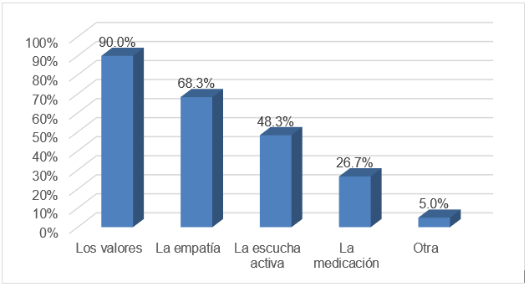
Source: self made

Furthermore, regarding the knowledge that the academics surveyed have about the ethical principles and values promoted in the institution in which they work, it was observed that 88.3% of them are aware of these principles, while the remaining 11.7% are unaware of them, as It can be seen in Figure 2. presented below:

Figure 2. Knowledge that the academics surveyed have of the ethical principles and values that are promoted in the institution in which they work
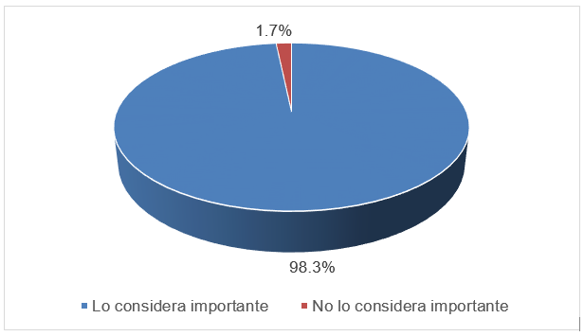
Source: self made
Regarding the way in which the participating academics promote ethical principles and values in their class, 75% indicated that they do so by serving as a model through their behavior (implicitly), 65% mentioned that they apply participatory and experiential strategies in the development of their courses, and 51.7% report on these principles within the framework of their course, as seen in Figure 3.

Figure 3. Way in which participating academics promote ethical principles and values in their class
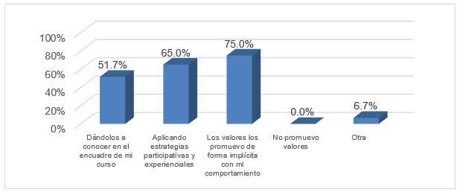
Source: self made
Regarding how academics believe they can strengthen their teaching ethos, 71.7% think this is achieved by considering the consequences of their practice on students, colleagues, and activities. 65% say they are strengthened by reevaluating their teaching role and incorporating methodological, technical and ethical innovations ; 38.3% view feedback as a way to enhance their teaching ethos , and 36.7% analyze the origins of their attitudes and behaviors, as can be seen in Figure 4.

Figure 4. Way in which the participating academics consider that their teaching ethos can be strengthened
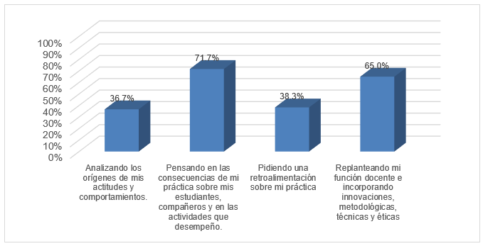
Source: self made

If we examine the relationship between the school level of the surveyed teachers with the number of elements they identify as strengthening their teaching ethos, we can conclude that primary education teachers selected more elements discussed in current studies on the construction of ethos, unlike those at the upper secondary and tertiary levels can be seen in Table 4.

Table 4. Number of elements to strengthen the ethos , according to the narrative of the current studies, identified by the teachers surveyed
 | 1 | 2 | 3 | 4
BASIC LEVEL | 3 | 4 | 8 | 5
 | fifteen % | twenty % | 40% | 25%
MEDIUM SUPERIOR LEVEL | 6 | 8 | 3 | 3
 | 30% | 40% | fifteen % | fifteen %
UPPER LEVEL | 4 | 9 | 5 | 2
 | twenty % | Four. Five % | 25% | 10%
 | 13 | twenty-one | 16 | 10
Source: self made
On the other hand, as can be seen in Figure 5 below, academics identify that to verify the internalization of a value by students, they must observe the students' behavior (83.3%), followed by building an emotional bond with them (41.7%) and/or analyzing the narratives of the youth (38.3%). Only one academic responded that they do not verify the internalization of values.

Figure 5. Way in which academics verify the internalization of a value by students
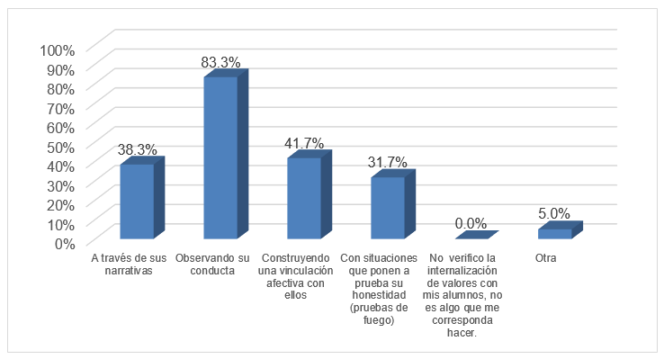
Source: self made
As illustrated in Figure 6, participating teachers considered that, when addressing students' doubts, concerns, and educational needs, they should facilitate dialogue and participation, as well as generate a climate of trust and harmony (85%).

Figure 6. Aspects considered by teachers to address the doubts, concerns and educational needs of students
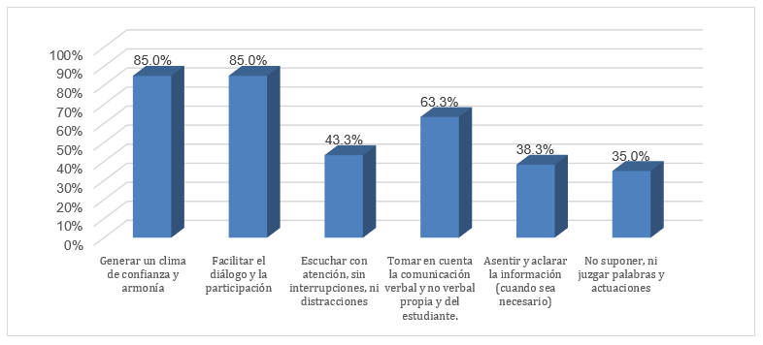
Source: self made

Regarding whether the academics considered it important for students to take into account the point of view, feelings, situation or what the teacher and/or their peers may experience, 98.3% affirmed, while the remaining 1.7% responded No, which can be corroborated in the following Figure 7.

Figure 7. Importance that academics give to students taking into account the point of view, feelings, situation or what the teacher and/or their peers may experience
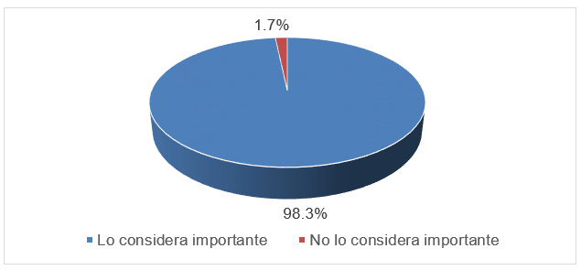
Source: self made
In relation to the strategies that the academics surveyed use to promote empathy (putting themselves in the place of others) in their students, as illustrated in Figure 8, 63.3% use participatory and experiential strategies (role-playing games, sociodramas, analysis of cases, discussion of dilemmas, critical reading and writing). This is followed by 61.7 % who do so through cooperative learning, while 38.3% do so through the development of class agreements and/or contracts.

Figure 8. Strategies used by the academics surveyed to promote empathy in their groups
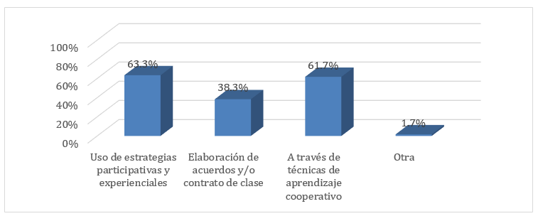
Source: self made
Regarding the identification by teachers of mediation as one of their functions, 100% of those surveyed responded that they do consider mediation to be part of their teaching functions. Furthermore, they largely agreed that in educational institutions mediation is necessary to promote dialogue and coexistence (91.7%), obtain a possible resolution of the conflict (56.7%), modify attitudes and behavioral patterns (50%), and regulate the conflict (48.3%), information that is presented graphically in the following Figure 9.

Figure 9. Opinion of the academics surveyed that mediation is necessary
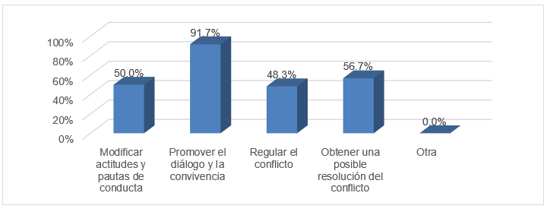
Source: self made
As can be seen in Figure 10, academics identify several important aspects to take into account for mediation in educational institutions: analysis and reflection on the perception of the conflict between the parties (70%), followed by recognizing that it is necessary external help to resolve difficulties (61.7%), reflection on the concrete consequences of actions (56.7%), the willingness to ask for help (53.3%), and with percentages less than 35%, working on negative emotions and reflecting on the suffering of the other.
Figure 10. Elements identified by academics that must be taken into account for mediation in institutions
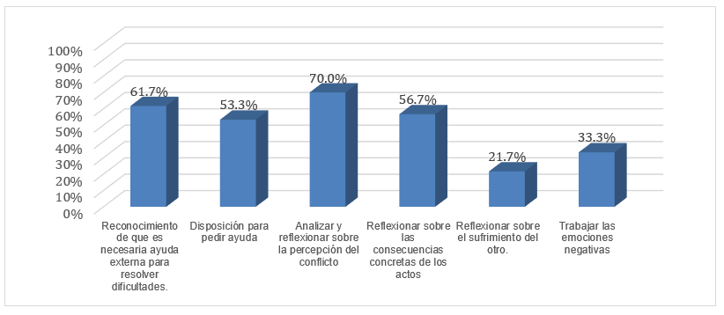
Source: self made

Discussion
As indicated in the section referring to the teaching role, the teacher acts as a facilitator to allow young people to understand the world through mediation, especially in challenging scenarios such as those that arose with the covid-19 pandemic, where they had to develop skills. and apply them to manage conflicts and reduce inequalities.
Likewise, and as mentioned in the section on ethos , the essence of the teacher lies in a continuous reflection on what he or she must learn or strengthen to constantly adapt based on the necessary skills and behaviors. In this regard, they must be aware of the importance of being a model of moral and institutional values, that is, a professional who respects and promotes the dignity and fundamental rights of people, and who helps develop such values in their students.
On the other hand , you must encourage active listening, paying attention to both verbal and non-verbal communication, without interrupting your students' contributions and promoting an environment of trust. In this regard, and according to the narrative of current studies, it is essential that the teacher recognizes himself as a mediator in the resolution of conflicts in the school community, which is achieved by promoting dialogue, empathy, and the management of negative emotions. , negotiation and agreement.
Now, it should be noted that, due to time and resource limitations, this study focused on the identification and description of activities and elements present in the narrative of current studies on teaching ethos and ethics. In this sense, the results show that the teachers surveyed recognize the importance of ethos and ethics in their teaching practice, as well as their responsibility in their own training, as pointed out by Jiménez et al . (2005) and Marcell and Barreto da Cruz (2018).
Regarding knowledge about the elements to build the teaching ethos and ethics, the majority (90%) identified values as crucial, which agrees with what was reported by Fierro and Carvajal (2003), García López et al . (2006), Rodríguez-Sedano et al . (2011), Kings Sanchez et al . (2017). However, active listening (48.3%) and mediation (26.7%) were identified to a lesser extent, although it should be noted that the former was considered an action carried out by the teacher when addressing the doubts, concerns and educational needs of the students. , and not as an element to build the ethos . On the other hand, mediation was recognized by all respondents as a teaching function, as reported by Parra Villena et al . (2020).
Moreover, primary education teachers identified more elements that make up the construction of ethos than those in upper secondary and higher education, possibly due to the lack of formal teacher training at these educational levels. However, as Diez Gutiérrez (2020) and Metzberg and Duening (2020) point out, these educational levels also influence and should contribute to the development of ethical attitudes and behaviors related to professional ideals, which should be evaluated in a comparative study.
Furthermore, the majority of respondents consider that they promote values mainly through their behavior, as also indicated by Reyes Sánchez et al also point out . (2017), and then through experiential strategies. Furthermore, they strengthen their teaching ethos by reflecting on the consequences of their practices in the school community, as mentioned in the research of Velázquez Gómez. et al. (2018).

Conclusions
The teacher plays a fundamental role in the comprehensive training of students at all levels and educational modalities. To achieve this, besides imparting knowledge, teachers must promote positive values and attitudes to ensure that the educational process is carried out in an environment of respect, harmony and trust. Therefore, it is crucial that ethos and ethics are present in your teaching practice.
The teaching ethos involves constant and introspective reflection that allows the teacher to identify his or her strengths as a facilitator of knowledge, as well as areas in which he or she needs to improve and the strategies to achieve it. It involves a continuous evaluation of their very essence, of their identity as a teacher from an ethical perspective.
In teaching practice, ethos focuses on the formation of habits, attitudes and virtues such as justice, honesty, integrity, moderation and prudence. These, together with the principles of professional ethics such as dignity and human rights, promote the comprehensive training of students. In this way, their development is ensured both in the scientific and technical fields as well as in the human field, promoting their respect and solidarity towards others.
In other words, developing a teaching ethos and ethics is based not only on positive attitudes and values but also must include other crucial elements, such as active listening, empathy and mediation, which together contribute to the consolidation of meaningful learning environments. In this sense, it can be stated that active listening, within a climate of trust and respect, favors participation, the exchange of opinions and points of view, and, as a result, the collaborative construction of knowledge.
Of course, empathy is also a crucial element in any educational process, since it allows the teacher to understand students and, at the same time, act as a mediator in conflict situations. By placing himself at the level of the student, the teacher becomes a model to follow in attitudes, habits and practices, so he must be aware and responsible to invite all participants in the teaching-learning process to build harmonious spaces, of trust and collaboration.
Regarding the results of this study, a significant majority of surveyed teachers (86.7%) agree completely that, beyond class preparation, it is essential to attend to their conduct and performance in the classroom, that is, their behavior and performance in front of the students. Furthermore, a point of consensus, present in 91.7% of the participants, is that teaching ethics is essential in education.
Regarding the most important aspects to promote these values in the educational field, the need to include teaching ethos and ethics as part of the evaluation criteria in competitive examinations stands out. This moment is crucial to select the teaching staff who will teach the courses, but it also represents an important challenge to develop a methodology that allows these aspects to be objectively evaluated.
Furthermore, a significant number of respondents (40%) mentioned ongoing education and training activities on ethics as a key factor in promoting teaching ethos . This signals an important opportunity in educational institutions to rethink the planning of teacher training and updating courses, including relevant topics such as human rights, gender equality and the promotion of values that promote comprehensive training of students.
Regarding the elements that the participating teachers consider as a basis for building the teaching ethos and ethics, 90% categorized the values as essential, followed by empathy (63.3%), active listening (48.3%) and mediation ( 26.7%). These data underline the importance of teaching values at all educational levels, which suggests the possibility of incorporating this topic into the curriculum, supported by methodological, technical and ethical innovations, or as part of continuing training programs for both teaching staff and students.
In addition to these training aspects, teachers also value the importance of active listening when addressing students' doubts, concerns and needs in an empathetic manner, which is achieved by promoting dialogue and participation through participatory and experiential strategies, within a collaborative learning environment.
Finally, regarding their role as mediators, all teachers believe that mediation is an inherent part of their functions, based on the promotion of dialogue and harmonious coexistence, as well as their direct participation in conflict resolution and identification. of institutional bodies or mechanisms that contribute to solving the difficulties.

Future lines of research
In future research, the following aspects should be addressed:
- Comparative analysis of ethics education for academics by educational level.
- Evaluate the importance they give to the ethical dimension in their reflective teaching practice.
- Evaluate the appropriation of the elements of ethics and teaching ethos .
- Evaluate the level of importance given to the development of virtues and values in students and for professional practice.

Thanks
Thanks are extended to the faculty who kindly responded to the survey presented in this study, for their time and patience.

References
Diez Gutiérrez, E. J. (2020). Valores transmitidos en la formación inicial del profesorado. Educar, 56(1), 129-144. https://web.a.ebscohost.com/ehost/pdfviewer/pdfviewer?vid=14&sid=2b446f29-f294-490f-b54a-15356ca9d411%40sdc-v-sessmgr01
Fierro, C. y Carbajal, P. (2003). El docente y los valores desde su práctica. Sinéctica, (22), 3-11. https://web.a.ebscohost.com/ehost/pdfviewer/pdfviewer?vid=7&sid=8ace29c2-6417-4fb1-bb76-4054f3241799%40sessionmgr4007
García López, R., Gil, F., Fernández, R., Moliner, O. y Sales, A. (2006). El profesorado universitario ante la ética profesional docente. Revista Española de Pedagogía, 64(235), 545-566. https://web.a.ebscohost.com/ehost/pdfviewer/pdfviewer?vid=4&sid=7c298c3a-b2d5-4df2-a1d8-2a786041c47e%40sessionmgr4008
García López, R., Jover, G. y Escámez, J. (2010). Ética profesional docente. Editorial Síntesis.
Geng, Y., Gu, J., Zhu, X., Yang, M., Shi, D., Shang, J. and Zhao, F. (2020). Negative emotions and quality of life among adolescents: A moderated mediation model. International Journal of Clinical and Health Psychology 20(2). doi:10.1016/j.ijchp.2020.02.001
González-Noguera, T. y Guevara Rumbos, B. (2018). Responsabilidad ética del docente de enfermería en el fomento de la calidad de vida de estudiantes universitarios. Duazary. Revista de la Facultad de Ciencias de la Salud 15(1), 87-93. doi:10.21676/2389783X.2102
Grigoropoulos, J. (2020). How Can Manifesting Leadership Skills Infused with Ethos, Empathy, and Compassion Better Prepare Students to Assume Leadership Roles? International Journal of Progressive Education, 16(1), 54-66. https://files.eric.ed.gov/fulltext/EJ1245093.pdf
Hernández Sampieri, R., Fernández-Collado, C. y Baptista Lucio, P. (2006). Metodología de la investigación. McGrawn Hill.
Inostroza Araya, L., Santander Ramírez, V. y Severino González, P. (2020). Ética y actitud hacia los valores que promueve la universidad. Revista Lasallista de Investigación 17(1), 291-300. https://web.a.ebscohost.com/ehost/pdfviewer/pdfviewer?vid=11&sid=2b446f29-f294-490f-b54a-15356ca9d411%40sdc-v-sessmgr01
Jiménez, N., Luque, M. y Chacín, N. (2005). Ética praxis educativa y práctica pedagógica deldocente universitario. Encuentro Educacional, 12(2), 173-193. https://produccioncientificaluz.org/index.php/encuentro/article/view/871/873
Llorent, V. J., González Gómez, A. L. y Zych, I. (2020). Social and emotional competencies and empathy as predictors of literacy competence. Psicothema, 32(1), 47-53. https://web.a.ebscohost.com/ehost/pdfviewer/pdfviewer?vid=5&sid=28605f89-74e4-472a-8eb5-60af226dcbf0%40sessionmgr4007
Marcell, J. and Barreto da Cruz, G. (2018). Teaching Ethos of Reference Professors. Educação e Realidade. 43(1), 363-379. https://web.a.ebscohost.com/ehost/pdfviewer/pdfviewer?vid=2&sid=1706b4e5-de36-4fe5-a133-2ba718efa62f%40sessionmgr4008
Martins Candeias, E. and Martins Bartolo, S. (2016). The gravitation of the ethics of care in mediation: social intervention and school education in schools. Poiésis, 10(18), 371-388. doi:10.19177/prppge.v10e182016371-388
Metzger, M. L. and Duening, T. N. (2020). Exploring the use of virtues to facilitate identity construction among management students. European Management Journal, 39(1), 1-9. doi:10.1016/j.emj.2020.08.005
Munné, M. y Mac-Cragh, P. (2006). Los 10 principios de la cultura de la mediación. Graó.
Muñoz Proto, C., Ancapichún Hernández, A. y Squella Soto, R. (2020). El proceso de diseño de un estudio narrativo sobre no violencia centrado en la escucha. Desafíos éticos, socio-históricos y metodológicos del trabajo con relatos de lucha social en Chile. Empiria. Revista de Metodología de Ciencias Sociales, (45), 143-163. https://web.b.ebscohost.com/ehost/pdfviewer/pdfviewer?vid=3&sid=80ced6c8-6948-4c8d-aae5-27e220ff5083%40sessionmgr103
Naciones Unidas (1948). Declaración Universal de los Derechos Humanos. ONU. https://www.un.org/es/about-us/universal-declaration-of-human-rights
Nelson, J. (2008). Exploring diversity through ethos in initial teacher education. Teaching and Teacher Education, 24(7), 1729-1738. doi:10.1016/j.tate.2008.02.014
Nosei, C. (2004). Rol docente y su importancia social. Praxis Educativa, 8(8), 50-54. https://web.a.ebscohost.com/ehost/pdfviewer/pdfviewer?vid=6&sid=1706b4e5-de36-4fe5-a133-2ba718efa62f%40sessionmgr4008
Parra Villena, A., Morales Hernández, A. J. y Caurín Alonso, C. (2020). La solidaridad y la sostenibilidad a través de los docentes con formación en mediación: ¿una realidad indisociable? Didáctica de las Ciencias Experimentales y Sociales, (38), 61-79. doi:10.7203/DCES.38.13828
Perea Castaño, E., Fernández Blanco, A. y Castañeda Asensio, E. (2012). Competencias para la tutoría: experiencia de formación con profesores Universitarios. Revista de Docencia Universitaria, 10(2), 193-2010. https://web.b.ebscohost.com/ehost/pdfviewer/pdfviewer?vid=8&sid=80ced6c8-6948-4c8d-aae5-27e220ff5083%40sessionmgr103
Reyes Sánchez, G., Guevara Burgos, J. I. y Bonne Galí, N. M. (2017). Formación de valores en futuros docentes ecuatorianos. Medisan 21(4), 468-474. https://web.a.ebscohost.com/ehost/pdfviewer/pdfviewer?vid=3&sid=8e5544d1-80a2-4f73-a62b-8e40f33e1949%40sessionmgr4006
Rodríguez-Sedano, A., Rumayor, M. and Costa Paris, A. (2011). The formation of the professional ethos as a factor of integration through the virtues. Procedia - Social and Behavioral Sciences, 15, 1661-1666. doi:10.1016/j.sbspro.2011.03.349
The Volunteer Management Report (2020). Elements of Active Listening. The Volunteer Management Report. doi:10.1002/vmr.31357
Velázquez Gómez, J. (2015). Reflexión del ethos docente para la resignificación de la práctica educativa (trabajo de grado). Universidad Autónoma del Estado de México. http://ri.uaemex.mx/bitstream/handle/20.500.11799/95015/TESIS%20GABRIEL.pdf?sequence=1&isAllowed=y
Wagner, R. V. (2011). Empathy. En D. J. Christie (ed.), Encyclopedia of Peace Psychology. doi:10.1002/9780470672532.wbepp100
Zachary, L. J. and Fischler, L. A. (2017). Adopt strategies for listening actively. The Successful Registrer, 21(2), 9. doi:10.1002/tsr.30298

Contribution Role | Author(s)
Conceptualization | Gabriela Ruiz de la Torre
Methodology | María Luisa Sáenz Gallegos
Software | María Luisa Sáenz Gallegos
Validation | Perla Araceli Barbosa Muñoz
Formal Analysis | Perla Araceli Barbosa Muñoz
Investigation | María Luisa Sáenz Gallegos
Resources | María Luisa Sáenz Gallegos
Data curation | María Luisa Sáenz Gallegos
Writing - Preparation of the original draft | Gabriela Ruiz de la Torre
Writing - Review and editing | Perla Araceli Barbosa Muñoz
Display | Perla Araceli Barbosa Muñoz
Supervision | Perla Araceli Barbosa Muñoz
Project management | Perla Araceli Barbosa Muñoz
Fund acquisition | Perla Araceli Barbosa Muñoz

