***https://doi.org/10.23913/ride.v15i29.2037***

***Artículos científicos***

**Socio-environmental perception of corn producers, due to the passage of hurricane Otis in the state of Guerrero, Mexico**

***Percepción socioambiental de los productores de maíz, debido al paso del huracán Otis en el estado de Guerrero, México***

***Percepção socioambiental dos produtores de milho, devido à passagem do furacão Otis no estado de Guerrero, México***

**Enrique Moreno Mendoza**

Autonomous University of Guerrero, México

08226185@uagro.mx

https://orcid.org/0009-0001-7137-6764

**Marco Polo Calderón Arellanes**

Autonomous University of Guerrero, México

15756@uagro.mx

https://orcid.org/0000-0002-7329-5925

**Sirilo Suastegui Cruz\***

Autonomous University of Guerrero, México

sirilo_sc@uagro.mx

https://orcid.org/0000-0001-6795-6312

* Main and corresponding author

**Abstract**

This article aims to analyze the socio-environmental perception that corn producers have about the passage of hurricane Otis in the state of Guerrero, Mexico, as well as the environmental, social, economic and political problems that arise. This research used mixed methods. A survey and interviews were carried out with 30 corn-producing farmers. The variables for both instruments were the social, environmental, economic and cultural factors of the people. The survey consisted of 9 questions, 6 multiple choice and three open-ended. In the interview case, there were only three open questions where the farmers expressed their feelings about Otis' impact on production, their economy and their way of living. Low-intensity hurricanes have occurred in the state since 1921, which were the first events that occurred. In 1988, Hurricane Gilberto occurred, which had a rainfall of 320 mm for 24 hours. Despite this intensity of rain, the low intensity infrastructure allowed a filtration to the subsoil and relief of the channels to the sea, in the case of Hurricane Paulina in 1997 the rainy season was two hours and caused disaster in all social areas, in 2013 with Íngrid and Manuel, Max 2017 until reaching to Hurricane Otis 2023. Hurricane Otis caused environmental problems (falling of trees of all types, generation of organic waste), economic (losses in agricultural production, materials, high prices of basic basket products), social (health problems due to the accumulation of garbage and psychological) and political (lack of support with programs to encourage the economy of corn producers).

**Keywords:** climate change, perception, material losses, production.

**Resumen**

Este artículo tiene como objetivo analizar la percepción socioambiental que tienen los productores de maíz sobre el paso del huracán Otis en el estado de Guerrero, México, así como los problemas ambientales, sociales, económicos y políticos que se presentan. Esta investigación utilizó métodos mixtos. Se realizó una encuesta y entrevistas a 30 agricultores productores de maíz. Las variables para ambos instrumentos fueron los factores sociales, ambientales, económicos y culturales de las personas. La encuesta constaba de 9 preguntas, 6 de opción múltiple y tres abiertas. En el caso de la entrevista, sólo hubo tres preguntas abiertas en las que los agricultores expresaron sus sentimientos sobre el impacto de Otis en la producción, su economía y su forma de vida. En el estado se han presentado huracanes de baja intensidad desde 1921, que fueron los primeros eventos que ocurrieron. En 1988 ocurrió el huracán Gilberto, que tuvo una precipitación de 320 mm durante 24 horas. A pesar de esta intensidad de lluvias, la infraestructura de baja intensidad permitió una filtración al subsuelo y alivio de los canales al mar, en el caso del huracán Paulina en 1997 la temporada de lluvias fue de dos horas y causó desastre en todos los ámbitos sociales, en el año 2013 con Íngrid y Manuel, Max 2017 hasta llegar al huracán Otis 2023. El huracán Otis provocó problemas ambientales (caída de árboles de todo tipo, generación de residuos orgánicos), económicos (pérdidas en producción agrícola, materiales, altos precios de productos de la canasta básica), sociales (problemas de salud por acumulación de basura y psicológicos) y políticos (falta de apoyo con programas para incentivar la economía de los productores de maíz).

**Palabras claves:** cambio climático, percepción, pérdidas materiales, producción.

**Resumo**

Este artigo tem como objetivo analisar a percepção socioambiental que os produtores de milho têm sobre a passagem do furacão Otis no estado de Guerrero, no México, bem como os problemas ambientais, sociais, econômicos e políticos que surgem. Esta pesquisa utilizou métodos mistos. Foram realizadas pesquisas e entrevistas com 30 agricultores produtores de milho. As variáveis para ambos os instrumentos foram os fatores sociais, ambientais, econômicos e culturais das pessoas. A pesquisa consistiu em 9 questões, sendo 6 de múltipla escolha e três abertas. No caso da entrevista, havia apenas três questões abertas onde os agricultores expressavam os seus sentimentos sobre o impacto da Otis na produção, na sua economia e no seu modo de vida. Furacões de baixa intensidade ocorrem no estado desde 1921, sendo os primeiros eventos ocorridos. Em 1988 ocorreu o furacão Gilberto, que teve precipitação de 320 mm durante 24 horas. Apesar desta intensidade de chuvas, a infraestrutura de baixa intensidade permitiu uma filtragem para o subsolo e alívio dos canais para o mar, no caso do Furacão Paulina em 1997 o período chuvoso foi de duas horas e causou desastre em todas as áreas sociais, em 2013 com Íngrid e Manuel, Max 2017 até chegar ao Furacão Otis 2023. O furacão Otis causou problemas ambientais (queda de árvores de todos os tipos, geração de lixo orgânico), econômicos (perdas na produção agrícola, materiais, preços elevados de produtos da cesta básica), sociais (problemas de saúde pelo acúmulo de lixo e psicológicos) e político (falta de apoio a programas de incentivo à economia dos produtores de milho).

**Palavras-chave:** mudanças climáticas, percepção, perdas materiais, produção.

**Fecha Recepción:** Mayo 2023 **Fecha Aceptación:** Agosto 2024

**Introduction**

Climatic phenomena cause direct physical damage to production in general, due to heavy rains that cause flooding, which can result in the total or partial loss of crops in the milpa system (Cruz Hernández et al. 2020; Leyva-Trinidad et al. 2020), composed mainly of corn, beans and pumpkin, essential products for feeding rural communities (Arriaga-Vázquez et al. 2020; López-Velasco et al. 2015).

This system has been modified by these climatic impacts, from the incorporation of improved seeds to the sowing periods. Due to the high temperatures that have increased significantly in recent years (Diédhiou et al. 2022), affecting both the growth of plants and the quality of products. Climate change also poses a threat to human security by decreasing access to and quality of natural resources that support livelihoods (Meng et al. 2021; Roque-Malo & Kumar, 2017).

The rapid changes associated with increasing temperatures have triggered socio-environmental problems that until then did not exist (Ray et al. 2015), including the change in the water cycle and in the supply and demand patterns of this resource, which directly affects agricultura (Kang et al. 2009; Wada & Bierkens, 2014). Therefore, it is crucial to guarantee security in rural areas and among social groups considered the most vulnerable (Misselhorn & Hendriks, 2017).

In the specific case of the state of Guerrero, in recent years it has witnessed these phenomena, facing a series of environmental challenges that endanger the biodiversity, economy and quality of life of its inhabitants. Climate change has manifested itself in various ways in Guerrero, from extreme weather events to alterations in precipitation and temperature patterns, resulting in erratic or irregular rains and droughts (Suryabhagavan, 2017).

In 2015, entire plots dried up in the municipality of Tecoanapa due to the lack of rain, which unleashed chaos and increased prices for corn (Suastegui, 2021). The El Niño and La Niña phenomenon caused losses in agriculture due to intense rains (McNeeley et al. 2018) and this happens every year for producers. Parry et al. (2007), for its part, mentions that food production in some regions of the world will be stable for the years 2030 and 2050, which means that some places are benefiting from the climate imbalance on the planet. On the other hand, Hasegawa et al. (2018) project an increase in water and food insecurity, with substantial increases in prices and a higher incidence of hunger in the poorest regions, which will combine with heat waves during droughts, causing damage to agriculture, species extinction and shortages of wáter (Esparza, 2014; McMaster et al. 2019; Miralles et al. 2019; Naumann et al. 2018; Sánchez-Arias et al. 2019).

Therefore, the objective of this study was to understand the socio-environmental perception that corn producers have about the passage of Hurricane Otis in the state of Guerrero, Mexico.

**Investigation methodology**

This research used mixed methods, with random probabilistic sampling, a survey was applied to 30 corn farmers. The variables for both instruments were the social, environmental, economic and cultural factors of the people. The survey consisted of 9 questions, 6 multiple choice and three open. In the case of the interview, there were only three open questions in which farmers expressed their feelings about the impact of Otis on production, their economy and their way of life. The participating communities were El Pericón, Las Animas, Saucitos, Huamuchapa, El Limón and Xalpatlahua, where their main activity is production for self-consumption.

The results of the survey were processed in the SPSS 2019 program, for creation of figures for representation and the interviews are expressed in the form of texts that help to understand certain actions and attitudes of the interviewees.

A timeline of past and future rainfall was created to visualize climate variations. The data were downloaded from the CONAGUA page, in the Climatological Normals by State section, from the Presa de la Revolución Mexicana station belonging to the municipality of Tecoanapa. Warrior. For the projections, the data were downloaded from the digital climate atlas of Mexico and the information was obtained from the global circulation models (IPM ECHAM 5) scenario A2 for the years 2030 and 2050; This type of models present information from the Mexican territory from which cuts were made to the national raster with the shapefile of the municipality, with the support of the ArcGIS 10.3 tool for monthly precipitation in the study área (Suastegui Cruz, 2021; Suastegui Cruz & Gallardo López, 2024).

**Results**

Hurricane Otis hit the city and port of Acapulco with an intensity of category 5 (Miranda et al. 2023), although the city was the eye of the hurricane, the winds intensified south of the port of Acapulco. The impacts covered various aspects, including environmental, social and economic areas. Environmentally, the devastation affected vegetation, native trees, ornamental plants and water. Socially, losses of products for food, housing and viability. Economically, high prices of products in business.

In this sense, the change in rainfall in recent years in the municipality of Tecoanapa has varied greatly, where the lowest occurred in the years 2003, 2004, 2005, 2006 and 2007, in a range of 1,000 to 1,771.8 mm. annually, in recent years, these precipitations occur in a short period, affecting production, but also affecting the recharge of the groundwater to support the tenants in the dry period in Figure 1.

**Figure 1.** Annual precipitation of the municipality of Tecoanapa Guerrero, Mexico.

Source: Own design

The lowest precipitation occurred in 2020 with 614.4 mm, these variations have been occurring more frequently in recent years, according to the data from the MPIECHAM5-A2-2030 and 2050 model, the precipitations for 2030 will do from 1,330 to 1,835 mm, being the highest in the history of the municipality of Tecoanapa in Figure 2, in the case of 2050, rainfall will decrease.

**Figure 2.** Precipitation for the years 2030 and 2050, with the MPIECHAM5-A2 model.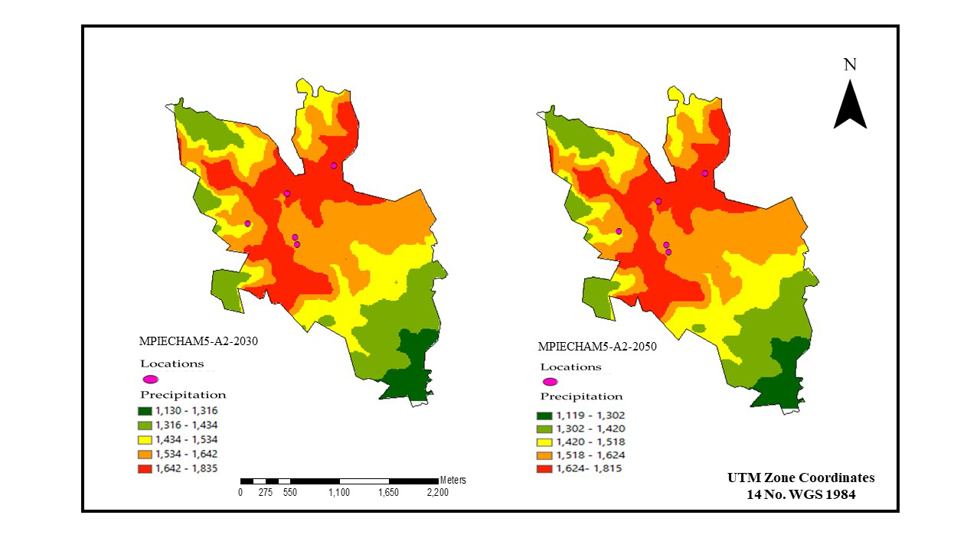

Source: Own design

These high rainfalls are accompanied by hurricanes, intense rains and tornadoes, which puts society at risk, because the majority of the houses in rural communities are made of adobe material which are at risk of collapsing, as happened with Hurricane Paulina.

Those surveyed had some damage from the passage of Hurricane Otis, this is assumed because 53% said yes and only 47% of the farmers responded no. The type of damage they had was material with 53% (with losses due to galvanized sheet roofs) and 47% losses in production.

In the case of the question which products were affected by Otis, with 34% native corn, beans 21% and pumpkin with 24% in Figure 3, which generated increases in corn prices reaching 7 pesos per kilo, there was also an increase in basic basket products. Although Hurricane Otis had an impact on material issues in Acapulco, in the southern municipalities there are often problems of flooding and material losses due to the decompensation of the climate and the passage of hurricanes, as well as high intensity winds, which makes them vulnerable in figure 4. In the case of the question if they received support from the government, 97% said no and only 3% said yes.

**Figure 3.**  Loss of products: Creole corn, beans and pumpkin.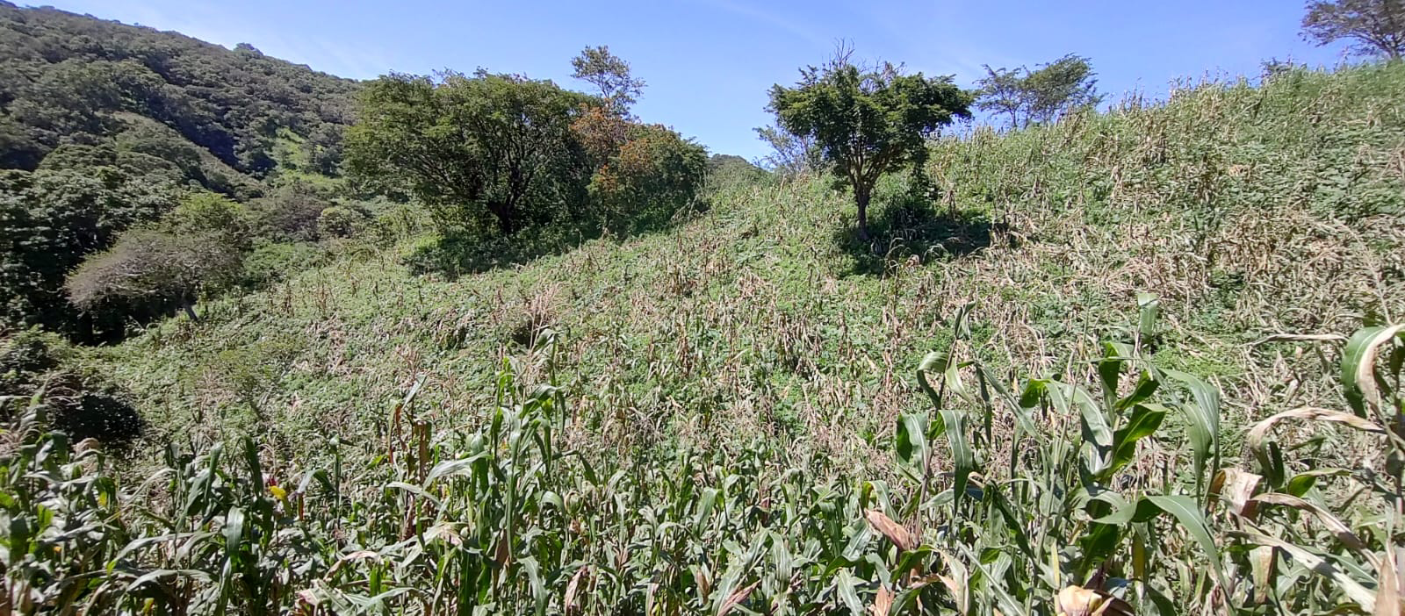

Source: Photos taken on the field trip by researchers 2024.

**Figure 4.** Loss of roofs from homes due to Hurricane Otis.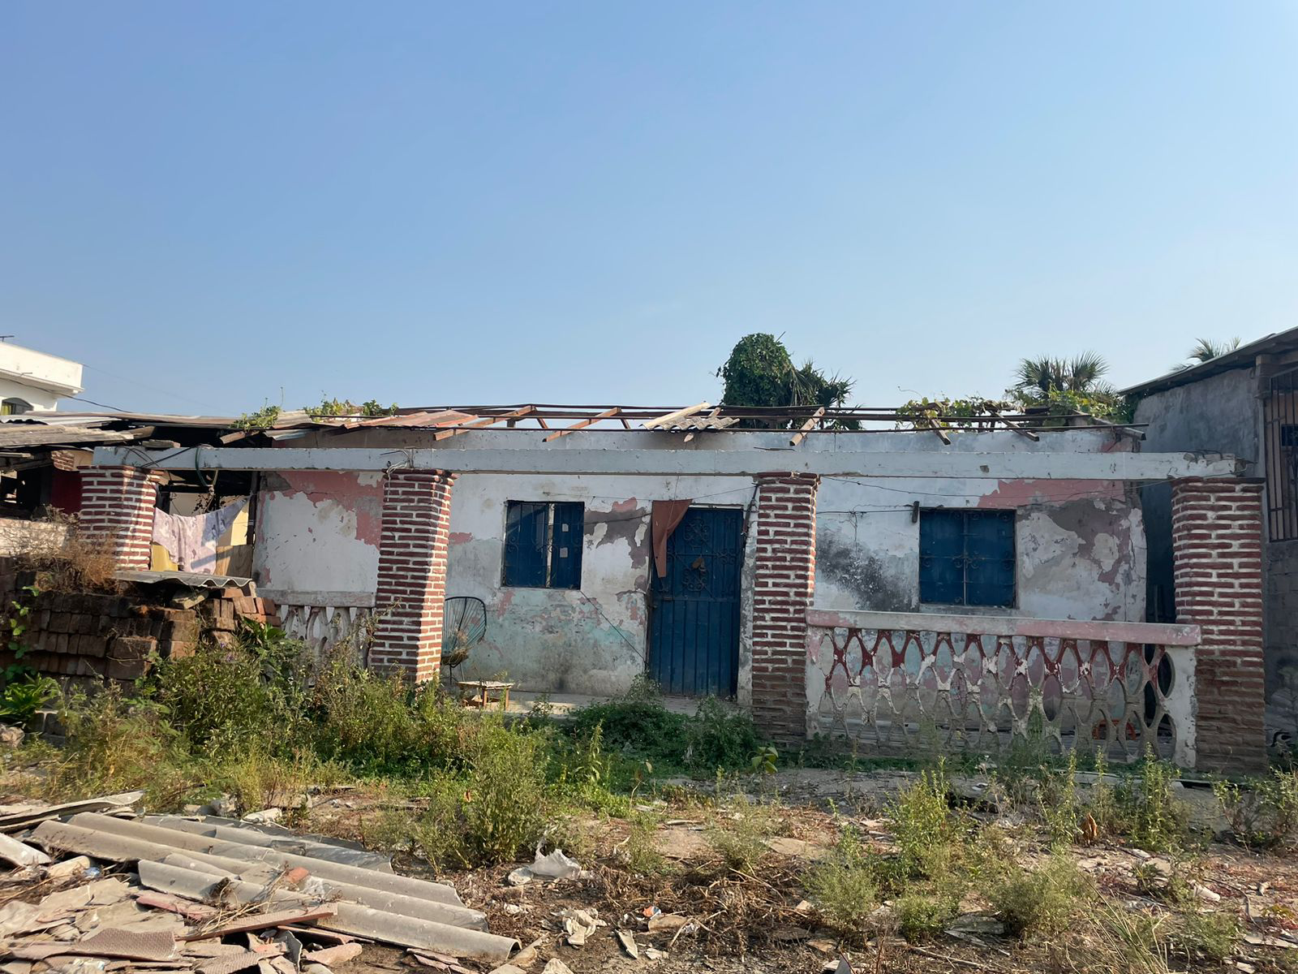

Source: Photos taken on the field trip by researchers 2024.

To complement the information from the survey, three interviews were carried out, where the results were that people had effects on the production of hibiscus, sesame, cornfields and nurseries, approximately two hectares per producer. People were unaware of the intensity of the hurricane and had no reaction at the time of the phenomenon; The trees fell on their houses and roofs causing total losses, people did not have a source of income after the hurricane, which made the problem increase more economically.

The lack of public service for the collection of solid waste generated health problems, with the outbreak of blemishes and bad odors, causing fever, flu, cough and bone pain; Although people are already overcoming this Otis phenomenon, they were forever marked by the strong winds and rains that occurred, where psychological traumas return when talking about hurricanes that could be generated during the rainy season. This Otis phenomenon brought with it a dry nature problem, which is causing sporadic or intentional fire problems mainly in Acapulco, as well as in the study area.

The prices of basic basket products increased, reaching prices that were unattainable for people with medium and low income levels; corn reached a price of 50 pesos per liter. Although they received support from the federal government, such as food and basic supplies for their families, the economy has not been able to recover because some producers have to recover from the losses caused by Hurricane Otis, where they have to invest in purchasing for production, in In this case, the bag of hybrid corn is priced at 4,300 pesos, followed by inputs and fertilizers. The results indicate that people had problems due to the passage of Hurricane Otis, both social, economic, environmental and political.

**Discussion**

The factors involved in causing this type of weather events are diverse; intense precipitation, seismic activity, soil characteristics, terrain slope, absence of vegetation, geological faults, presence of previous landslides, etc. (Ramos-Bernal et al. 2015). Some of these phenomena also originate as a consequence of anthropogenic activities, such as the construction of roads, overexploitation of the subsoil; deforestation for agriculture, population growth, industrial activity, which directly affect the water resource (Shano et al. 2020).

Low-intensity hurricanes have occurred in the state since 1921, which were the first events that occurred. In 1988, Hurricane Gilberto occurred, which had a rainfall of 320 mm for 24 hours. Despite this intensity of rain, the low intensity infrastructure allowed a filtration to the subsoil and relief of the channels to the sea, in the case of Hurricane Paulina in 1997 the rainy season was two hours and caused disaster in all social áreas (Matías Ramírez, 1998; Toscana Aparicio, 2003).

El Íngrid and Manuel in September 2013, the state had damage to infrastructure, housing and heavy losses in production among farmers, lack of communication in localities where their roads are dirt, this due to the high rainfall that occurred in this period (Vega et al. 2018; Villaseñor-Franco et al. 2017).

In September 2017, the Max effect caused negative environmental, economic and social impacts. Economically, the population lost material goods, animals and damage to their homes, social aspects, physical and emotional damage and losses in the production of food and wáter (Bedolla Solano et al. 2021).

Most weather phenomena are associated with climate change, but with increasing intensity, such is the case of Hurricane Otis, where its dimensions and projections are more like that of a tornado, this is due to the phenomenon of the boy and the girl in the case of Mexico (Molina et al. 2018). This is due to masses of cold and warm air, with relatively high humidity, which affects the creation of tornadoes (Carbajal et al. 2019; Monterde et al. 2023). In the USA this type of phenomenon is more common, similar to Hurricane Otis in the state of Guerrero (Elsner et al. 2019; Moore & DeBoer, 2019).

**Conclusions**

Hurricane Otis caused environmental problems (falling of trees of all types, generation of organic waste), economic (losses in agricultural production, materials, high prices of basic basket products), social (health problems due to the accumulation of garbage and psychological) and political (lack of support with programs to encourage the economy of corn producers).

People must be trained to be prepared for phenomena of this type, which are becoming more frequent due to climate change.

**Future lines of research**

One of the future lines would be to raise awareness and educate people about the environmental phenomena that are happening in recent years, this would help the citizen attitude to react to these phenomena, this derived from the fact that Hurricane Otis left material losses, which generated problems in its economy due to the lack of jobs, but this helped create a strong and supportive community organization, and the support from the federal authorities was also important. The passage of Hurricane Otis left a society battered, psychologically traumatized by what may come in the future.

**References**

Arriaga-Vázquez, A. M., Martínez-Menez, M. R., Rubiños-Panta, J. E., Fernández-Reynoso, D. S., Delgadillo-Martínez, J., & Vázquez-Alarcón, A. (2020). Propiedades químicas y biológicas de los suelos en milpa intercalada con árboles frutales. REVISTA TERRA LATINOAMERICANA, 38(3), 465-474. https://doi.org/10.28940/terra.v38i3.599

Bedolla Solano, R., Miranda Esteban, A., Bedolla Solano, J. J., & Sánchez Adame, O. (2021). Análisis prospectivo-educativo del impacto del huracán Max en una comunidad de Guerrero. RIDE. Revista Iberoamericana para la Investigación y el Desarrollo Educativo, 11(22). https://www.scielo.org.mx/scielo.php?pid=S2007-74672021000100133&script=sci_arttext

Carbajal, N., León-Cruz, J. F., Pineda-Martínez, L. F., Tuxpan-Vargas, J., & Gaviño-Rodríguez, J. H. (2019). Occurrence of Anticyclonic Tornadoes in a Topographically Complex Region of Mexico. Advances in Meteorology, 2019, 1-11. https://doi.org/10.1155/2019/2763153

Cruz Hernández, S., Torres Carral, G. A., Cruz León, A., Salcedo Baca, I., & Victorino Ramírez, L. (2020). Saberes tradicionales locales y el cambio climático global. Revista Mexicana de Ciencias Agrícolas, 11(8), 1917-1928. https://doi.org/10.29312/remexca.v11i8.2748

Diédhiou, I., Ramírez-Tobias, H. M., Fortanelli-Martinez, J., & Flores-Ramírez, R. (2022). Maize Intercropping in the Traditional “Milpa” System. Physiological, Morphological, and Agronomical Parameters under Induced Warming: Evidence of related Effect of Climate Change in San Luis Potosí (Mexico). Life, 12(10), 1589. https://doi.org/10.3390/life12101589

Elsner, J. B., Fricker, T., & Schroder, Z. (2019). Increasingly Powerful Tornadoes in the United States. Geophysical Research Letters, 46(1), 392-398. https://doi.org/10.1029/2018GL080819

Esparza, M. (2014). La sequía y la escasez de agua en México: Situación actual y perspectivas futuras. Secuencia, 89, 193-219.

Hasegawa, T., Fujimori, S., Havlík, P., Valin, H., Bodirsky, B. L., Doelman, J. C., Fellmann, T., Kyle, P., Koopman, J. F. L., Lotze-Campen, H., Mason-D’Croz, D., Ochi, Y., Pérez Domínguez, I., Stehfest, E., Sulser, T. B., Tabeau, A., Takahashi, K., Takakura, J., van Meijl, H., … Witzke, P. (2018). Risk of increased food insecurity under stringent global climate change mitigation policy. Nature Climate Change, 8(8), 699-703. https://doi.org/10.1038/s41558-018-0230-x

Kang, K., Park, S., Kim, Y. S., Lee, S., & Back, K. (2009). Biosynthesis and biotechnological production of serotonin derivatives. Applied Microbiology and Biotechnology, 83(1), 27-34. https://doi.org/10.1007/s00253-009-1956-1

Leyva-Trinidad, D. A., Pérez-Vázquez, A., Bezerra Da Costa, I., & Formighieri Giordani, R. C. (2020). El papel de la milpa en la seguridad alimentaria y nutricional en hogares de Ocotal Texizapan, Veracruz, México. Polibotánica, 0(50). https://doi.org/10.18387/polibotanica.50.16

López-Velasco, R., Rodríguez-Herrera, A., González-González, H., Olivier-Salomé, B., & Montalvo-Marques, C. (2015). Percepción de calidad de vida, contaminación y riesgo en localidades rurales del Municipio de Tecoanapa, Guerrero.

Matías Ramírez, L. G. (1998). Algunos efectos de la precipitación del huracán Paulina en Acapulco, Guerrero. Invest. Geog, 7-19. https://www.scielo.org.mx/scielo.php?pid=S0188-46111998000300002&script=sci_abstract&tlng=en

McMaster, G. S., Edmunds, D. A., Marquez, R., Haley, S., Buchleiter, G., Byrne, P., Green, T. R., Erskine, R., Lighthart, N., Kipka, H., Fox, F., Wagner, L., Tatarko, J., Moragues, M., & Ascough, J. (2019). Winter Wheat Phenology Simulations Improve when Adding Responses to Water Stress. Agronomy Journal, 111(5), 2350-2360. https://doi.org/10.2134/agronj2018.09.0615

Meng, J., Zhang, Q., Zheng, Y., He, G., & Shi, H. (2021). Plastic waste as the potential carriers of pathogens. Current Opinion in Food Science, 41, 224-230. https://doi.org/10.1016/j.cofs.2021.04.016

Miralles, D. G., Gentine, P., Seneviratne, S. I., & Teuling, A. J. (2019). Land-atmospheric feedbacks during droughts and heatwaves: State of the science and current challenges: Land feedbacks during droughts and heatwaves. Annals of the New York Academy of Sciences, 1436(1), 19-35. https://doi.org/10.1111/nyas.13912

Misselhorn, A., & Hendriks, S. L. (2017). A systematic review of sub-national food insecurity research in South Africa: Missed opportunities for policy insights. PLOS ONE, 12(8), e0182399. https://doi.org/10.1371/journal.pone.0182399

Molina, M. J., Allen, J. T., & Gensini, V. A. (2018). The Gulf of Mexico and ENSO Influence on Subseasonal and Seasonal CONUS Winter Tornado Variability. Journal of Applied Meteorology and Climatology, 57(10), 2439-2463. https://doi.org/10.1175/JAMC-D-18-0046.1

Monterde, D., Carbajal, N., Pineda-Martínez, L. F., & León-Cruz, J. F. (2023). Analysis of a multiple non-supercell tornado event in Mexico. Atmospheric Research, 293, 106916. https://doi.org/10.1016/j.atmosres.2023.106916

Moore, T. W., & DeBoer, T. A. (2019). A review and analysis of possible changes to the climatology of tornadoes in the United States. Progress in Physical Geography: Earth and Environment, 43(3), 365-390. https://doi.org/10.1177/0309133319829398

Naumann, G., Alfieri, L., Wyser, K., Mentaschi, L., Betts, R. A., Carrao, H., Spinoni, J., Vogt, J., & Feyen, L. (2018). Global Changes in Drought Conditions Under Different Levels of Warming. Geophysical Research Letters, 45(7), 3285-3296. https://doi.org/10.1002/2017GL076521

Parry, M., Parry, M. L., Canziani, O., Palutikof, J., Van der Linden, P., & Hanson, C. (2007). Climate change 2007-impacts, adaptation and vulnerability: Working group II contribution to the fourth assessment report of the IPCC (Vol. 4). Cambridge University Press.

Ramos-Bernal, R. N., Vázquez-Jiménez, R., Romero-Calcerrada, R., Novillo, C. J., Arrogante-Funes, P., & Sánchez-Tizapa, S. (2015). Identificación de deslizamientos de laderas aplicando técnicas de detección de cambios a imágenes Landsat en la zona costera del Estado de Guerrero, México. Análisis espacial y representación geográfica: innovación y aplicación, 827-834. https://www.researchgate.net/profile/Rene-Vazquez-Jimenez/publication/283301065_Identificacion_de_deslizamientos_de_laderas_aplicando_tecnicas_de_deteccion_de_cambios_a_imagenes_Landsat_en_la_zona_costera_del_Estado_de_Guerrero_Mexico/links/5631f33108ae0530378d3a55/Identificacion-de-deslizamientos-de-laderas-aplicando-tecnicas-de-deteccion-de-cambios-a-imagenes-Landsat-en-la-zona-costera-del-Estado-de-Guerrero-Mexico.pdf

Ray, D. K., Gerber, J. S., MacDonald, G. K., & West, P. C. (2015). Climate variation explains a third of global crop yield variability. Nature Communications, 6(1), 5989. https://doi.org/10.1038/ncomms6989

Roque-Malo, S., & Kumar, P. (2017). Patterns of change in high frequency precipitation variability over North America. Scientific Reports, 7(1), 10853. https://doi.org/10.1038/s41598-017-10827-8

Sánchez-Arias, M., Riojas-Rodríguez, H., Catalán-Vázquez, M., Terrazas-Meraz, M. A., Rosas, I., Espinosa-García, A. C., Santos-Luna, R., & Siebe, C. (2019). Socio-environmental assessment of a landfill using a mixed study design: A case study from México. Waste Management, 85, 42-59. https://doi.org/10.1016/j.wasman.2018.12.012

Shano, L., Raghuvanshi, T. K., & Meten, M. (2020). Landslide susceptibility evaluation and hazard zonation techniques – a review. Geoenvironmental Disasters, 7(1), 18. https://doi.org/10.1186/s40677-020-00152-0

Suastegui Cruz, S. (2021). Estrategias para la seguridad hídrica ante los cambios de precipitación por efectos del cambio climático. RIDE Revista Iberoamericana para la Investigación y el Desarrollo Educativo, 12(23). https://doi.org/10.23913/ride.v12i23.1039

Suastegui Cruz, S., & Gallardo López, F. (2024). Plan de manejo para la seguridad hídrica en una comunidad rural del estado de Guerrero, México. RIDE Revista Iberoamericana para la Investigación y el Desarrollo Educativo, 14(28). https://doi.org/10.23913/ride.v14i28.1751

Suryabhagavan, K. V. (2017). GIS-based climate variability and drought characterization in Ethiopia over three decades. Weather and Climate Extremes, 15, 11-23. https://doi.org/10.1016/j.wace.2016.11.005

Toscana Aparicio, A. (2003). Impacto del huracán Paulina en la política local de Acapulco. https://repositorio.xoc.uam.mx/jspui/handle/123456789/32309

Vega, N. G. A., MILIAN, G., & Romero, M. L. G. (2018). Otra respuesta frente a los desastres. Huracán Ingrid y tormenta tropical Manuel, Chilpancingo, Guerrero, México. Espacio y desarrollo, 32, 29-54. https://dialnet.unirioja.es/servlet/articulo?codigo=6750505

Villaseñor-Franco, A., Toscana-Aparicio, A., & Granados-Ramírez, G. R. (2017). In-justicia espacial en Guerrero, México: Estudio de la red vial en relación a los fenómenos meteorológicos Ingrid y Manuel. Journal of Latin American Geography, 49-67. https://www.jstor.org/stable/44861331

Wada, Y., & Bierkens, M. F. (2014). Sustainability of global water use: Past reconstruction and future projections. Environmental Research Letters, 9(10), 104003.

|  |  |
| --- | --- |
| Contribution Role | Author(s) |
| Conceptualization | Enrique (principal) Marco Polo (que apoya) |
| Methodology | Sirilo (principal) |
| Software | Sirilo (principal) and Enrique (que apoya) |
| Validation | Enrique, Marco Polo and Sirilo (igual) |
| Formal Analysis | Sirilo (principal) |
| Investigation | Enrique, Marco Polo and Sirilo (igual) |
| Resources | Enrique (principal) and Marco Polo (que apoya) |
| Data curation | Sirilo (principal) and Enrique (que apoya) |
| Writing - Preparing the original draft | Sirilo (principal) and Marco Polo (que apoya) |
| Writing - Review and editing | Enrique, Marco Polo and Sirilo (igual) |
| Data visualization | Sirilo (principal) |
| Supervision | Sirilo (principal) |
| Project Management | Enrique (principal) and Sirilo (que apoya) |
| Acquisition of funds | Enrique (principal) and Marco Polo (que apoya) |