https://doi.org/10.23913/ride.v15i29.2178
Scientific articles
Hybrid Education, an Option for Medical Teaching?
Educación Híbrida, ¿Una Opción Para La Enseñanza Médica?
Educação híbrida, uma opção para a educação médica?

Sánchez-Adame Erik
Autonomous University of Tamaulipas, Faculty of Medicine “Dr. Alberto Romo Caballero”, Mexico
a2183310140@alumnos.uat.edu.mx
https://orcid.org/0009-0003-5261-8216

Flores-Reyes Alejandra
Autonomous University of Tamaulipas, Faculty of Medicine “Dr. Alberto Romo Caballero”, Mexico
a2203340286@alumnos.uat.edu.mx
https://orcid.org/0009-0003-2800-5022

Reyna-Beltrán Elizabeth
Autonomous University of Tamaulipas, Faculty of Medicine “Dr. Alberto Romo Caballero”, Mexico
ereyna@docentes.uat.edu.mx
https://orcid.org/0000-0001-7896-0560

Tavera-Tapia Alejandra*
Autonomous University of Tamaulipas, Faculty of Medicine “Dr. Alberto Romo Caballero”, Mexico
ataveratapia@gmail.com
https://orcid.org/0000-0002-5950-9341

*Corresponding author

Abstract
With the COVID-19 pandemic, there was an accelerated transition to adapt traditional models to virtuality. This rapid adaptation had advantages and disadvantages. In the landscape of higher education in medicine, it was challenging. The objective of this research was to establish the relevance of hybrid education for medical education, as well as to identify those tools that could translate into a benefit for medical education and to comprehend the effect of the COVID-19 pandemic on the promotion of hybrid education. A descriptive and cross-sectional study was performed. 300 students from the Faculty of Medicine of our institution were surveyed. The completion period was six weeks. Data was analyzed with descriptive statistics and presented in the form of graphs. 61% of medical students believe that medical education can integrate hybrid education. Respondents considered that there are tools developed for hybrid education that are applicable to medical education. The main limitations include organization of online courses, difficulties related to synchronous classes, and the lack of training courses, where improvements implemented would translate into an effective combination between the traditional and hybrid models. Despite the return to face-to-face education, hybrid education can be a practical option with advantages immediately applicable to traditional teaching.
Keywords: hybrid education, medicine, research, COVID-19

Resumen
Con la pandemia de COVID-19 se produjo una transición acelerada para adaptar los modelos tradicionales a la virtualidad. Esta rápida adaptación tuvo ventajas y desventajas. En el panorama de la educación superior en medicina, esto fue un desafío. El objetivo de esta investigación fue establecer la relevancia de la educación híbrida para la educación médica, así como localizar aquellas herramientas que podrían traducirse en un beneficio para la educación médica y comprender el efecto de la pandemia de COVID-19 en la promoción de la educación híbrida. Se realizó un estudio descriptivo y transversal. Se encuestaron 300 estudiantes de la Facultad de Medicina de nuestra institución. El período de realización fue de 6 semanas. Los datos fueron analizados con estadística descriptiva y presentados en forma de gráficos. El 61% de los estudiantes de medicina cree que la educación médica puede integrar la educación híbrida. Los encuestados consideraron que existen herramientas desarrolladas para la educación híbrida, aplicables en la educación médica. Las principales limitaciones incluyen la organización de los cursos en línea, las dificultades relacionadas con las clases sincrónicas y la falta de cursos de capacitación, donde las mejoras implementadas se traducirían en una combinación efectiva entre los modelos tradicionales e híbridos. A pesar del regreso a la educación presencial, la educación híbrida puede ser una opción práctica con ventajas inmediatamente aplicables a la enseñanza tradicional.
Palabras clave: educación híbrida, medicina, investigación, COVID-19.

Resumo
Com a pandemia da COVID-19, houve uma transição acelerada para adaptação dos modelos tradicionais à virtualidade. Esta rápida adaptação teve vantagens e desvantagens. No cenário do ensino médico superior, isso era um desafio. O objetivo desta pesquisa foi estabelecer a relevância da educação híbrida para a educação médica, bem como localizar as ferramentas que poderiam se traduzir em um benefício para a educação médica e compreender o efeito da pandemia da COVID-19 na promoção da educação híbrida. Foi realizado um estudo descritivo e transversal. Foram entrevistados 300 alunos da Faculdade de Medicina da nossa instituição. O período de conclusão foi de 6 semanas. Os dados foram analisados ​​com estatística descritiva e apresentados em forma de gráficos. 61% dos estudantes de medicina acreditam que a educação médica pode integrar a educação híbrida. Os entrevistados consideraram que existem ferramentas desenvolvidas para o ensino híbrido, aplicáveis ​​na educação médica. As principais limitações incluem a organização de cursos online, as dificuldades relacionadas com aulas síncronas e a falta de cursos de formação, onde as melhorias implementadas resultariam numa combinação eficaz entre os modelos tradicional e híbrido. Apesar do regresso ao ensino presencial, o ensino híbrido pode ser uma opção prática com vantagens imediatamente aplicáveis ​​ao ensino tradicional.
Palavras-chave: ensino híbrido, medicina, pesquisa, COVID-19.
Reception Date: June 2024 Acceptance Date: November 2024

Introduction
Over the years, face-to-face learning was the traditional form of learning in school classrooms. However, because of the COVID-19 pandemic, drastic measures were imposed to contain infections and reduce their spread, such as the pandemic confinement. Consequently, challenges arise in continuing daily living activities remotely, including education. For this reason, educational institutions opted to adapt the educational system by employing Information and Communication Technologies (ICTs) (Viñas, 2021), facilitating distance education through online classes, as well as offering advantages such as stimulating cognitive, emotional, and sensory abilities (Rosales-Gracia et al.,2008). It was estimated that about 94% of students worldwide were affected, which corresponds to about 1.58 billion students from pre-primary to university, in over 200 countries who were implicitly part of an unprecedented distance learning experiment in human history (Carbonell-García et al., 2021; De Obesso & Núnez-Canal, 2021). Hybrid education alternates online activities through ICTs and face-to-face activities. In addition, it presents a particular scenario with its advantages and limitations (Saavedra-Jaramillo et al., 2022; Rama, 2020). Implementing it entails challenges for schools, teachers, and students, so it is necessary to have good infrastructure and organization, resources and technological equipment, internet connectivity, and training in the use of ICTs (Manley-Baeza, 2023). Therefore, this study evaluates if hybrid education can be an alternative to medical teaching.

Methods
A descriptive and cross-sectional study was conducted. The main material of this study included a self-administered virtual survey created using Google Forms, and the participants were the medical student population of our institution. Students of all semesters of this institution were included. The final number of respondents was n=300. All participants signed an informed consent form before conducting the surveys. The answers provided were kept strictly confidential. The protocol was registered in the research committee and approved by the ethics committee of our institution under registration number 94-2023. The protocol followed the provisions of the Declaration of Helsinki on research involving human participants. The participation of the students was voluntary. The objective of the study was made known to all participants. The survey period was six weeks. The survey was based on combining numerous medical research instruments encompassing Likert, multiple-response, and short open-ended questions. It consisted of three sections; the first collected information on cohort data. The second section corresponded to the perception of research on hybrid education and the third was related to COVID-19 education impact. The inclusion criteria were students who provided complete information on the study variables. The exclusion criteria were applied in those cases in which responses were obtained from medical interns or graduates of this institution, students who refused to participate in the study, or who did not provide complete information. The survey was disseminated through university mail as an invitation, presenting the project, the purpose of the study, as well as the letter of informed consent before viewing the survey. The average survey response time was ten minutes. The materials needed for answering the survey were any device (desktop computer, laptop, tablet, or cell phone) with internet access. Survey data was collected in an Excel database. Descriptive statistical analyzes were performed using SPSS software (IBM, version 20). The construction of figures was done with the GraphPad Prism program version 8.0.2.

Results
Demographic characteristics of the studied population
The study included the participation of 300 respondents from all semesters, with higher participation from the second (21%), fourth (19.7%), and tenth semester (22.3%) (Figure 1A). In all years, female participation was higher (64%) compared to male participation (35%) (Figure 1B). All participants were undergraduate students (99%), with less than 1% not indicating whether they had a previous university degree. Most participants were under 22 years old (n = 250; 83.3%), with the age range for respondents between 18 and 25 years (Figure 1C). Additionally, 84% of respondents were in a regular situation compared to 16% who were not (Figure 1D).

Figure 1. Demographics of the cohort. A) Semester of school completed. B) Gender. C) Age. D) Regular or irregular situation
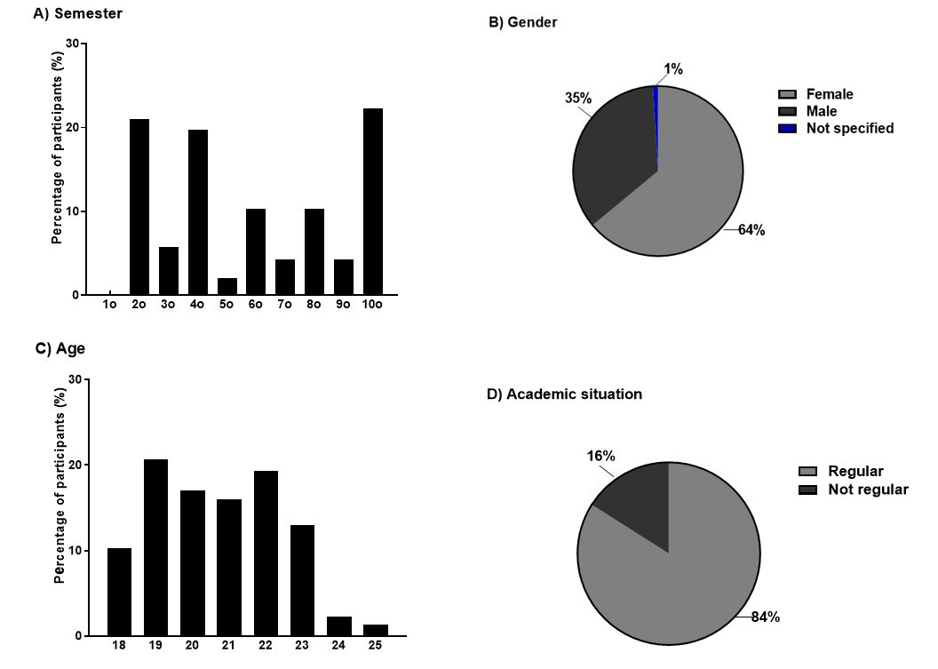

Source: Elaborated by the authors

Hybrid education and teaching of medicine
When asked on a scale of 1 to 10 about the applicability of hybrid education, with 8 - 10 being very applicable, 5-7 moderately applicable, 2-3 slightly applicable, and 1 not applicable at all, it was observed that 27.7% considered it very applicable, 42.3% moderately applicable, 18.3% slightly applicable, and 11.7% not applicable at all (Figure 2A). Respondents considered the following tools are applicable in medical education: 73.7% with the use of virtual platforms; 61% with theoretical classes coupled with virtual modalities; 37% with demonstrations; 60.7% with simulators; 49.3% through study sessions via video call, and <1% did not believe any of these could apply to medical education (Figure 2B). Respondents were also surveyed about the advantages of hybrid education in medical teaching, where they considered that 10.3% would make teaching more flexible; 18.7% would allow alternating teaching with other professional activities; 12.7% believed it would allow a more autonomous form of study for the student; 17% considered it not applicable; 36% considered it could be a complementary option to in-person teaching ; and 5.3% would allow them to exploit their self-taught potential (Figure 2C).

Figure 2. Hybrid education in medical teaching. A) Quantification of the application of hybrid education. B) Hybrid education tools transferable to medical teaching. C) Advantages of hybrid education in medical teaching.

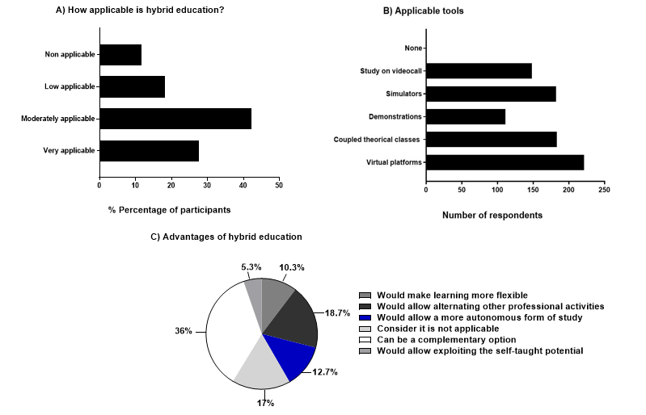

Source: Elaborated by the authors
When questioned about the platforms most used for virtuality and that could be applied in medical education, Teams was the most used (43%), followed by Zoom (33%), the UAT university platform (12%), and Google Classroom and Moodle with 5% each (Figure 3A). When people were asked which ICTs they thought could be used in hybrid education, 26% said software, 18% said epidemiological information accessed through specific or public databases, 9% said electronic games, 4% said telemedicine, 20% said electronic medical records, 11% said some other (which was later expanded upon), 0.5% did not mention which, <2% did not know which ICTs could be used, and <1% did not agree with the use of these (Figure 3B). Among the respondents who chose others, elements such as Microsoft Office, video conferences, social networks, specialized pages for exams, video call platforms, applications for spaced repetition of knowledge, and applications like Kahoot, Canva, and Socrati for knowledge reinforcement were suggested. Regarding the benefits of this model, 13.5% believed it allowed more significant learning, 26% indicated quality time, 22% greater autonomy in learning, and 39% indicated the use of ICTs as a benefit (Figure 3C). Students were also questioned about the feasibility of adopting remote laboratory practices, where 89% of respondents stated that they did not agree, 10% mentioned that it could be occasionally, and only 1% agreed to carry them out remotely. This is related to the fact that laboratory practices have a practical component that any virtual model cannot substitute, as it requires learning either laboratory techniques or patient management traditionally, with a teacher guiding the acquisition of such knowledge at the moment. However, in this section, hybrid education could be interesting for subjects with an exclusive theoretical component. On the other hand, it was found that 62% (n = 186) of respondents considered that classes could be asynchronous, while 38% (n = 114) answered that they did not consider it so. They were questioned about the main limitations of developing hybrid learning. The most voted option was "incomplete organization of online courses" (n = 230 votes), suggesting that the lack of adequate structure and organization of online courses hinders the development of effective hybrid learning, followed by "Lack of training courses for both students and teachers" (n = 192 votes), highlighting the need to offer training courses for both students and teachers to improve the skills and competencies necessary for successful hybrid learning. In third place, the limitation "Asynchronous classes as a challenge for hybrid learning" (n = 28 votes) was found, implying difficulties in participating in real-time, connectivity problems, or obstacles in interacting with the instructor and peers during live sessions. Other limitations included a lack of interest of both teachers and students in training in modern technologies, as well as a lack of motivation or distractions for students. These results indicate vital areas that need to be addressed for improvement to achieve more effective and satisfying hybrid learning (Figure 3D).

Figure 3. Characteristics of hybrid education applied to medical education. A) Platforms. B) Transferable ICTs. C) Benefits. D) Limitations
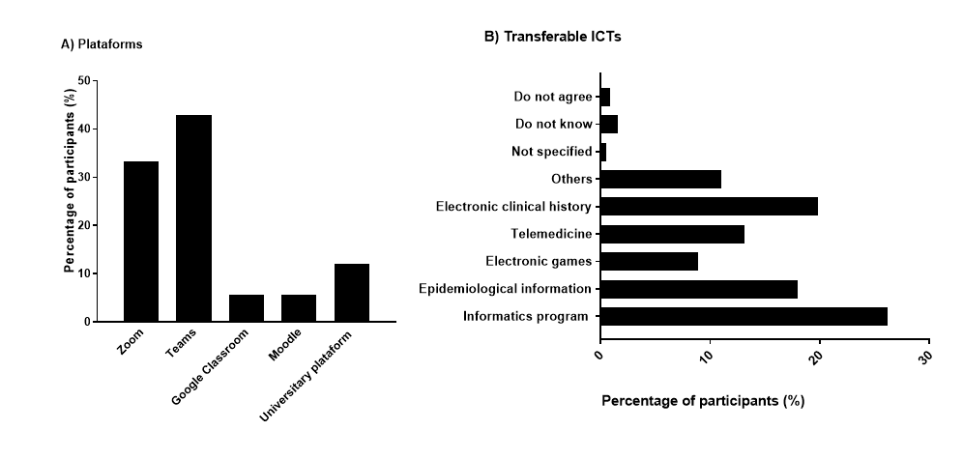
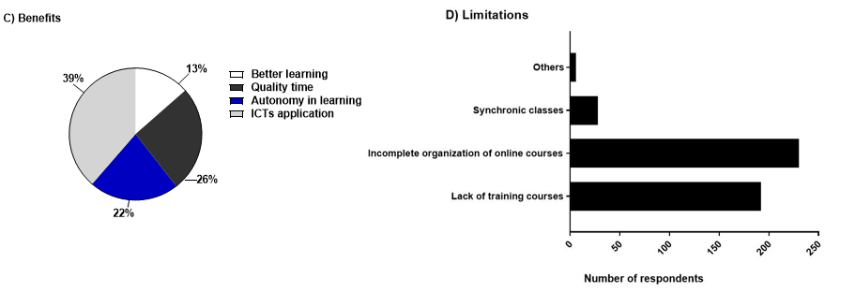
Source: Elaborated by the authors

Application of hybrid education in medicine during the COVID-19 pandemic
During the pandemic, students' assessment was done through the delivery of tasks (summaries, practices, concept maps, synoptic tables, among others) 100% online through platforms such as Teams, Google Forms, Blackboard, Moodle, and email. Although classes are now practically in-person, teachers still request tasks through the aforementioned platforms. In this research, 82% of evaluated medical students indicated that they prefer task delivery to be online, and 17% disagree with this modality. On the other hand, one of the main problems of medical education during the COVID-19 pandemic was maintaining academic interaction with students. Therefore, by combining in-person and online learning techniques, hybrid education provides flexibility in learning for medical students to accommodate various learning styles. Hybrid education integrates a mixed approach, allowing students to interact with the subject according to their needs. In this study, students were asked how they felt about the activities used in hybrid education. They said they liked creating case studies (65.3%), simulations (60.3%), and using specific software, like anatomy teaching (57%). They were less interested in teamwork (49%), debates on specific topics (39%), and making forums or wikis (31%), (See Figure 4A of the annexes section). It was found that 61% of post-pandemic-evaluated medical students believe that medical education can integrate hybrid education. However, another group (21%) of students indicated that medical education cannot use these virtual tools, and 17% believe that medical education must continue its traditional model (See Figure 4B of the annexes section).

Discussion
The applicability of hybrid education in medicine has caused uncertainty since diverse groups support the idea of ​​a new education model, and others prefer the permanence of the traditional on-site model. This research analyzed the factors that could benefit or make the hybrid education modality difficult. Within the framework of satisfaction of the students towards the application of hybrid education, it was found that 49.3% of the surveyed students agree with its application in medicine, which is related to the results of a study by Hsu et al., (2022) found that 96.5% of medical student participants are satisfied with the hands-on practice, online teaching, instructors, interactions, course content, and training implemented in hybrid education modality because they felt more confident in the knowledge and expertise in medical practice. ICTs must be used to apply hybrid education. Nowadays there are different platforms where online classes can be transmitted, Dimitrov & Kovatcheva (2022) analyzed the distinct available platforms and classified four of them as the best for student learning: Canvas, Blackboard Learn, Desire2Learn Brightspace, and Moodle, in our university environment only 5% of the students use the latter. Nevertheless, this criterion fundamentally depends on each platform's functions and each person's needs. During the COVID-19 pandemic, tasks were completed completely online; when on-site classes summarized, 82% of the respondents voted for submitting assignments online, and only 17% opted for the traditional way. This contrasted with the research by Faizan et al., (2023) who discovered that 70.7% of the students preferred traditional teaching and 31.3% chose the online model. Most respondents (n = 230) indicated that one of the limitations of hybrid education was the incomplete organization of the course, which is like the study by Heilporn et al., (2021). According to them, university teachers must encourage students to commit to learning by facilitating a clear, continuous, and unified structure of the program, designing dynamic activities, and accessing information regarding duration, contents, and where the activities should be performed. On the other hand, 192 students indicated a lack of knowledge about adequate use of ICTs by the teachers and the students themselves. Technical difficulties online, a lack of skills to conduct computer operations, and internet availability are obstacles to hybrid education success (Vallée et al., 2020). Boychuk et al., (2022) found comparable results where the teachers (29%) referred to a lack of knowledge in using ICTs. Viñas (2021) mentioned among the disadvantages of hybrid education: the difficulty in managing and organizing time with students, less participation than in remote class discussions, difficulties in accessing the Internet, and the lack of intellectual and social stimulation in classes in comparison with on-site classes. The advantages of hybrid education included the opportunity to ask questions and obtain additional explanations in virtual interactions, reinforcement of concepts, personalization of learning, and flexibility. Nevertheless, among the difficulties detected, there is a lack of orientation toward the students, a higher volume of work, and a lack of personal contact among students. Our results aligned with these studies on the transcendence of online course organization and the need for training courses for teachers and students. In addition to the difficulties related to synchronic classes, there is a lack of interest and motivation in the students. On the other hand, hybrid education combines on-site and online activities, along with synchronous and asynchronous classes. At this point, the students were asked if they agreed about applying asynchronous classes in medicine, observing that 62% agreed. Serrano et al., (2019) emphasized that the latter positively impacts general learning, particularly those students who can organize themselves because they have more time to reaffirm what they have learned. However, they also mention a lower commitment from the student because of the lack of interaction with other classmates. For example, Viljoen et al., (2020) implemented this modality in an electrocardiogram course and graded the academic performance by applying evaluations before and after the course. They found that students who used the hybrid modality had better knowledge retention and less difficulty analyzing and interpreting the electrocardiogram than those who just had the on-site class. In medicine, it is necessary to acquire basic medical knowledge in the classroom. Even so, it is also fundamental to introduce the students to clinical scenarios where they apply what they have learned. Because of that, 89% of respondents did not agree with online laboratory/clinical practice, which is related to the study by El-Hawy et al., (2022) where the students of medicine from the University of Zagazig (Egypt) reported that acquiring practical skills in the clinic via online was quite a challenge, which is why 55.5% did not agree with this modality. Another study by Abbasi et al., (2020) found that students, who only had online clinical sessions, did not feel confident enough to perform a physical examination on a patient in real life. An advantage of ICTs is a better experience integrating information for optimal academic performance. Respondents agreed that a recourse that can be used from hybrid education is the implementation of informatics programs for medicine. This was in line with a study by Sonne et al., (2021) who compared two groups of students to whom a “clinical examination” course was taught: one with an application and another where they used the conventional handwritten notes. The group with the application had better results in the final evaluation than the others. In addition, certain interactive online resources, such as short questionnaires, helped the students develop the capacity for feedback and teamwork (Ballouk et al., 2022). In our study, just over 10% suggested another type of transferable source, e.g., the Kahoot platform. Likewise, when investigating what activities they prefer for the implementation of hybrid education, 65.3% preferred the resolution of clinical cases. Fehl et al., (2022) applied and evaluated a new learning format completely digital in the general medicine rotation, which includes clinical cases: it was found that most of the students (59.6%) agreed with using them, 64.6% reported having greater learning and 62.6% agreed that it has a high relevance in clinical practice. Furthermore, in a systematic review conducted by Ahmady et al., (2021) it was concluded that technology-enhanced learning in medical education, using simulation-based learning, virtual classes, video conferencing, webinar design, teleconferencing, and interactive synchronous small group sessions, have the potential to improve students' level of knowledge and performance by making learning resources accessible. A situation that serves as an example is the application of hands-on surgical simulation training which enhances the learning experience by helping students gain knowledge and confidence in surgical skills (Lentz et al., 2020). Among the challenges of hybrid education, one of the most important is the lack of engagement of the students in online classes and encouraging those who do not participate in class (Ilankoon et al., 2022). This could be related to 27% of respondents who mentioned that two hours of online classes per day and five online subjects (26%) would be ideal to avoid “Zoom fatigue,” which is the product of many academic sessions on a given day ( Fitzgerald et al., 2022). The “Flipped classroom” employs technological media, such as videos where the topic to be addressed is exposed, and subsequently, in the classroom, doubts are clarified, and concepts are discussed with the teacher (Mandasari & Wahyudin, 2021). In our study, 135 students (45%) agreed that the “Flipped classroom” option could be applied to certain subjects, 39.7% disagreed, and 16.3% approved its application in all subjects. This could be associated with the fact that certain subjects entail a degree of complexity and require the correct guidance of the teacher; if not, learning may not be as expected. Lomer & Palmer (2023) confirmed this in a study where the students concluded that the teachers should expose the important subjects, so hybrid education does not replace teacher-directed study, which differs totally from the original concept. It should be noted that the strategies proposed by the respondents to achieve an effective hybrid education include better training in the use of ICTs, good connectivity to the internet, a support network from the teacher, didactic classes, actively engaging in learning from both teachers and students, optimization of the number of hours of online classes, application of clinical cases, use of clinical practice programs, along with studying online subjects that do not require clinical practice. All this largely coincides with the results of different authors worldwide. The limitations of this study include the size of the cohort since a larger number would have higher statistical significance. In addition to being a single-center study, it would be interesting to expand the scope to evaluate similarities and differences between public and private medicine universities. However, this study has highlighted the advantages of hybrid education that could be implemented in traditional medical teaching.

Conclusions
Online classes took place after confinement by replacing face-to-face classes. The advantages and disadvantages of this model in medical education were found. However, with the on-site return, it is evident that tools and resources used remotely can be advantageous in implementing a hybrid model in medicine. The present study has made it clear that one of the strong points of this model would be good course planning, with a clear, concise, dynamic, and unsaturated structure together with more training in the use of the ICTs, which is applicable in those subjects where the contents are purely theoretical. Although the study of medicine has a practical component that requires mandatory presence, hybrid education can be a helpful option with immediate applicable advantages.

Future Research Lines
Future lines of research are proposed to include the analysis of strategies for teaching update in the use of technologies employed in medical education that allow the implementation of hybrid education such as a) simulation-based learning , and b) webinar design. This requires the evaluation of the topics that could be transferred to these modalities, which include those with theoretical content. On the other hand, the analysis of the limitations and areas for improvement regarding this educational model , such as greater training with courses on the management of information technologies, as well as stipulating how synchronous classes can be addressed so that they can be used in the best way by students, as well as lines of research with a focus on organizational design of online courses. After implementation, monitoring students and surveys to assess the perspective on this academic modality and propose a resolution for the problems detected is essential.

Acknowledgements
The authors would like to thank the Faculty of Medicine of Tampico "Dr. Alberto Romo Caballero" of the Autonomous University of Tamaulipas for their financial support for the publication of this article.

References
Abbasi, M. S., Ahmed, N., Sajjad, B., Alshahrani, A., Saeed, S., Sarfaraz, S., Alhamdan, R. S., Vohra, F., and Abduljabbar, T. (2020). E-Learning perception and satisfaction among health sciences students amid the COVID-19 pandemic. Work, 67(3), 549–556. https://doi.org/10.3233/WOR-203308
Ahmady, S., Kallestrup, P., Sadoughi, M. M., Katibeh, M., Kalantarion, M., Amini, M., and Khajeali, N. (2021). Distance learning strategies in medical education during COVID-19: A systematic review. Journal of Education and Health Promotion, 10(1), 421. https://doi.org/10.4103/jehp.jehp_318_21
Ballouk, R., Mansour, V., Dalziel, B., McDonald, J., and Hegazi, I. (2022). Medical students’ self-regulation of learning in a blended learning environment: a systematic scoping review. Medical Education Online, 27(1), 1–8. https://doi.org/10.1080/10872981.2022.2029336
Boychuk, Y., Novikova, V., Opanasenko, Y., Olena, K., and Kostina, V. (2022). Pedagogical Conditions for the Introduction of Blended Learning Technologies in Ukrainian Higher Education Institutions. Romanian Journal for Multidimensional Education, 14(3), 32–50. https://doi.org/10.18662/rrem/14.3/596
Carbonell-García, C.E., Rodríguez-Román, R., Sosa-Aparicio, L.A., and Alva-Olivos, M.A. (2021). De la educación a distancia en pandemia a la modalidad hibrida en pospandemia. Revista Venezolana de Gerencia, 26(96), 1154-1171. https://doi.org/10.52080/rvgluz.26.96.10
De Obesso, M., and Núnez-Canal, M. (2021). El modelo educativo híbrido: una respuesta necesaria de la enseñanza universitaria a partir de la COVID-19. In Colección comunica. https://doi.org/10.13140/RG.2.2.34706.89289
Dimitrov, K., and Kovatcheva, E. (2022). Best E-Learning Platforms for Blended Learning in Higher Education. Mathematics & Informatics, 65(6), 533–545. https://doi.org/10.53656/math2022-6-2-bes
El-Hawy, L. L., Alssarat, K. A., Dimetry, S. R., and Allah, M. B. A. (2022). Medical Students’ Satisfaction Regarding Blended Learning during COVID-19 Pandemic. Egyptian Journal of Hospital Medicine, 86(1), 645–652. https://doi.org/10.21608/ejhm.2022.215203
Faizan, M., Barsha, S., Eqbal, N., and Munshi, S. A. (2023). Blended Learning vs. E-learning: Determining the Best Mode of Education from the Perspective of the Learners. DESIDOC Journal of Library & Information Technology, 43(1), 30–38. https://doi.org/10.14429/djlit.43.01.18620
Fehl, M., Gehres, V., Geier, A.-K., Mundt, T., Klinge, K., Frese, T., Bleckwenn, M., and Deutsch, T. (2022). Medical students’ adoption and evaluation of a completely digital general practice clerkship – cross-sectional survey and cohort comparison with face-to-face teaching. Medical Education Online, 27(1), 1–12. https://doi.org/10.1080/10872981.2022.2028334
Fitzgerald, D. A., Scott, K. M., and Ryan, M. S. (2022). Blended and e-learning in pediatric education: harnessing lessons learned from the COVID-19 pandemic. European Journal of Pediatrics, 181(2), 447–452. https://doi.org/10.1007/s00431-021-04149-1
Heilporn, G., Lakhal, S., and Bélisle, M. (2021). An examination of teachers’ strategies to foster student engagement in blended learning in higher education. International Journal of Educational Technology in Higher Education, 18(1), 1–25. https://doi.org/10.1186/s41239-021-00260-3
Hsu, C. C., Tsai, S. H., Tsai, P. J., Chang, Y. C., Tsai, Y. D., Chen, Y. C., Lai, K. C., Wang, J. C., Yang, T. C., Liao, W. I., and Chen, S. J. (2022). An Adapted Hybrid Model for Hands-On Practice on Disaster and Military Medicine Education in Undergraduate Medical Students During the COVID-19 Pandemic. Journal of Acute Medicine, 12(4), 145–157. https://doi.org/10.6705/j.jacme.202212_12(4).0003
Ilankoon, I. M. P.S., Kisokanth, G., and Warnakulasuriya, S. S. P. (2022). Blended Learning Approaches in Nursing Education During the COVID-19 Pandemic: A Review. Education in Medicine Journal, 14(2), 103–109. https://doi.org/10.21315/eimj2022.14.2.8
Lentz, A. C., Rodríguez, D., Chandrapal, J. C., Davis, L. G., Ghazi, A., Gross, M. S., and Munarriz, R. (2020). Cadaveric Laboratory Simulation Training of Male Stress Urinary Incontinence Treatment Improves Trainee Knowledge and Confidence. Urology, 143, 48–54. https://doi.org/10.1016/j.urology.2020.06.008
Lomer, S., and Palmer, E. (2023). ‘I didn’t know this was actually stuff that could help us, with actually learning’: student perceptions of Active Blended Learning. Teaching in Higher Education, 28(4), 679-698. https://doi.org/10.1080/13562517.2020.1852202
Mandasari, B., and Wahyudin, A. Y. (2021). Flipped Classroom Learning Model: Implementation and Its Impact on EFL Learners’ Satisfaction on Grammar Class. Ethical Lingua: Journal of Language Teaching and Literature, 8(1), 150-158. https://ethicallingua.org/25409190/article/view/234
Manley-Baeza, M. (2023). Desafíos de la educación híbrida. InterSedes, 24(Num Esp 1), 97-121. https://doi.org/10.15517/isucr.v24inúmero%20especial%201.53762
Rama, C. (2020). La nueva educación híbrida (1ª ed). Cuadernos de Universidades. México: UDUAL. 11-13 pp.
Rosales-Gracia, S., Gómez-López, V.M., Durán-Rodríguez, S., Salinas-Fregoso, M., and Saldaña-Cedillo, S. (2008). Modalidad híbrida y presencial. Comparación de dos modalidades educativas. Revista de la Educación Superior, 4(148), 23-29.
Saavedra-Jaramillo de Sedamano, M.J., Saavedra-Jaramillo, C.C., Medina-Sotelo, C., Sedamano-Ballesteros, M.A., and Saadra Jaramillo, D.I. (2022). Aulas híbridas: la nueva normalidad de la educación superior a partir del COVID-19. Apuntes Universitarios, 12(2), 162-178. https://doi.org/10.17162/au.v12i2.1044
Serrano-López, D. R., Dea-Ayuela, M. A., Gonzalez-Burgos, E, Serrano-Gil A, and Lalastra K. (2019). Technology‐enhanced learning in higher education: How to enhance student engagement through blended learning. European Journal of Education, 54(2), 273–286. https://doi.org/10.1111/ejed.12330
Sonne, C., Persch, H., Rosner, S., Ott, I., Nagy, E., and Nikendei, C. (2021). Significant differences in written assessments as a result of a blended learning approach used in a clinical examination course in internal medicine: a randomized controlled pilot study. GMS Journal for Medical Education, 38(2), 1–22. https://doi.org/10.3205/zma001438
Vallée, A., Blacher, J., Cariou, A., and Sorbets, E. (2020). Blended Learning Compared to Traditional Learning in Medical Education: Systematic Review and Meta-Analysis. Journal of Medical Internet Research, 22(8), e16504. https://doi.org/10.2196/16504
Viljoen, C. A., Millar, R. S., Manning, K., and Burch, V. C. (2020). Effectiveness of blended learning versus lectures alone on ECG analysis and interpretation by medical students. BMC Medical Education, 20(1), 488. https://doi.org/10.1186/s12909-020-02403-y
Viñas, M. (2021). Retos y posibilidades de la educación híbrida en tiempos de pandemia. Plurentes. Artes y Letras, 12(E027), 1-9. https://doi.org/10.24215/18536212e027

Contribution Role | Authors (s)
Conceptualization | Alejandra Tavera Tapia (principal)
Methodology | Alejandra Tavera Tapia and Elizabeth Reyna Beltrán (equal)
Software | Alejandra Tavera Tapia (equal), Elizabeth Reyna Beltrán (equal), Erik Sánchez Adame (equal), Alejandra Flores Reyes (equal)
Validation | Alejandra Tavera Tapia (equal), Elizabeth Reyna Beltrán, (equal), Erik Sánchez Adame (equal), Alejandra Flores Reyes (equal)
Formal Analysis | Alejandra Tavera Tapia (equal), Elizabeth Reyna Beltrán, (equal), Erik Sánchez Adame (equal), Alejandra Flores Reyes (equal)
Investigation | Alejandra Tavera Tapia (equal), Elizabeth Reyna Beltrán, (equal) Erik Sánchez Adame (equal), Alejandra Flores Reyes (equal)
Resources | Alejandra Tavera Tapia, Elizabeth Reyna Beltrán (equal)
Data curation | Alejandra Tavera Tapia, Elizabeth Reyna Beltrán (equal)
Writing – Preparation of the original draft | Alejandra Tavera Tapia (equal), Elizabeth Reyna Beltrán, (equal), Erik Sánchez Adame (equal), Alejandra Flores Reyes (equal)
Writing – Review and editing | Alejandra Tavera Tapia, Elizabeth Reyna Beltrán (equal)
Display | Alejandra Tavera Tapia, Elizabeth Reyna Beltrán (equal)
Supervision | Alejandra Tavera Tapia (principal)
Project Management | Alejandra Tavera Tapia and Elizabeth Reyna Beltrán (equal)
Fund Acquisition | Alejandra Tavera Tapia and Elizabeth Reyna Beltrán (equal)

Annexes

Figure 4. Hybrid education and COVID-19. A) Activities implemented to perform hybrid education during the pandemic. B) Medical students' perception of hybrid education

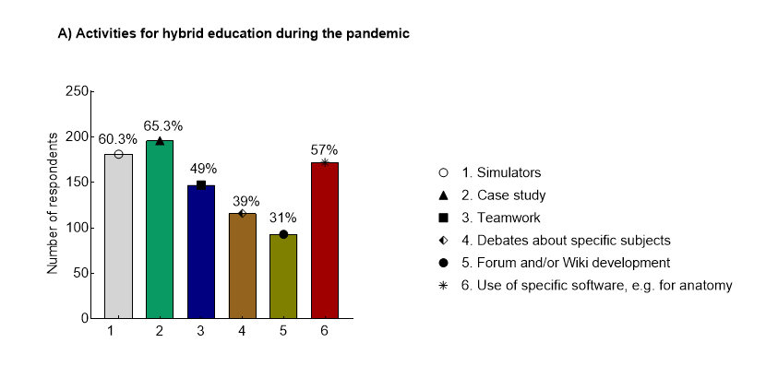

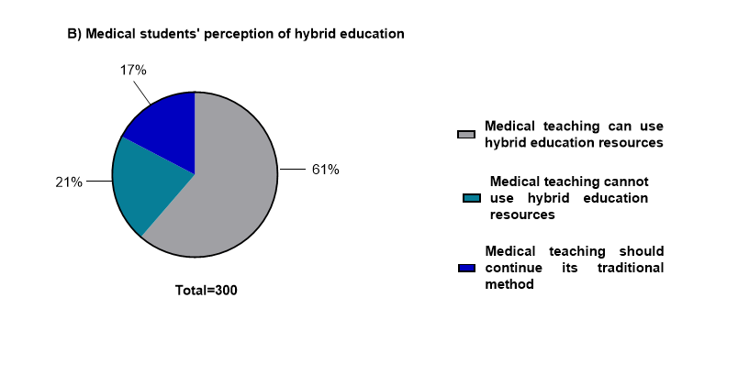
Source: Elaborated by the authors

