https://doi.org/10.23913/ride.v15i29.2226
Scientific articles

Optimizing the implementation of skill-focused hybrid learning in an educational engineering experience. LSC Skills

Optimizando el aprendizaje hibrido implementación del enfoque de competencias en una experiencia educativa de ingeniería. Competencias en LCS
Otimizando a implementação de aprendizagem híbrida focada em habilidades em uma experiência de engenharia educacional. Habilidades LSC

Erika Barojas-Payán
Universidad Veracruzana, Facultad de Ingeniería, México
ebarojas@uv.mx
https://orcid.org/0000-0002-3087-4046

Dulce-Rocío Mota-López
Universidad Veracruzana, Facultad de Ingeniería, México
dumota@uv.mx
https://orcid.org/0000-000-9521-392X

Victorino Juárez-Rivera
Universidad Veracruzana, Facultad de Ingeniería, México
vijuarez@uv.mx
https://orcid.org/0000-0003-4243-0415

Abstract
This document described the design and application of the Educational Experience (EE) of Logistics and Supply Chain (LSC) based on Competency-Based Education within the Industrial Engineering program. The design objective was to develop the skills necessary for logistics and supply chain management in future industrial engineers. Balancing theory and practice through the use of various technological and design tools. Also considering elements such as productivity, costs, safety, sustainability, ergonomics, and environmental impact. With the objective of acquiring the necessary skills to enter the work force, enhancing educational objectives, and aligning with the professional profile required after graduation. Activities such as active listening, research, topic presentations, application of new techniques and methods, project development, and theory-practice evaluations help students meet the competencies required by the EE. Students also developed research, oral and written communication skills, meaningful learning, autonomous development, collaborative work, and values such as tolerance and solidarity. This project was carried out with a distributed method, theoretical classes, and laboratory practice using institutional platform, e-mail, and WhatsApp as alternative means of communication and information transfer. The results showed that of the 42 students that had this educational experience, 83.3% of students were certified as ordinary, 14.3% extraordinary, and 2.4% weren’t present for the certification. Of the 42 students, only 41 responded to the satisfaction survey: 97.6% rated their satisfaction as high, based on the clarity of instruction and responsiveness to inquiries, and 92.7% also argued that the topics and activities have been adequate and understandable. These findings demonstrate the effectiveness of the EE in equipping students with essential skills and fostering high levels of satisfaction, validating its application within hybrid learning models.
Keywords: educational experience; skills; hybrid model.

Resumen
En este documento se describe el diseño y aplicación de la Experiencia Educativa (EE) de Logística y Cadena de Suministro (LSC) basada en la Educación Basada en Competencias dentro del programa de Ingeniería Industrial. El objetivo del diseño es desarrollar las competencias necesarias para la gestión logística y de la cadena de suministro en los futuros ingenieros industriales. Balanceando la teoría y la práctica mediante el uso de diversas herramientas tecnológicas y de diseño. Considerando además elementos como productividad, costos, seguridad, sustentabilidad, ergonomía e impacto ambiental. Con el objetivo de adquirir las competencias necesarias para insertarse en el mundo laboral, potenciando los objetivos educativos y alineándose con el perfil profesional requerido al egresar. Actividades como escucha activa, investigación, exposición de temas, aplicación de nuevas técnicas y métodos, desarrollo de proyectos y evaluaciones teórico-prácticas ayudan a los estudiantes a cumplir con las competencias requeridas por la EE. Además, los estudiantes desarrollan habilidades de investigación, comunicación oral y escrita, aprendizaje significativo, desarrollo autónomo, trabajo colaborativo y valores como la tolerancia y la solidaridad. Este proyecto se llevó a cabo con un método distribuido, clases teóricas y prácticas de laboratorio utilizando la plataforma institucional, el correo electrónico y WhatsApp como medios alternativos de comunicación y transferencia de información. Los resultados muestran que de los 42 estudiantes que tuvieron esta experiencia educativa, el 83.3% de los estudiantes fueron acreditados en ordinario, el 14.3% en extraordinarios y el 2.4% no se presentó a la acreditación. De los 42 estudiantes, solo 41 respondieron la encuesta de satisfacción: el 97.6% calificó su satisfacción como alta, con base en la claridad de la instrucción y la capacidad de respuesta a las consultas y el 92.7% argumentó que los temas y actividades han sido adecuados y comprensibles. Estos hallazgos demuestran la efectividad de la EE para dotar a los estudiantes de habilidades esenciales y fomentar altos niveles de satisfacción, validando su aplicación dentro de modelos de aprendizaje híbridos.
Palabras clave: experiencia educativa; competencias; modelo híbrido.

Resumo
Este documento descreve o projeto e a aplicação da Experiência Educacional (EE) de Logística e Cadeia de Suprimentos (LSC) baseada na Educação Baseada em Competências dentro do programa de Engenharia Industrial. O objetivo do projeto é desenvolver as habilidades necessárias para logística e gestão da cadeia de suprimentos em futuros engenheiros industriais. Equilibrar teoria e prática através da utilização de diversas ferramentas tecnológicas e de design. Considerando também elementos como produtividade, custos, segurança, sustentabilidade, ergonomia e impacto ambiental. Com o objetivo de adquirir as competências necessárias para ingressar no mundo do trabalho, potencializando os objetivos educacionais e alinhando-se ao perfil profissional exigido na graduação. Atividades como escuta ativa, pesquisa, apresentação de temas, aplicação de novas técnicas e métodos, desenvolvimento de projetos e avaliações teórico-práticas ajudam os alunos a cumprir as competências exigidas pela EE. Além disso, os alunos desenvolvem habilidades de pesquisa e comunicação oral e escrita. aprendizagem significativa, desenvolvimento autônomo, trabalho colaborativo e valores como tolerância e solidariedade. Este projeto foi realizado com método distribuído, aulas teóricas e práticas laboratoriais utilizando a plataforma institucional, e-mail e WhatsApp como meios alternativos de comunicação e transferência de informações. Os resultados mostram que dos 42 alunos que tiveram esta experiência educativa, 83,3% dos alunos foram credenciados em ordinário, 14,3% em extraordinário e 2,4% não compareceram para credenciamento. Dos 42 alunos, apenas 41 responderam ao inquérito de satisfação: 97,6% avaliaram a sua satisfação como elevada, com base na clareza da instrução e na capacidade de responder a dúvidas, e 92,7% argumentaram que os temas e atividades foram adequados e compreensíveis . Estas descobertas demonstram a eficácia da EE em proporcionar aos alunos competências essenciais e promover elevados níveis de satisfação, validando a sua aplicação em modelos de aprendizagem híbridos.
Palavras-chave: experiência educacional; competências; modelo híbrido.
Fecha Recepción: Julio 2024 Fecha Aceptación: Diciembre 2024

Introduction
This article aims to develop competencies in future engineers by integrating theory, practice, and technological tools into logistics and supply chain education.
Individual development and global progress rely on quality teaching (Pearson Corporate, 2022). The coordination between teaching, research, connections, and extensions in a framework that is respectful of rights and liberties in a university community favors a comprehensive learning experience for students and ensures quality and innovation in university education (Aguilar et al., 2021).
In the 1970s, McClellan introduced the term competency as a practical way to know and evaluate work performance affirming that optimal work performance occurs when workers demonstrate their knowledge and experience during job execution (Guevara De la Rosa & Plascencia Villafuerte, 2011). Competence training is a teaching and learning process aimed at equipping individuals with the skills, knowledge, and attitudes necessary for optimal performance (Cejas-Martínez et al., 2019). According to Argudín (2001), performance in education is determined by an external expression that demonstrates the level of learning, development of abilities, and values of the students. The purpose of competence is to achieve performance or produce results for oneself and others, linked to both the individual's cognitive structure and the norms and criteria of those evaluating the output.
Among different learning channels, we can mention a) visual, the perception of the subject through images, the capacity to capture information is fast, learning is through reading and observing figures; b) auditive, learning increases when receiving oral explanations and explaining some type of information to other individuals, and c) kinesthetic, learning is slower but deeper, acquired through sensations and executing body movements (Reyes-Rivero et al., 2017).
As society evolves, education must adapt accordingly. Behaviorist methodologies often fail to inspire interest in learning, making it essential to develop new strategies for the teaching and learning process (Montero-Herrera, 2017).
There are different methods for teaching and learning, among which are:
- Lecture (explanatory method), present updated content with a didactic objective.
- Case study, show a situation is articulated that presents problems that need to be resolved by the students.
- Learning based on problems, beginning from a problem, the students determine their learning objectives, look for information, and give a solution.
- Exercises and problems. execute a task beginning with the knowledge required and a series of given data.
- Learning based on projects, create a final project by the students through the application of research strategies.
- Practices, starting with a guide provided by the teacher and with specific materials, the students show what they have learned.
- Teamwork, do activities in groups, generally ending with the development of a document to be evaluated.
- Exams, evaluate tests in different formats.
- Presentations from the students of a previously developed task (Alcoba-González, 2012; Botella-Nicolás & Ramos-Ramos, 2019).
In this same sphere, information and communication technologies (ICT) are valuable tools within higher education, derived from what favors the transmission of context and harmonizes formative teaching activities, and is linked to investigation (Zambrano-Quiroz & Zambrano-Quiroz, 2019). Among the advantages are the influence that it has on a student’s daily life, and they are also present in informal education, promote communication, and give diverse possibilities for application, and they develop an ability for the students to do research (Méndez-Coca, 2015).
According to the Department of Public Education [SEP in Spanish] (2023) the dropout rate in higher education in Mexico is 8.1%, while the National Institute of Statistics and Geography [INEGI in Spanish] (2023) with information from the SEP mentions that the dropout rate of higher education in Veracruz during 2022/2023 was 12.3%. Studies done in Mexico mention that among the pedagogical factors that lead to abandoning the continuation of studies are: 1. The scant didactic capacity of teachers to teach content (Otero-Escobar, 2021), and 2. those related to strategies, activities, resources, and academic evaluation (Berumen, 2021). This situation leads to a strategy development that allows for getting the interest and the attention of students and thereby generating educational competency for the study program and supporting competency development in the educational program. As these elements converge, addressing pedagogical challenges and adopting innovative strategies becomes critical in higher education.
The efforts of various researchers to improve the teaching and learning process are reflected in numerous sources of information. An example of this is Cejas-Martínez et al. (2019), in which the researchers analyzed competency training beginning with existing theory, with the objective of characterizing the factors that make it possible to guarantee optimal performance in the framework of professional training. Moreover, Zambrano-Quiroz & Zambrano-Quiroz (2019) presented theoretical considerations about information and communication technologies (ICT) in higher education to be used by teachers as a component in work and investigation.
The study of Rivero et al. (2016), investigated active and participative methodologies that motivate autonomous training and the use of ICTs in the learning process. Reyes-Santander & Ramos-Rodríguez (2018) showed the reach that concept maps have in the learning process in mathematical education. Reibán-Barrera et al. (2017) are also worth mentioning, they have analyzed competency proposals planned in specialized literature, which allowed these competencies to be specified for Bachelor, Masters, and Doctorate students.
The document is structured as follows: (1) Methodology for imparting the Logistics and Supply Chain Educational Experience (EE) at the bachelor's level; (2) Accreditation and satisfaction results; (3) Design-related conclusions; (4) Future projects; and (5) References.

Implemented Methodology
The methodology employed to impart the educational experience of Logistics and Supply Chain is illustrated in Figure 1. As can be observed, it starts with a course presentation and a diagnostic evaluation of the students. Following the initial diagnostic evaluation, active learning techniques are introduced to engage students in the competency development process. Throughout the Educational Experience (EE), the teacher employs expository, demonstrative, and energetic learning techniques. This intervention is carried out with seven topics which are composed of simultaneous study programs, where students complete formative and summative assessments.

Figure 1. Methodology to impart Logistics and Supply Chain EE
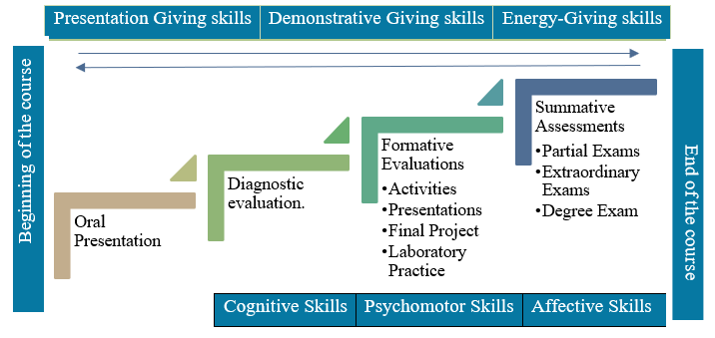
Source: Own elaboration based on study program.
These active learning techniques are supplemented by activities and evaluations that students must perform. Active learning, research, topic presentation, technique application, conceptualization, physical project development, and theoretical evaluations are among the activities that allow the students to achieve the competency that the educative experience demands, without losing sight of the internationalization of qualifications. Students also develop skills in research, oral communication, effective writing, deep learning, autonomous development, collaborative work, and values such as tolerance and solidarity.
Each evaluation has a percentage value, with the exception of the diagnostic evaluation, the theoretical aspects are addressed in the classroom and reinforced through activities such as mental maps, conceptual maps, timelines, and infographics, some of which are in English or another foreign language.
In the same way, there is a focus on article research that shows case studies (in Spanish and English) located in the indexed Scopus magazines, through which students observed the application of techniques and methodologies covered in class. Through video design, students learned about the behavior of supply chains in different industries. The presentations allow for the development of working in teams and evaluation of topics and classmates through activities carried out by fellow classmates. The course has the development of a final integrated project, that incorporates not only the course content on design but also topics from other EEs, including 1. Location and Plant Distribution, 2. Ergonomics, and 3. Industrial Security. The final integrated project consolidates knowledge and skills gained throughout the course, focusing on real-world applications.
The proposed technological tools are 1) Institutional platform, to follow the course; 2) Synchronous and asynchronous WhatsApp communication to clarify doubts; 3) Google Meet® video conferences to communicate with students in real-time from a distance, and 4) E-mail for asynchronous communication and the delivery of assignments in case of platform failure. Among special programs, Lingo_19®, Microsoft® programs, AutoCAD, and free online software were used. Laboratory practice allowed for the development of information searching, database creation, result evaluation skills, among other skills.
The evaluation methods employed during the course are detailed in Tables 1 through 5: 1) The type of evaluation; 2) A description of each evaluation; 3) Methodology used to carry out the evaluation; 4) Complexity of the evaluation; 5) Use of technology; 6) Investigative Aspect, and 7) Some checklists used for the presented evaluation. We should emphasize the application of three summative assessments during the teaching period of EE as well as two recovery evaluations at the end of the course for students that did not complete the collection of completed evaluations.

Table 1. Evaluation 1
Type of evaluation: | Mental map, conceptual map, infographics, plans, timelines, etc.
Description: | The students design, develop and explain with text and graphs one or various concepts linked to the relevant topics during the session.
Methodology: | - Analyze the recommended reading material and complete it in good time.  - Investigate the topic to develop.  - Design and develop it or the concepts of the relevant topic with the requested learning tool with graphic design software.  - Present the design in front of classmates.
Complexity: | It is necessary to select, organize, interpret, and use the information in an effective way to develop the designs, as well as skills in the use of ICTs.
Investigation: | The students should be capable of choosing the information sources that allow him to supplement the information provided by the professor by carrying out the assigned activity.
Use of technology: | The information used to carry out the different activities should be downloaded from the recommended electronic sources using the virtual library of the institution and expressed with different learning tools using online software.
General Scale: | - Insufficient  - Deficient  - Sufficient  - Good  - Excellent
Observation of attitudes | - Organization of information.  - Adherence to the topic.  - Logical connections.  - Clarity of concepts and spelling.  - Creativity.  - Investigation.  - Knowledge.
Source: Own elaboration based on study program.

Table 2. Evaluation 2
Type of evaluation: | Visual and video summary.
Description: | The students investigate, analyzes, understands, and explains visually and verbally the research articles about the relevant topics during the session.
Methodology: | - Analyze the recommended reading material and complete it in good time.  - Investigate the topic to develop with specialized scientific magazines.  - Present using a video or a visual summary using design software, the article, and its connection to the topic.  - Present the design in front of classmates.
Complexity: | It is necessary to investigate, analyze, organize interpret, and use the information in an effective way to develop the designs, as well as skills in the use of  ICTs.
Investigation: | The students should be capable of looking for, analyzing, and understanding articles as appropriate sources of information (webpages Elservier, Scopus) that allow him to supplement the information provided by the professor to carry out the assigned activity.
Use of technology: | The information to carry out the different activities should be downloaded with the recommended electronic resources and demonstrated with different learning tools using online software.
General Scale: | - Insufficient  - Deficient  - Sufficient  - Good  - Excellent
Checklist:  Observation of attitudes | - Organization of information.  - Adherence to the topic.  - Logical connections.  - Clarity of concepts and spelling.  - Creativity.  - Adequate Investigation.  - Knowledge.
Source: Own elaboration based on study program.

Table 3. Evaluation 3
Type of evaluation: |  | Presentation of a research topic.
Description: |  | During the course, the students will be assigned a subtopic about which they should investigate, analyze, select, and discuss the information, and later explain it to their classmates in a presentation with extension .pptx, moreover they should turn in a PDF document in APA format, design an activity for their classmates (example: Kahoot), and present an illustrative video as well as a research article (case study) related to the magazine topic indicated in Scopus.
Methodology: |  | - Active listening during the lecture of the professor regarding the topic.  - Investigate, analyze, and select additional information (assigned subtopic).  - Discuss and select the information with classmates.  - Prepare the research document, which will contain title page, index, introduction, development, conclusions, bibliography, and glossary.  - Prepare slides.  - Look for an illustrative video.  - Create an activity for classmates.  - Investigate a related article.  - Present it in class.
Complexity: |  | It is necessary to analyze the information, investigate unknown terms, listen, and discuss it before the presentation.
Investigation: |  | The students should link the sub-topic that corresponds to the class topic, investigate it, and analyze it.
Use of Technology: |  | The products should be turned in virtually, and the products should also be developed with word processors and design software. The activity for the classmates should give immediate results.
General Scale: | - Insufficient  - Deficient  - Sufficient  - Good  - Excellent
Investigation  Knowledge observations |  | - Understands fundamental concepts.  - Adequately registers the information.  - Synthesizes.  - Links ideas.  - Establishes the relationship between concepts and information.  - Organizes ideas with clarity.
Presentation quality  Knowledge observations |  | - Was punctual with the necessary equipment to carry out the activity.  - The presented information was organized and coherent according to what was assigned.  - The slides had good quality.  - Made good use of time.  - Showed knowledge of the topic.
Source: Own elaboration based on study program.

Table 4. Evaluation 4
Type of evaluation: | Laboratory Practice
Description: | The students developed the practice provided by the professor regarding the topics given in class.
Methodology: | - The professor provided practice through the educational platform.  - The students in groups or individually responded to each of the elements that made up the practice in the laboratory.  - The students uploaded the practice to the educational platform.
Complexity: | Selection, organization, resolution of practice cases, interpretation, and use of information that is effective for the development and skill in the use of the ICTs are necessary.
Investigation: | The students should be capable of choosing the appropriate sources of information (institutional library, Elservier, Scopus) that allows for the supplementation of information provided by the professor to carry out the assigned activity.
Use of technology: | The information to carry out different practices and offer solutions should be downloaded from recommended electronic sources, using the institutional library, transparent webpages, and through different specialized software.
General Scale: | - Insufficient  - Deficient  - Sufficient  - Good  - Excellent
Knowledge observations | - Understands fundamental concepts.  - Adequately registers the information.  - Synthesizes.  - Links ideas.  - Establishes relationship between concepts and information.  - Adequately solves.  - Selects adequate sources of information.  - Organizes ideas with clarity.
Source: Own elaboration based on study program.

Table 5. Evaluation 5
Type of evaluation: | Final integrated project.
Description: | Upon finishing the course, the students should give a solution to a topic related to humanitarian logistics and the establishment of pre-positioned warehouses. The research will consist of the location (municipality where the warehouse will be located) and distribution of a warehouse (apartments, areas, zones), inventories (product stock), aspects of security and hygiene, and an ergonomic workstation. For humanitarian help, the delivery routes will be given with specialty software and a physical presentation will be made with a model.
Methodology: | - Look for related information in recognized databases and transparent webpages.  - Select the information.  - Test and design with specialty software.  - Design model.  - Presentation
Complexity: | Resolve a real problem with the application of the acquired knowledge in four educational experiences.
Investigation: | The students should link what he has learned in class with the content of the research and its applications.
Use of Technology: | Software lingo_19, Excel Microsoft, AutoCAD, Internet.
Knowledge observations | - Was punctual with the correct equipment.  - The information presented was coherent to what was requested.  - Application of techniques and methods.  - Adequately used time.  - Showed knowledge.  - The model met the design, quality, and element requirements.
Source: Own elaboration based on study program.

Results
The satisfaction survey was completed by 41 out of 42 students, representing 97.6% of the cohort. Figure 2 illustrates the accreditation levels of students, showing that 83.3% passed as ordinary students, while 14.3% required extraordinary means. Only 2.4% did not present the final exam.

Figure 2. Educational Experience approval levels of Logistics and Supply Chains.
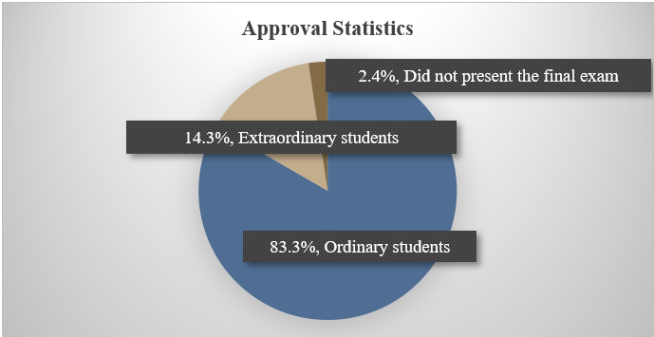
Source: Own elaboration based on student score.
As shown in Figure 3, grades ranged from 6.00 to 9.00 on a 10-point scale, with 8.00 being the most common grade obtained by 20 students, representing approximately 50% of the class.

Figure 3. Frequency of Educational Experience Logistics and Supply Chain Qualifications.
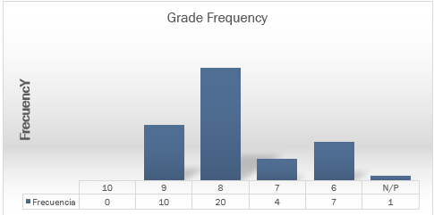
Source: Own elaboration based on student score.
Figures 4,5 and 6, show the results of the satisfaction survey completed by 41 students. Of these, 97.6% found the knowledge gained from the Educational Experience (EE) of Logistics and Supply Chain (LSC) satisfactory, and 2.4% were not satisfied. Moreover, 97.6% mentioned excellent attention quality and 2.4% evaluated it as good. In terms of the adequacy and comprehensibility of the activities, 92.7% strongly agreed, and 7.3% somewhat agreed regarding the adequacy and comprehensibility of the activities

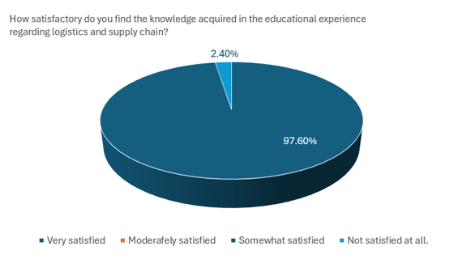
Figure 4. Knowledge acquired.
Source: Own elaboration based on applied satisfaction survey

Figure 5. Attention received.
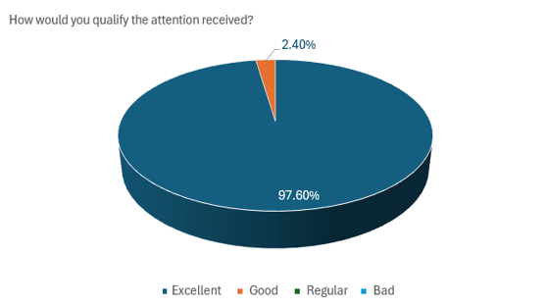
Source: Own elaboration based on applied satisfaction survey

Figure 6. Topics and activities.
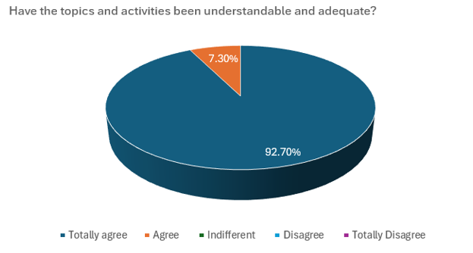
Source: Own elaboration based on applied satisfaction survey

Discussion
The implementation of the Educational Experience (EE) of Logistics and Supply Chain (LSC) resulted in satisfactory outcomes, reducing the percentage of unaccredited students by 15%. Among the 42 seventh-semester students in the Industrial Engineering program, 83.3% were accredited as ordinary students, 14.3% as extraordinary, and 2.4% did not complete the EE.
A satisfaction survey was answered by 40 students that took the EE course, of which 97.5% found it satisfactory and 2.5% unsatisfactory, and 97.5% rated the attention as excellent while 2.5% rated it as adequate. Regarding the topics and activities, 92.5% found them completely adequate, and 7.5% found them satisfactory.
In terms of areas of improvement, there was a balance in the number of activities per topic and the poster presentations in in-person events.
Research in the literature has applied educational tools similar to those used in this study and reported comparable results. For example, Reyes-Santander & Ramos-Rodríguez (2018) mention that, by creating mental maps, the students show his progress in learning and treating concepts, fostering independence and reflective thinking. In a similar fashion, our investigation uses mental and conceptual maps, infographics, and timelines to promote learning.
Flores-Fuentes & Juárez-Ruiz (2019), indicate that project-based learning allows students to achieve significant learning outcomes, develop critical and creative thinking skills and improve their oral and written expression. Similarly, our findings indicate that project-based learning applied to real-world problems in humanitarian logistics enhances knowledge, competencies, and skills, while fostering interest in solving social issues.
Furthermore, Álvarez-Ochoa et al., (2022) suggested that teachers should prepare and build formative classroom research projects as a basis to developing investigative competencies. This suggestion is conducted in the EE teaching methodology proposed in this document. This methodology fosters investigative competencies through various evaluations, including videos, visual summaries, integrative projects, and topic presentations.
As can be seen, the methodology presented is not based on the use of a single type of tool or learning method but rather a mixture of elements, that enable students not only to achieve the competencies proposed by the EE but also to acquire research skills, effective oral and written communication, meaningful learning, autonomous development, collaborative work and values ​​such as tolerance and solidarity.
Overall, the results and comparisons with literature highlight the value of diverse educational tools and methodologies in fostering comprehensive competency development.

Conclusions
During the implementation of the Educational Experience (EE) Logistics and Supply Chain (LSC), students displayed strong interest and initiative in completing various evaluations that enhanced and developed their abilities. These activities included partial exams, mental maps, infographics, and visual summaries. These activities demonstrated their skills in using design software to summarize investigations and provided an international perspective on logistics and supply chain studies.
In developing the final project, students showed significant interest in exploring additional topics and acquiring knowledge. They also demonstrated a clear understanding of their tasks, effectively presenting their work publicly and supporting teammates, thereby fostering solidarity in teamwork. Investigating successful and unsuccessful cases in recognized publications sparked greater interest in the logistics and supply chain field and its global importance.
The group-based design enabled students to explore diverse learning methods, use tools to solve problems, and apply their knowledge to real-world topics such as climate change and natural disasters, with an emphasis on internationalizing qualifications.
More than 95% of students achieved accreditation, with an average grade of 8.00. Their satisfaction was evident in the survey results. The students' interest in the topics after their presentations indicates that the design and implementation of the EE for logistics and supply chain was successful. These results align with the objective of developing competencies in logistics and supply chain management through a balanced blend of theory and practical application.
In summary, the EE for LSC successfully achieved its goals of fostering key competencies, encouraging global awareness, and engaging students in meaningful and collaborative learning experiences.

Future areas of research
Future research could explore the integration of EE into Method Engineering, Applied Statistics, Quality Control and Reliability, and Production Control. These areas are critical for fostering a holistic understanding of industrial engineering and for addressing complex, real-world challenges in integrated project settings.

References
Aguilar, M.G. y los miembros de la comunidad universitaria. (2021). Programa de Trabajo 2021 - 2025, por una transformación integral. Universidad Veracruzana. https://www.uv.mx/documentos/files/2022/03/Programa-Trabajo-2021-2025.pdf
Alcoba-González, J. (2012). La clasificación de los métodos de enseñanza en educación superior. Contextos Educativos. Revista De Educación, (15), 93-106. https://doi.org/10.18172/con.657
Alvarez-Ochoa, R., Cabrera-Berrezueta, L., & Mena-Clerque, S. (2022). Competencias investigativas en estudiantes de Educación Superior: aproximaciones desde estudiantes de Medicina. Digital Publisher CEIT, 7(4-2), 312-327. https://doi.org/10.33386/593dp.2022.4-2.1425
Argudín, Y. (2001). Educación basada en competencias. Magistralis, (20), 39-61. https://repositorio.iberopuebla.mx/bitstream/handle/20.500.11777/521/Magistralis20-Argudin.pdf?sequence=1
Berumen, F. L. (2021). Deserción escolar en la educación superior en México: revisión de literatura. RIDE. Revista Iberoamericana para la Investigación y el Desarrollo Educativo, 11(22). https://doi.org/10.23913/ride.v11i22.821
Botella-Nicolás, A. M., & Ramos-Ramos, P. (2019). Investigación-acción y aprendizaje basado en proyectos. Una revisión bibliográfica. Perfiles educativos, 14(63), 127-141. https://www.scielo.org.mx/scielo.php?script=sci_arttext&pid=S0185-26982019000100127
Cejas-Martínez, M. F., Rueda-Manzano, M. J., Cayo-Lema, L. E., & Villa-Andrade, L. C. (2019). Formación por competencias: Reto de la educación superior. Revista de Ciencias Sociales, 25(1), 94-101. https://www.redalyc.org/journal/280/28059678009/28059678009.pdf
Flores-Fuentes, G., & Juaréz-Ruíz, E. D. (2019). Aprendizaje basado en proyectos para el desarrollo de competencias matemáticas en Bachillerato. Revista Electrónica de Investigación Educativa, 19(3), 71-91. https://doi.org/10.24320/redie.2017.19.3.721
Guevara-De la Rosa, F., & Plascencia-Villafuerte, A. B. (5,6,7 de octubre de 2011). XVI Congreso Internacional de Contaduría, Administración e Informática. Hacia una metodología para la enseñanza de las competencias directivas. México, D.F., México. https://investigacion.fca.unam.mx/docs/memorias/2011/4.07.pdf
Instituto Nacional de Estadística y Geografía [INEGI]. (2023, November 07). Tasa de abandono escolar por entidad federativa según nivel educativo, ciclos escolares seleccionados de 2000/2001 a 2022/2023. https://www.inegi.org.mx/app/tabulados/interactivos/?pxq=9171df60-8e9e-4417-932e-9b80593216ee
Méndez-Coca, D. (2015). Estudio de las motivaciones de los estudiantes de secundaria de física y química y la influencia de las metodologías de enseñanza en su interés. Educación XX1: Revista de la Facultad de Educación, 18(2), 215-235. https://dialnet.unirioja.es/servlet/articulo?codigo=5078815
Montero-Herrera, B. (2017). Aplicación de juegos didácticos como metodología de enseñanza: Una revisión de la literatura. Pensamiento matemático, 7(1), 75-92. https://dialnet.unirioja.es/servlet/articulo?codigo=6000065
Otero-Escobar, A. D. (2021). Deserción escolar en estudiantes universitarios: estudio de caso del área económico-administrativa. RIDE Revista Iberoamericana para la Investigación y el Desarrollo Educativo, 12(23). https://doi.org/10.23913/ride.v12i23.1084
Pearson Corporate. (2022, 5 October). Los 5 países con la mejor educación del mundo, ¿cómo lo hicieron? https://blog.pearsonlatam.com/en-el-aula/paises-con-mejor-educacion
Reiban-Barrera, R. E., De la Rosa-Rodríguez, H., & Zeballos-Chang, J. M. (2017). Competencias investigativas en la Educación Superior. Revista Publicando, 4(1), 395-405. https://d1wqtxts1xzle7.cloudfront.net/90106907/439-Texto_del_articulo-1741-1-10-20170510-libre.pdf?1661211831=&response-content-disposition=inline%3B+filename%3DCompetencias_investigativas_en_la_Educac.pdf&Expires=1707703615&Signature=EqPPBRZeklXTeSCdYhB1
Reyes-Rivero, L., Cespedes-Gómez, G., & Molina-Cedeño, J. (2017). Tipos de aprendizaje y tendencia según modelo VAK. Tecnología, Investigación y Académica, 5(2), 237-242. https://revistas.udistrital.edu.co/index.php/tia/article/view/9785/pdf
Reyes-Santander, P. A., & Ramos-Rodríguez, E. (2018). Mapas conceptuales en educación matemática a nivel universitario. Revista electrónica de investigación educativa, 20(2), 25-36. https://doi.org/10.24320/redie.2018.20.2.1657
Rivero, C., Chávez, A., Vásquez, A., & Blumen, S. (2016). Las TIC en la formación universitaria. Logros y desafíos para la formación en psicología y educación. Revista de Psicología (PUCP), 34(1), 185-199. http://dx.doi.org/10.18800/psico.201601.007
Secretaria de Educación Pública [SEP]. (23 mayo 2023). Boletín 100 Desciende a 8.1% tasa de abandono escolar en Educación Superior. Gobierno de México. https://www.gob.mx/sep/articulos/boletin-100-desciende-8-1-tasa-de-abandono-escolar-en-educacion-superior-sep?idiom=es#:~:text=El%20Gobierno%20de%20M%C3%A9xico%2C%20por,inform%C3%B3%20el%20subsecretario%20de%20ese
Zambrano Quiroz, D. L., & Zambrano Quiroz, M. S. (2019). Las Tecnologías de la Información y las Comunicaciones (Tics) en la Educación Superior: Consideraciones teóricas. REFCalE: Revista Electrónica Formación Y Calidad Educativa, 7(1), 213-228. https://refcale.uleam.edu.ec/index.php/refcale/article/view/2750

Rol de Contribución | Autor (es)
Conceptualización | Erika Barojas Payán con apoyo de Dulce Rocío Mota López
Metodología | Erika Barojas Payán
Software | Dulce Rocío Mota López
Validación | Dulce Rocío Mota López
Análisis Formal | Dulce Rocío Mota López
Investigación | Erika Barojas Payán
Recursos | Victorino Juárez rivera
Curación de datos | Erika Barojas Payán
Escritura - Preparación del borrador original | Erika Barojas Payán con apoyo de Dulce Rocío Mota López
Escritura - Revisión y edición | Dulce Rocío Mota López
Visualización | Erika Barojas Payán con apoyo de Victorino Juárez Rivera
Supervisión | Erika Barojas Payán
Administración de Proyectos | Victorino Juárez Rivera
Adquisición de fondos | Erika Barojas Payán con apoyo de Victorino Juárez Rivera y Dulce Rocío Mota López

