https://doi.org/10.23913/ride.v16i31.2496
Artículos científicos
Development of a Chatbot to Improve Tutoring in Engineering Programs: A Focus at the Universidad Politécnica Metropolitana de Hidalgo
Desarrollo de un Chatbot para Mejorar la Tutoría en Carreras de Ingeniería: Un enfoque en la Universidad Politécnica Metropolitana de Hidalgo
Desenvolvimento de um Chatbot para Melhorar a Tutoria em Programas de Engenharia: Um foco na Universidade Politécnica Metropolitana de Hidalgo

Glendamira Serrano Franco
Universidad Politécnica Metropolitana, México
gfranco@upmh.edu.mx
https://orcid.org/0000-0003-3176-3433

Abstract
This research proposes the development of a chatbot aimed at complementing academic tutoring processes and addressing the frequently asked questions of students enrolled in the academic programs of Information Technology Engineering and Animation and Visual Effects Engineering at the Universidad Politécnica Metropolitana de Hidalgo. The study adopts a quantitative approach, with a non-experimental, cross-sectional, and exploratory design. Data collection was carried out through surveys applied to a representative sample of 213 students—from both academic programs and of both genders—selected through probabilistic sampling. For data analysis, an evaluation matrix was employed to reflect the students’ experience while interacting with the chatbot during a four-month pilot phase. The results obtained will serve as a basis for optimizing the chatbot’s performance by incorporating the suggestions and feedback provided by the users. The ultimate goal is to enhance the efficiency in addressing students’ inquiries and to improve the quality of personalized support offered to them.
Keywords: Chatbot, tutorial, questions, technological tool, students.

Resumen

La presente investigación propone el desarrollo de un chatbot orientado a complementar los procesos de tutoría y atender las consultas frecuentes de los estudiantes de los programas educativos de Ingeniería en Tecnologías de la Información e Ingeniería en Animación y Efectos Visuales de la Universidad Politécnica Metropolitana de Hidalgo. El estudio adopta un enfoque cuantitativo, con un diseño no experimental, transversal y de tipo exploratorio. La recolección de datos se realizó mediante encuestas aplicadas a una muestra representativa de 213 estudiantes, pertenecientes de ambos géneros y programas educativos, seleccionados mediante un muestreo probabilístico. Para el análisis de los datos se utilizó una matriz de evaluación que permitió reflejar la experiencia de los estudiantes al interactuar con el chatbot durante un periodo de cuatro meses. Los resultados obtenidos servirán como base para optimizar el funcionamiento del chatbot, incorporando las sugerencias y observaciones proporcionadas por los usuarios. El objetivo final es mejorar la eficiencia en la resolución de dudas y elevar la calidad de la atención personalizada brindada a los estudiantes.
Palabras clave: Chatbot, tutorial, dudas, herramienta tecnológica, estudiantes.

Resumo
A presente pesquisa propõe o desenvolvimento de um chatbot voltado a complementar os processos de tutoria e atender às dúvidas frequentes dos estudantes dos cursos de Engenharia em Tecnologias da Informação e Engenharia em Animação e Efeitos Visuais da Universidade Politécnica Metropolitana de Hidalgo. O estudo adota uma abordagem quantitativa, com um desenho não experimental, transversal e de caráter exploratório. A coleta de dados foi realizada por meio de questionários aplicados a uma amostra representativa de 213 estudantes, de ambos os cursos e gêneros, selecionados por amostragem probabilística. Para a análise dos dados, utilizou-se uma matriz de avaliação que permitiu refletir a experiência dos estudantes ao interagir com o chatbot durante um determinado período. Os resultados obtidos servirão de base para otimizar o funcionamento do chatbot, incorporando as sugestões e observações fornecidas pelos usuários. O objetivo final é melhorar a eficiência na resolução de dúvidas e elevar a qualidade do atendimento personalizado oferecido aos estudantes.
Palavras-chave: Chatbot, tutorial, dúvidas, ferramenta tecnológica, alunos.
Fecha Recepción: Enero 2025 Fecha Aceptación: Junio 2025

Introduction
With ongoing technological advancements, new tools have emerged that enhance processes across various sectors, including education. As a result, numerous digital solutions have been integrated into academic environments to improve learning and support mechanisms. This research focuses on optimizing the tutoring process within the Information Technology and Animation and Visual Effects Engineering programs at the Metropolitan Polytechnic University of Hidalgo (UPMH), with the aim of identifying and addressing areas of opportunity that strengthen academic support and promote the holistic development of students.
The relevance of tutorial action was consolidated in 2000, when the National Association of Universities and Higher Education Institutions (ANUIES) formulated two key strategic proposals that promoted the implementation and consolidation of Programas Institucionales de Tutoría (PIT) in Institutions of Higher Education (IES) in Mexico. These initiatives sought to strengthen the academic and personal support of students, aligning tutoring with the objectives of educational quality and equity in access to higher learning (Sánchez, 2017).
The term "chatbot" is derived from the combination of two words: "chat", which refers to a conversation, and "bot", which is an abbreviation of "robot", as described by Zamora et al. (2020), a chatbot is a system designed to facilitate interaction between humans and machines, providing coherent and relevant responses in a conversational environment. These systems utilize advanced natural language processing (NLP) techniques and machine learning algorithms to simulate human-like conversations and dynamically adapt to user needs. A chatbot is, therefore, a web-based program designed to convincingly emulate human behavior within a conversational environment.
According to Paredes (2021), chatbots represent an innovative tool in the educational field, offering a wide set of applications. These systems can perform key functions such as answering student questions, formulating instructional strategies, providing personalized guidance, and assisting in problem solving. Their implementation allows students to advance in their educational process even in the absence of the teacher, thus promoting autonomy in learning and mitigating possible feelings of isolation during their training.

The role of the tutor in student accompaniment
Tutoring was originally conceived with the purpose of enhancing the academic development of students, providing support that facilitates decision-making in both their academic and personal spheres. According to Boroel et al. (2018), this educational process is based on closeness and the willingness to influence and be influenced by others, with the primary objective of enhancing the student's capabilities and allowing them to continue achieving their academic and professional goals.
From the perspective of Martínez et al. (2021), tutoring also plays a crucial role in the development of transversal skills, which serve as fundamental pillars for both the personal growth and future employability of graduates. In today’s work environment—marked by increasing demands for adaptability and lifelong learning—mastery of these transversal competencies has become an essential requirement.

Problem Statement
Tutoring within the educational context is a fundamental strategy for promoting students' academic success. Its primary objectives include increasing graduation rates, reducing academic underachievement, and preventing school dropout. In line with this perspective, the National Association of Universities and Higher Education Institutions (ANUIES) established in 2001 that, by the year 2020, all Higher Education Institutions (HEIs) in Mexico should implement a comprehensive tutoring program designed to support students from the moment of entry into the institution until the completion of their degree.
Consequently, full-time teachers at UPMH are assigned to a group of students with the responsibility of performing tutoring functions each semester. The academic days of these teachers are extensive, exceeding 8 hours a day, because, in addition to teaching classes, they participate in research activities, development of teaching materials, academic consulting, industrial visits, academic meetings and, finally, in tutorial accompaniment. Therefore, situations have been identified in which students do not receive adequate attention to resolve their concerns throughout their academic career. Although it is understandable that, in certain cases, tutors cannot attend to outside scheduled tutorial hours, due to the diversity of academic responsibilities they must assume.
In response to the identified challenges, various support strategies have been explored to optimize tutoring processes while ensuring a balance with the additional responsibilities of faculty members—even in contexts characterized by extended working hours. It is essential to implement mechanisms that enable efficient and continuous communication with students, ensuring timely responses to their inquiries and thereby promoting the effective and uninterrupted progression of their academic activities.

Research question
How can a chatbot be developed as a technological tool to facilitate the resolution of students' recurring questions and enable them to track their administrative procedures without having to wait for a scheduled session with their tutor, specifically in the Information Technology and Animation and Visual Effects Engineering programs at UPMH?

General objective
To explore the development of a chatbot as a technological tool that facilitates the resolution of recurring student inquiries and enables real-time follow-up of administrative procedures, without the need to wait for a tutoring session, within the Information Technology and Animation and Visual Effects Engineering programs at UPMH.

Hypothesis
The implementation of a chatbot as a technological support tool within the tutoring processes of the Information Technology and Animation and Visual Effects Engineering programs at UPMH will enhance the immediate resolution of students’ recurring questions and allow timely follow-up of administrative procedures, without requiring them to wait for the next scheduled session with their tutor.

State of the art
According to the studies reviewed, Mongue and Avalos (2020), developed a chatbot as a teaching support tool. Their research focused on sharing the experience of the design and implementation of this technology in teaching-learning processes, applied during the health emergency. The main objective was to optimize the management of queries by the teaching staff, which allowed them to dedicate more time to academic activities related to the subject. On the other hand, Múnera et al. (2022), designed a virtual assistant with the objective of resolving the concerns of archival and library science students in virtual mode, at the Inter-American School of Library Science (EIB) of the University of Antioquia.
Similarly, the research by Medrano et al. (2018), they developed a chatbot as a tool for a course in the University Programmer Analyst (APU) program at the National University of Jujuy. This tool is designed to automate responses to questions that students may have at any time. These tools are operational 24 hours a day and do not require the presence or connection of the teacher. From another perspective, Bullón et al. (2022), identify limited internet access in both rural and urban areas of Peru as a significant challenge. In response to this issue, their research proposes a solution based on technological innovation: the implementation of a chatbot.
In alignment with this approach, Reina et al. (2024), conducted a study aimed at analyzing students’ perceptions regarding the use of a chatbot as a support tool in the course “Information and Communication Technologies Applied to Education”. The results obtained through a satisfaction assessment indicated that the majority of students perceived the chatbot as a technology that not only met but, in many cases, exceeded their expectations. This positive perception underscores the chatbot's value not merely as a functional tool, but as a meaningful innovation within the teaching and learning process. Building on this favorable experience, students suggested enhancements such as incorporating audio-based explanations for complex topics, supported by visual resources such as images or videos to facilitate a more comprehensive understanding.
Similarly, García et al. (2023) examined the level of awareness and understanding of chatbots and their integration with artificial intelligence (AI) in educational environments. Their findings highlighted an increasing recognition of chatbot capabilities, particularly in relation to natural language processing (NLP). The study revealed that while the majority of participants were familiar with chatbots, approximately one-third had utilized them within educational contexts. Although the potential benefits of AI-powered chatbots for higher education were acknowledged, the authors emphasized the need for further research and technological advancements to address existing limitations and implementation challenges.
A fundamental distinction in chatbot development lies in the technological paradigm employed: rule-based chatbots versus those leveraging natural language processing techniques. Rule-based chatbots operate on predefined conversational paths, employing conditional logic (e.g., “if X occurs, then respond with Y”). While suitable for managing straightforward and repetitive tasks, these systems exhibit significant limitations when confronted with complex user inputs, linguistic ambiguity, or deviations from scripted interactions (Jain et al., 2018).
Conversely, NLP-based chatbots utilize artificial intelligence algorithms, machine learning, and advanced linguistic models to interpret user inputs within contextual frameworks. These systems are capable of learning from previous interactions and generating responses that are more natural, adaptive, and personalized. This enhanced flexibility and semantic comprehension make NLP-driven chatbots particularly advantageous in educational settings, where the nature of student inquiries may vary widely in form, content, and complexity (Adamopoulou & Moussiades, 2020).

Materials and methods
This research was developed using the quantitative method. According to the research of Alan and Cortez (2018), the quantitative research approach is distinguished by its rationalist or positivist perspective, since it is based on the analysis of numerical data to investigate, evaluate and validate information and results. Additionally, Sánchez (2019), It indicates that the primary objective of the quantitative approach is to describe, explain, predict, and objectively control the causes of a phenomenon, as well as to anticipate its occurrence based on the identification of these causes.
For this research, a non-experimental, cross-sectional design was chosen with an exploratory approach. According to Huaire (2019), this type of design aims to describe the variables and analyze their incidence and interrelation at a given time. Similarly Sánchez et al (2018), define them as studies carried out at a specific point in time, with the purpose of analyzing a phenomenon that is developing in the present.
According to the above, in the proposed methodology, the variables will be collected simultaneously, involving the participants: students and teachers.
The methodological model used for the development of the chatbot is described below. This model includes a series of stages and processes that that illustrate the flow followed in chatbot development.
1. Objectives:
• Define objectives of the chatbot: resolve frequently asked questions from students of the Bachelor of Information Technology (ITI) and Animation and Visual Effects (IAEV) programs.
• Optimize the user experience by providing clear and useful answers.
2. Determination of requirements:
• Select a suitable programming language for the development of the chatbot; Python will be used, according to the technical needs and preferences of the project.
3. Identification of questions:
• Compile frequently asked questions and their specific answers through a Forms (Google Forms), in which students can register their concerns related to the academic program.
4. Conversation flow design:
• Create a structured conversation design that efficiently addresses students' most frequently asked questions.
• Establish intuitive and natural dialogue flows to guarantee effective interaction.
• Preprocess the survey data to ensure consistency and clarity
5. Web application design:
• Design the user interface (UI) of the web application for interaction with the chatbot, using appropriate technologies for its development.
• Integrate the chatbot functionality with the interface, ensuring a seamless user experience.
6. Chatbot training:
• Apply natural language processing (NLP) techniques to train the chatbot to understand students' language, based on the data collected.
• Feed the model with question and answer data from official university sources to improve its responsiveness.
7. Trials and errors:
• Conduct extensive testing to verify the accuracy of the answers and the smoothness of the user experience.
• Adjust the chatbot model and logic based on test results, incorporating new questions that students can ask.
8. Launch and monitoring:
• Implement the chatbot on the website for use by students.
• Start monitoring the chatbot's responses and adapting them according to the questions posed.
9. Chatbot monitoring and improvement:
• Continue to monitor chatbot interactions and collect student feedback, including possible new questions.
• An instrument was applied to analyze student experiences of a group of students during their interaction with the Chatbot
10. Continuous optimization:
• Based on the results obtained from the instrument applied to the students, continuous improvements were implemented, which were based on the analysis of usage data and the comments provided by the students themselves.
• Add new questions and answers as new FAQs arise.

Technique and instrument for data collection
Within the framework of methodological development, the survey was selected as a data collection technique, the objective of which is to obtain detailed information from a specific segment of the population of interest. According to Gallardo (2017), the survey is defined as a standardized procedure designed to collect information, either orally or in writing, from a representative sample of the target population. In another context Torres and Torquemada (2017), conceptualizes the questionnaire as an instrument composed of a series of questions focused on a specific topic, designed to collect relevant data that contribute to the development of the research.
The research was conducted in two stages. The first stage focused on identifying the most frequently asked questions by students, as well as analyzing the time and processes involved in resolving their common concerns. Two questionnaires were developed—one for students and one for teachers—to examine the process of addressing academic inquiries, the time required to receive responses, and the level of satisfaction with the process. Both questionnaires were administered through Google Forms, and the corresponding links were shared with students and teachers, allowing them to complete the survey only once.
In the second stage, a new questionnaire was designed and used to collect information regarding students’ experiences interacting with the chatbot. This tool was developed to improve service quality and reduce response times for frequently asked questions. The questionnaire aimed to measure user satisfaction with the chatbot’s response time and the relevance of its answers. It was also administered via Google Forms, and students were invited to complete it once through a shared link.

Sample
Regarding the selected units of analysis, for the first stage two groups were considered: students and teachers, chosen from a population of 386 students, both men and women, belonging to both Educational Programs. The instrument was applied to two hundred fifty-one students through simple random probabilistic sampling, where each individual has the same probability of being included in the sample through random selection, as described Otzen and Manterola (2017). Once the sampling for students and teachers was identified, the information collection instruments were applied to the selected sample groups.
In the second stage, a sample of 213 students—both male and female—was selected from a total population of 386 students enrolled in both Educational Programs. The sample was chosen using simple random probabilistic sampling, a method in which each individual has an equal chance of being selected, as described by Otzen and Manterola (2017). Once the sample size was determined, the data collection instrument was administered to the selected participants.

Information triangulation
For the triangulation of information in the first stage, the analysis continued with the analysis of the data obtained. According to the definition provided by Charres et al. (2018), information triangulation refers to the process of systematically collecting all relevant data about the object of study, using the appropriate instruments to guarantee the validity and consistency of the information obtained. With the data collected through the two instruments applied to both students and teachers, the information was processed into a structured matrix, categorized by each of the items. This made it possible to carry out an exhaustive comparative analysis and carry out a statistical interpretation of the information obtained.
Subsequently, in the second stage, the data obtained from students’ experiences with the chatbot were analyzed. The information was organized into a matrix, which enabled a more comprehensive comparative analysis and a thorough statistical understanding of students’ perceptions regarding the use of the chatbot. This process also allowed for the evaluation of the accuracy and relevance of the chatbot’s responses to their inquiries.

Results
The results obtained from the two instruments applied in the first stage were systematized in a structured matrix, in order to precisely identify the findings and facilitate the analysis from various perspectives. As part of the results, the variables that presented interdependence between the two instruments applied were identified, which are shown in Table 1. The following table presents the results obtained, reflecting the frequency with which teachers respond to the students’ frequently asked questions.

Table 1. Estimated time to receive a response
Item | Respondent | Immediate | Next day | By mail | In Tutoring | Unknown
How long does it take to hear back from your Tutor? | Student | 40.3% | 35.5% | 12.9% | 8.6% | 2.6%
How long does it take you to respond to the student? | Teacher | 40.0% | 28.5% | 12.5% | 11.5% | 7.5%
Source: Authors’ elaboration
On the other hand, the analysis focused on how often students seek support from tutors. Table 2 presents the results, highlighting both the number of consultations directed to tutors and those occurring among students. The data show that, in many cases, students continue to have questions even when no tutoring session is scheduled.
Table 2. Frequency of questions to the tutors by the student
Item | Respondent | Daily | 3 times/week | Once a week | Once a fortnight | Once a quarter
How often do you ask your tutor procedural questions? | Student | 3.3% | 18.5% | 29.6% | 32.9% | 15.7%
How often do you receive questions from your tutors? | Teacher | 6.6% | 19.5% | 32.5% | 35.5% | 5.9%
Source: Authors’ elaboration
Given the teachers’ workload, the student questionnaire included a question about alternative sources of information students use to address their concerns. This item aimed to identify the different means students rely on to obtain answers when direct support from teachers is not available. The results of this analysis are presented in Table 3. According to the data collected, students turn to other sources, such as classmates or the institutional website, to obtain answers when they do not receive a timely response from their tutor.
Table 3. Possible means of obtaining answers for the student
Item | I look for it myself | With my friends | I check it on the University website | Another teacher
If the tutor does not answer your question, who do you go to clarify your questions regarding your academic development? | 25.2% | 27.8% | 19.2% | 27.8%
Source: Authors’ elaboration
On the other hand, in relation to the development of the web application with the Chatbot, some screenshots are presented that illustrate its operation. Figure 1 presents a question linked to the student's emotional state, accompanied by the response generated by the Chatbot, which specifies the corresponding area to which the student should go, along with its location.

Figure 1. Example of chatbot response to emotional support queries
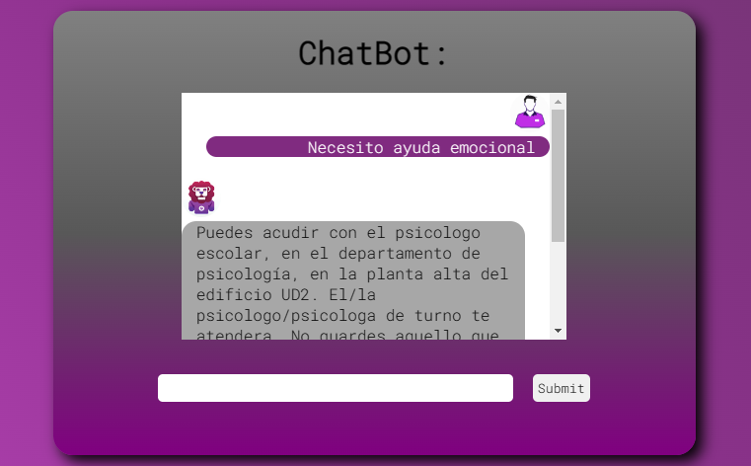
Source: Own elaboration
To illustrate how the Chatbot works, Figure 2 shows that, when entering a query about how to obtain a transcript, the Chatbot offers an indicative response, directing the user to the corresponding School Services area. However, before obtaining the certificate, the user is instructed to carry out a prior procedure on the Metronet platform (the university's internal system for managing various procedures). This process includes locating the paperwork area, selecting the payment option for the transcript and, once payment has been made, going to School Services to pick up the document.

Figure 2. Chatbot Proof of study
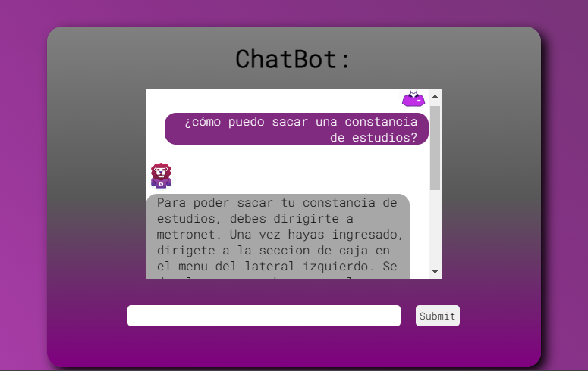
Source: Own elaboration
In the second stage, the chatbot application was implemented with the selected sample of students; in order to monitor and improve the interactions that students would experience during interaction, as well as to collect new questions that were not within their database.
After interacting with the chatbot, a questionnaire was administered to the students to share their experience. The results obtained from the questionnaire are presented below, which address the students' perception of their interaction with the chatbot. The collected data was organized in a matrix to carry out an analysis from multiple perspectives through triangulation. As a result of this process, various types of experiences related to the operation and interaction of the chatbot were identified, which are detailed in Table 4.

Table 4. Student evaluation of chatbot response efficiency.
Item | Yes | No
Communication with the chatbot was made easier for you? | 79% | 21%
The chatbot interface became friendly? | 81% | 19%
You felt confident using the chatbot? | 81% | 19%
Would you change the chatbot's design? | 21% | 79%
Source: Own elaboration
On the other hand, the effectiveness perceived by the students was observed by receiving faster answers to their questions from the chatbot compared to the answers from their tutors. The results are detailed in Table 5, where students expressed their satisfaction in obtaining quick responses from the chatbot. Additionally, they indicated that they prefer to wait for their tutor's response in person when the question is more complex and does not require an immediate response.

Table 5. Findings from the experience when interacting with the chatbot.
Item | Yes | No | When urgent | Prefer in-person tutor response
Do you consider it more efficient to get answers through the chatbot or wait to consult your tutor when they have free time? | 62% | 12% | 15% | 11%
Source: Own elaboration
After analyzing the students' interaction with the chatbot, it was observed that in certain cases the chatbot did not provide adequate answers, not matching the students' expectations, or even the questions were not formulated precisely. These findings are presented in Table 6, where the most frequent responses were grouped by topic and corresponding area. The purpose of this grouping was to identify areas of improvement and opportunities to retrain the chatbot, with the aim of correcting errors and improving its performance.

Table 6. Questions grouped by area where the chatbot did not answer correctly
Topic | %
Name of teachers, teachers' cubicle | 27%
Curriculum map, subjects, number of hours | 15%
What should I do if I have a competition, fail a course, or need to reschedule an exam? | 31%
Schedules, academic load | 27%
Source: Own elaboration
Based on the analysis of the results obtained, improvements have been made to the chatbot, taking into account the perspectives of the students during their interaction, as well as the suggestions they have presented. Below are some screenshots illustrating the improvements implemented in the chatbot.
The chatbot named "Leonora" is programmed to activate when a student initiates the conversation with a greeting or a question about how they can receive assistance. This behavior is illustrated in Figure 3, which shows the chatbot’s introduction and the information it can provide to help students with their university-related inquiries.

Figure 3. Chatbot presentation
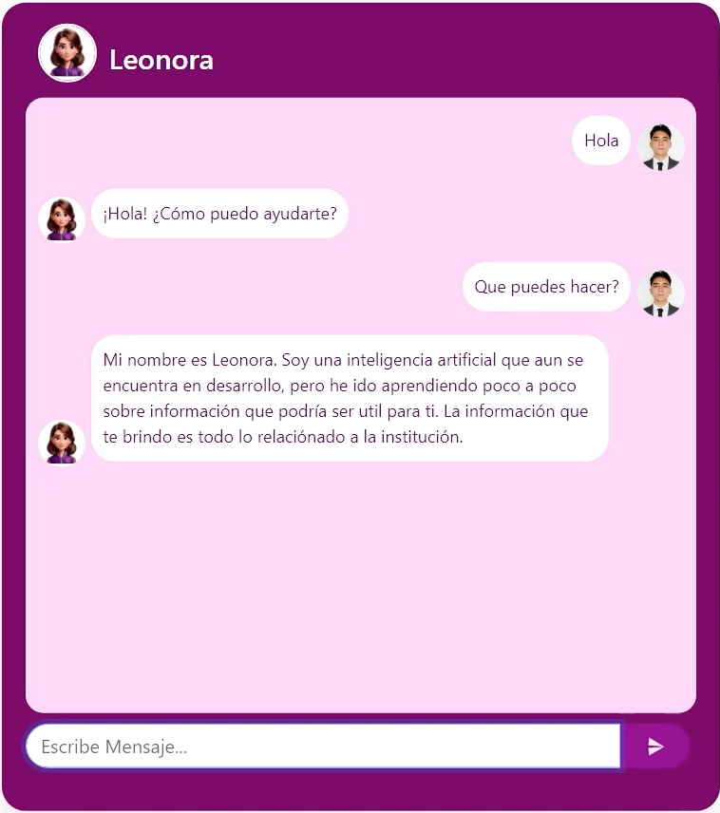
Source: Own elaboration
One of the most common questions students make refers to the process for requesting a transcript. Figure 4 illustrates the student's interaction with the chatbot by asking how to start this process and what the requirements are, including the corresponding payment.

Figure 4. Chatbot proof of study
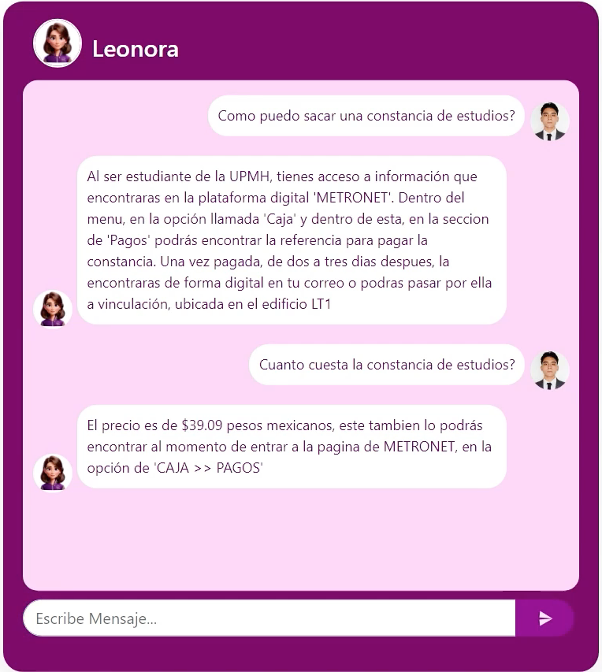
Source: Own elaboration
On the other hand, Figure 5 shows another query that students frequently ask: seeking support in medical and psychological services. In this interaction, the chatbot provides a brief explanation about the areas they should go to for medical assistance, as well as the people in charge of providing psychological support if necessary.

Figure 5. Chatbot medical care
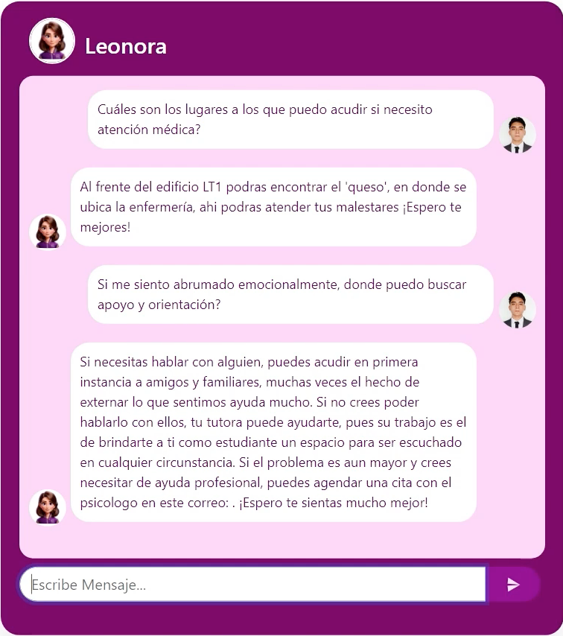
Source: Own elaboration
According to the results, The results suggest that the implementation of the chatbot has significantly improved and reduced response times to students' questions. Likewise, the use of the application has benefited students, which coincides with the findings of the research by Ortiz et al. (2022), in their project on chatbots as support in academic tutoring. In their study, students indicated that they used the chatbot outside of normal hours, and highlighted the speed with which they received answers to their questions. On the other hand, it was observed that the chatbot demonstrates a higher level of knowledge, based on the precision and effectiveness of its responses.

Discussion
Based on the findings from the form after interacting with the chatbot, it is notable that students found it more useful and faster to access the answers provided by the chatbot. In addition, the majority expressed feeling comfortable interacting with it. Some students suggested possible improvements, such as the inclusion of additional information to facilitate the location of teachers, subject syllabi, and academic workload. With these findings, the aim is to integrate new information to enrich the chatbot database and improve tutorial support, thus contributing to a more fluid and less stressful academic experience for students.
This approach streamlines students’ administrative processes, enabling timely and efficient management without the need to rely on external sources. Moreover, it offers the advantage of providing continuous support—24 hours a day, seven days a week—something that was previously limited to class hours and dependent on the tutor's availability.
As a result, by integrating the chatbot as a supportive technological tool in the tutoring processes, students reduce their dependence on tutors for routine consultations, contacting them only in critical situations, such as high levels of anxiety, frustration or stress. This model optimizes the workload of tutors, allowing them to provide more personalized and higher quality attention to students who require immediate assistance. Thus, an agile response is ensured during individual tutoring and, if necessary, referral to the psychological services department for specialized support is facilitated.
On the other hand, in the research by Anchapaxi et al. (2024), analyzed how chatbots and other artificial intelligence systems personalize teaching and monitor the progress of high school students in real time. The results obtained indicate that chatbots can improve interaction with learners, by offering immediate and personalized responses, which optimizes the learning process. In this way, it can be concluded that chatbots have proven to be valuable tools in both secondary and higher education settings, providing quick and adapted responses to benefit student learning.
In addition, Medrano et al. (2018) developed a chatbot to clarify students’ questions at any time during the course. The first tests showed very favorable results, since the questions were answered as expected. This new mechanism is not intended to replace traditional communication, but rather to enhance and complement it. Similarly, as with the chatbot implemented at UPMH, the goal is to expand and improve the handling of frequently asked questions that arise throughout students' academic journeys.

Conclusions
Based on the results obtained, the research question has been addressed through the successful implementation of a chatbot as a technological tool. This resource enables students to efficiently resolve common queries without having to wait for a scheduled tutoring session. In line with the study's objective, the development of the chatbot was analyzed as a technological support mechanism for tutoring processes. Designed to address students' most frequent questions, the system also facilitates continuity in administrative procedures by streamlining tasks and providing immediate responses.
The hypothesis has been confirmed: integrating the chatbot into tutoring processes has proven effective in resolving students’ recurring questions. As a result, students are able to progress in their academic and administrative tasks more autonomously, without depending on tutor availability or other external sources of support.
Additionally, the chatbot’s implementation allows for the simultaneous handling of multiple queries, significantly reducing the time and resources required for one-on-one attention. Students benefit from immediate assistance, eliminating the need to wait for in-person consultations.
A key advantage of this implementation is the ability to systematically collect data on students’ most frequent questions and the areas where they require more academic or administrative support. Analyzing this data enables the identification of patterns, recurring needs, and areas for improvement, thereby enhancing the quality of tutoring and contributing to better academic outcomes.
During the initial interactions, areas for improvement were identified, and new content was integrated into the chatbot’s database to further refine its performance. Student feedback indicates a positive reception and a sense of comfort in interacting with the chatbot, suggesting that it not only facilitates processes but may also help reduce stress associated with academic procedures.
It is important to highlight that the adoption of emerging technologies has proven highly beneficial across various educational institutions. Therefore, it is essential that students at our university also benefit from these innovations. The initial implementation of this technological tool was carried out within the Information Technology Engineering (ITI) and Animation and Visual Effects (IAEV) programs. However, its progressive adoption is planned across all academic programs at the university.
Finally, by providing students with access to the web-based chatbot application, its use has been initiated and continuously monitored. This ongoing process allows for the incorporation of new questions and answers, steadily enhancing its functionality and adaptability. We are committed to continuously improving the chatbot through regular analysis of user interactions and periodic updates to its knowledge base, ensuring a more effective and enriching user experience.

Future lines of research
Based on the results obtained, the goal is to continue monitoring the chatbot in order to expand and refine its database of questions and corresponding answers. This ongoing process will enable students to receive more accurate and relevant responses, supporting them in resolving any questions that may arise throughout their academic journey. Additionally, it is essential to continuously evaluate the chatbot’s performance. Therefore, a satisfaction survey will be conducted every six months among students to identify potential errors, gather feedback, and implement improvements to enhance its usability and effectiveness.

References
Adamopoulou, E., & Moussiades, L. (2020). An overview of chatbot technology. In Proceedings of the 16th International Conference on Artificial Intelligence Applications and Innovations (pp. 373–383). Springer. https://doi.org/10.1007/978-3-030-49186-4_31
Alan, D. & Cortez, L. (2018). Procesos y Fundamentos de la Investigación Científica [Processes and Fundamentals of Scientific Research]. UTMACH, Ecuador. Website: https://anyflip.com/kgwsu/zyde/basic#google_vignette
Anchapaxi, C., Pinenla, Y., Caiza, S., Parra, I., Abad, M. & Viñamagua, B. (2024). Uso de Chatbots educativos y su impacto en el aprendizaje autónomo en bachillerato [Use of educational Chatbots and their impact on autonomous learning in Baccalaureate]. Scientific Magazine Challenges of Science. 1(4) doi: http://doi.org/10.53877/rc.8.19e.202409.16
Boroel, B., Sánchez, J., Morales, K. & Henríquez, P. (2018). Educación exitosa para todos: la tutoría como proceso de acompañamiento escolar desde la mirada de la equidad educativa [Successful education for all: tutoring as a process of school support from the perspective of educational equity]. Sources Magazine. 20(2) doi: http://dx.doi.org/10.12795/revistafuentes.2018.v20.i2.06
Bullón, Y., Villanueva, J. & Huaranga, H. (2022). Educación virtual y el programa aprendo en casa, en condiciones desiguales, uso del chatbot para whatsapp [Virtual education and the I learn at home program, in unequal conditions, use of the chatbot for WhatsApp]. Latin Science Magazine, 6(1), 1-22. doi. https://doi.org/10.37811/cl_rcm.v6i1.1831
Charres, H., Villalaz, J. & Martínez, J. (2018). Triangulación: Una herramienta adecuada para las investigaciones en las ciencias administrativas y contables [Triangulation: An appropriate tool for research in administrative and accounting sciences]. FAECO sapiens Magazine. 1(1), 1-9. Website: http://portal.amelica.org/ameli/jatsRepo/221/2211026002/2211026002.pdf
Gallardo, E. (2017). Metodología de la Investigación [Investigation methodology]. Continental University. Huancayo. Website: https://repositorio.continental.edu.pe/bitstream/20.500.12394/4278/1/DO_UC_EG_MAI_UC0584_2018.pdf
García, A., López, M., & Torres, D. (2023). Conocimiento de los chatbots y su relación con la inteligencia artificial en contextos educativos universitarios [Understanding chatbots and their relationship with artificial intelligence in university educational contexts]. Ibero-American Journal of Technology in Education and Technology Education, (32), 15–25. Website: https://remcid.utgz.edu.mx/Archivos/Vol2/Articulo%202.1-6%20.pdf
Huaire, E. (2019). Research method. Class material. Academic. Website: https://www.aacademica.org/edson.jorge.huaire.inacio/35.pdf
Jain, M., Kumar, P., Kota, R., & Patel, S. N. (2018). Evaluating and informing the design of chatbots. In Proceedings of the 2018 CHI Conference on Human Factors in Computing Systems (pp. 1–12). ACM. https://doi.org/10.1145/3173574.3174214
Martínez, P., Pérez, J., González, N., González, C. & Martínez, M. (2021). La Tutoría universitaria vista por sus alumnos: Propuestas de mejora [University Tutoring as seen by its students: Proposals for improvement]. High School magazine, 49(1). Website: https://www.scielo.org.mx/scielo.php?script=sci_arttext&pid=S0185-27602020000300055
Medrano, J., Castillo, C. & Tejerina, M. (2018). Empleo de una Chatbot en el aula como herramienta de apoyo al proceso de enseñanza-aprendizaje [Use of a Chatbot in the classroom as a support tool for the teaching-learning process]. V Conference on Educational Innovation. 1(1). Website: https://www.researchgate.net/publication/344933328_EMPLEO_DE_UN_CHATBOT_EN_EL_AULA_COMO_HERRAMIENTA_DE_APOYO_AL_PROCESO_DE_ENSENANZA-APRENDIZAJE
Mongue, L. & Ávalos C. (2020). BOT0210, una herramienta de apoyo a la docencia. Experiencia de la Cátedra Tecnologías de la Información de la UNED, Costa Rica [BOT0210, a teaching support tool. Experience of the Information Technology Chair at UNED, Costa Rica]. Educational Innovations, 22(Special), 99.188. doi: https://doi.org/10.22458/ie.v22iEspecial.3196 Website: https://www.scielo.sa.cr/pdf/rie/v22s1/2215-4132-rie-22-s1-188.pdf
Múnera, M., Salazar, L. & Osorio, A. (2022). Estudio inicial de un chatbot para estudiantes de la modalidad virtual de la Escuela Interamericana de Bibliotecología [Initial study of a chatbot for students of the virtual modality of the Inter-American School of Library Science]. Library research, 36(1), 1-18 doi: https://doi.org/10.22201/iibi.24488321xe.2022.90.58452
Ortiz, G., Galindo, A., Martínez, B. & Gálvez. M. (2022) Chatbots como Apoyo a Tutorías Académicas en la Licenciatura en Sistemas Computacionales Administrativos de la Universidad Veracruzana Región Xalapa [Chatbots as Support for Academic Tutorials in the Bachelor's Degree in Administrative Computing Systems at the Universidad Veracruzana, Xalapa Region]. Magazine Interconectando Saberes, 14(1), 55-64. doi: https://doi.org/10.25009/is.v0i14.2760
Otzen, T. & Manterola, C. (2017). Técnicas de Muestreo sobre una Población a Estudio [Sampling Techniques on a Study Population], 35(1), 227-232 Sitio web: https://scielo.conicyt.cl/pdf/ijmorphol/v35n1/art37.pdf
Paredes, C. (2021). Chatbots en Educación Secundaria: Retos y propuestas para su aplicación en el aula [Chatbots in Secondary Education: Challenges and proposals for their application in the classroom]. Master's Thesis, University of Valladolid, 1(1), 1-12. Website: https://uvadoc.uva.es/bitstream/handle/10324/50989/TFM-G1530.pdf?sequence=1
Reina, M., Sánchez, J., & Delgado, L. (2024). Percepción del uso de chatbots como herramienta didáctica en la asignatura de TIC aplicadas a la Educación [Perceptions of the use of chatbots as a teaching tool in the subject of ICTs applied to Education]. Journal of Educational Innovation and Technology, 18(1), 55–67. Website: https://www.researchgate.net/publication/382448376_Chatbots_en_la_educacion_superior_la_mejora_del_desempeno_academico_en_un_terreno_de_desafios_y_oportunidades
Sánchez F. (2019). Fundamentos epistémicos de la investigación cualitativa y cuantitativa: consensos y disensos [Epistemic Foundations of Qualitative and Quantitative Research: Consensus and Dissent]. Digital Journal of Research in University Teaching, 13(1). Website: http://www.scielo.org.pe/scielo.php?pid=S2223-25162019000100008&script=sci_abstract
Sánchez, H., Reyes, C. & Mejía, S. (2018). Manual de términos en investigación científica, tecnológica y humanística [Manual of terms in scientific, technological and humanistic research]. Ricardo Palma University, Peru. Website: https://www.urp.edu.pe/pdf/id/13350/n/libro-manual-de-terminos-en-investigacion.pdf
Sánchez, M., Vega, M., Marín, C. & Hernández, J. (2017). Diseño e Implementación de una Plataforma Digital para la Gestión de Tutorías y su Impacto en la Deserción de Estudiantes de Nivel Superior [Design and Implementation of a Digital Platform for the Management of Tutoring and its Impact on the Dropout of Higher Level Students]. Computing and Information, 1(1). Website: https://www.redalyc.org/journal/5122/512253717008/html/
Torres, T. & Torquemada, A. (2017). El usos de las herramientas tecnológicas en la tutoría. Experiencias Universitarias [The use of Technological Tools in Tutoring. University Experiences]. National Educational Research Congress COMIE. Website: https://comie.org.mx/congreso/memoriaelectronica/v14/doc/0373.pdf
Zamora, J., Bello, S., Ortega, T. & Martín, M. (2020). Los Chatbosts como herramienta de apoyo a la enseñanza: una experiencia en el ambito jurídico [Chatbots as a teaching support tool: An experience in the legal field]. Educational Technologies and Teaching Strategies. 1-11. Website: https://accedacris.ulpgc.es/bitstream/10553/77957/1/Tecnologias_Educativas_Estrategias_Didacticas-682-692.pdf

