https://doi.org/10.23913/ride.v16i31.2596
Artículos científicos
Medición de los factores docentes que influyen en el rendimiento académico de matemáticas en estudiantes de preparatoria en México

Measuring Teacher-Related Factors Influencing the Academic Performance in Mathematics of High School Students in Mexico

Medindo os fatores que influenciam o desempenho acadêmico em matemática entre alunos do ensino médio no México

Elva Sinaí Gutiérrez-Guillén
Autonomous University of Querétaro, Faculty of Computer Science, Mexico
esinai@hotmail.com
http://orcid.org/0000-0003-1831-0157

Ricardo Chaparro-Sánchez
Autonomous University of Querétaro, Faculty of Computer Science, Mexico rchapa@uaq.mx
http://orcid.org/0000-0002-6842-2360

Efraín Soto-Bañuelos
Autonomous University of Zacatecas, Academic Preparatory Unit, Mexico
psefrasobe@gmail.com
http://orcid.org/0000-0002-2518-6660

Resumen
El objetivo de esta investigación fue determinar si los factores relacionados con los docentes son los que ejercen mayor influencia en el rendimiento académico en matemáticas de los estudiantes de preparatoria. Se analizaron tres factores principales: docentes, institución y alumnos, cada uno con sus respectivas variables. Para ello, se diseñaron dos cuestionarios, uno dirigido a estudiantes y otro a docentes, los cuales fueron aplicados a 75 alumnos de primer semestre, ya que en este periodo se registra la mayor tasa de reprobación en la asignatura de matemáticas, y a 5 docentes con 10 o más años de servicio, quienes cuentan con amplia experiencia en la enseñanza de la materia y profundo conocimiento de los desafíos y estrategias del proceso de enseñanza-aprendizaje. La muestra pertenece a la Preparatoria No. 1 de la Universidad Autónoma de Zacatecas, México. La investigación utilizó la aplicación APP VR Math (cuyo nombre hace referencia al uso de realidad virtual en el aprendizaje de las matemáticas), que emplea el método estadístico de Análisis de Componentes Principales y regresión lineal en un entorno de Realidad Virtual para identificar patrones de comportamiento entre las variables estudiadas. Los resultados mostraron que el factor docente, con variables como actualización, desinterés, vocación y compromiso, uso de herramientas tecnológicas y didácticas, asertividad y empatía, tuvo la mayor influencia en el rendimiento académico de los estudiantes en matemáticas. Además, se observó que, en la muestra de docentes con más de 10 años de experiencia, disminuyó el compromiso, la asertividad y el interés, mientras que aumentaba el desinterés.
Palabras clave: Factores, Rendimiento, Matemáticas, Docentes, Preparatoria, PCA, Realidad Virtual

Abstract
The objective of this research was to determine whether teacher-related factors exert the greatest influence on high school students' academic performance in mathematics. Three main factors were analyzed: teachers, institution, and students, each with its respective variables. To achieve this, two questionnaires were designed, one for students and one for teachers. The questionnaires were administered to 75 first-semester students, as this period shows a higher failure rate in mathematics, and to 5 teachers with 10 or more years of service, as they possess extensive experience in teaching the subject and a deep understanding of the challenges and strategies of the teaching-learning process. The sample belongs to Preparatoria No. 1 of the Universidad Autónoma de Zacatecas, Mexico. The research utilized the APP VR Math application, which employs the Principal Component Analysis method and linear regression in a Virtual Reality environment to identify behavior patterns among the studied variables. The results showed that the teacher factor, with variables such as professional development, disinterest, vocation and commitment, use of technological and instructional tools, assertiveness, and empathy, had the greatest influence on students' academic performance in mathematics. Additionally, it was observed that in the sample of teachers with over 10 years of experience, a decline was observed in commitment, assertiveness, and interest, while disinterest increased.
Keywords: Factors, Performance, Mathematics, Teachers, High School, PCA, Virtual Reality.

Resumo
O objetivo desta pesquisa foi determinar se os fatores relacionados ao professor exercem a maior influência no desempenho acadêmico de alunos do ensino médio em matemática. Três fatores principais foram analisados: professores, instituições e alunos, cada um com suas respectivas variáveis. Para isso, foram elaborados dois questionários, um para alunos e outro para professores. Esses questionários foram aplicados a 75 alunos do primeiro semestre, já que esse período registra a maior taxa de reprovação em matemática. Os questionários também foram aplicados a cinco professores com 10 ou mais anos de experiência, que têm ampla experiência no ensino da disciplina e profundo conhecimento dos desafios e estratégias do processo de ensino-aprendizagem. A amostra foi da Escola Secundária nº 1 da Universidade Autônoma de Zacatecas, México. A pesquisa utilizou o aplicativo VR Math (cujo nome faz referência ao uso da realidade virtual na aprendizagem de matemática), que emprega o método estatístico de Análise de Componentes Principais e regressão linear em um ambiente de Realidade Virtual para identificar padrões de comportamento entre as variáveis ​​estudadas. Os resultados mostraram que o fator professor, com variáveis ​​como situação atual, desinteresse, vocação e comprometimento, uso de ferramentas tecnológicas e didáticas, assertividade e empatia, teve a maior influência no desempenho acadêmico dos alunos em matemática. Além disso, observou-se que, na amostra de professores com mais de 10 anos de experiência, o comprometimento, a assertividade e o interesse diminuíram, enquanto o desinteresse aumentou.
Palavras-chave: Fatores, Desempenho, Matemática, Professores, Ensino Médio, ACP, Realidade Virtual.
Fecha Recepción: May 2025 Fecha Aceptación: September 2025

Introduction
Mathematics performance has been widely studied due to its importance in school achievement and its long-term impact on academic and professional development. In high school education, mathematics represents a particular challenge, as its abstract nature and complexity are seen as significant obstacles to learning by students (OECD, 2019). This situation can be observed globally, as well as in Mexico, where failure rates in mathematics are consistently high (INEE, 2019; Molero-Castillo et al., 2018). In this context, it is essential to identify the factors affecting academic performance in order to design pedagogical strategies that improve outcomes.
Various international studies have indicated that performance in mathematics is influenced by a combination of factors related to both the educational environment and the individual characteristics of students. Globally, assessments from the Programme for International Student Assessment (PISA) have highlighted the importance of teaching quality, pedagogical resources, and institutional support in students' academic outcomes (OECD, 2019). These assessments suggest that improving performance in mathematics requires a comprehensive approach that considers not only the cognitive aspects of learning but also emotional and motivational factors. Research has shown that elements such as prior mathematical preparation, confidence, and anxiety play a crucial role in students' success in mathematics courses (Clement, 1984; Anthony, 2000). In particular, structural equation modelling studies have highlighted how academic and social factors interact to influence mathematics achievement at different educational levels (Mosia et al., 2025).

Factors Influencing Academic Performance in Mathematics
Academic performance in mathematics is influenced by a variety of interrelated factors that can be grouped into three main categories: institutional factors, factors related to teachers, and individual student factors. These elements interact in a complex and dynamic way, affecting both the learning of mathematical concepts and students' performance on standardized assessments and internal exams.

Factors Related to Teachers
Teacher-related factors include the quality of teaching, teachers' mastery of mathematical content, their level of pedagogical preparation, and their ability to implement effective teaching strategies that cater to the diverse needs of students (Hanushek & Rivkin, 2010). Teachers with a high degree of specialization in mathematics and adequate pedagogical training are able to create a more inclusive and dynamic learning environment, thereby facilitating students’ development of problem-solving skills and critical thinking (Darling-Hammond, 2015; Lozano & Maldonado, 2021).
Furthermore, teachers' ability to foster interest and motivation in students plays a crucial role. Studies have shown that when teachers create an appropriate motivational environment, students tend to have a more positive attitude towards mathematics, resulting in better academic outcomes (Kyriakides et al., 2009). Research in mathematics education emphasizes the importance of instructional strategies and student engagement, which have been linked to better performance (Pizon & Ytoc, 2021).

Individual Student Factors
Among individual factors, motivation and self-confidence are key determinants of success in mathematics (Carballo Aguilar, 2016). Students with intrinsic motivation towards learning often show a greater commitment to academic tasks, allowing them to overcome the inherent challenges of the subject and achieve a higher level of conceptual mastery (Ryan & Deci, 2000). Similarly, self-confidence, or the student’s perception of their ability to overcome the challenges presented by the subject, is fundamental. Students with greater confidence in their mathematical abilities tend to persevere more in problem-solving and demonstrate more consistent performance (Pajares & Graham, 1999).
Conversely, mathematics anxiety has been found to negatively impact academic performance, creating cognitive barriers that prevent students from effectively applying their knowledge (Molina et al., 2022). Research also shows that students from social sciences backgrounds often struggle with mathematics, reporting lower confidence and higher anxiety levels (Brezavšček et al., 2020).

Institutional Factors
Institutional factors also have a direct impact on performance in mathematics. Educational infrastructure, which includes access to technological resources and teaching materials, is essential for creating a conducive learning environment. Schools equipped with advanced educational technologies, such as virtual laboratories or interactive simulations, facilitate more active learning and allow students to explore complex mathematical concepts visually and interactively (OECD, 2019). This is particularly relevant in mathematics teaching, where the abstraction of concepts can be challenging, and the use of technology can help visualize and manipulate abstract concepts more tangibly.
Furthermore, educational policies and school management influence student performance. Academic support programs that include personalized tutoring and academic counselling can significantly contribute to improving outcomes, especially for students who face difficulties in mathematics. Schools that promote an inclusive learning environment and have clear policies that support teachers through ongoing training and provision of pedagogical resources, tend to improve not only performance in mathematics but also overall student achievement (Leithwood et al., 2010a).

Statistical Analysis of Academic Performance Factors
The study of academic performance in mathematics requires a rigorous analysis to identify and quantify the most influential factors in student outcomes. Among these are Principal Component Analysis and linear regression, tools effective in extracting significant patterns from large datasets.
Principal Component Analysis (PCA) is a multivariate technique that reduces the dimensionality of datasets by identifying variables that explain most of the variability in outcomes (Jolliffe & Cadima, 2016). This dimensionality reduction is crucial in educational contexts, where the factors influencing academic performance can be multiple and complex. By using PCA, information can be synthesized into a reduced number of principal components, facilitating interpretation without losing essential information.
Linear regression is another fundamental statistical technique used to model the relationship between a dependent variable, such as academic performance, and one or more predictor variables, such as teaching strategies or students' individual characteristics (Montgomery et al., 2012). This model quantifies the impact of each independent variable on academic performance, providing both the direction (positive or negative) and magnitude of that relationship.
The use of these advanced statistical methodologies has significantly advanced the understanding of the factors influencing academic performance in mathematics. Together, PCA and linear regression offer a comprehensive view: PCA reduces complexity, while regression interprets causal relationships. Studies have used these techniques to identify the most critical factors influencing mathematics achievement, revealing that instructional strategies and student engagement are among the strongest predictors of success (Pizon & Ytoc, 2021).
The incorporation of emerging technologies, such as Virtual Reality (VR), offers new opportunities for analysing and visualizing the factors influencing academic performance. Virtual reality enables the creation of immersive three-dimensional environments where complex data can be represented interactively, enhancing the understanding of relationships between variables (Freina & Ott, 2015). In the educational field, virtual reality has begun to be used as an analytical tool, allowing researchers to explore patterns and trends in academic performance from a more intuitive and visual perspective (Merchant et al., 2014; Barrientos et al., 2023).
This study aimed to use virtual reality as a means to visualize the factors influencing academic performance in mathematics. Through this technology, it is expected that educators and educational administrators will be able to identify more efficiently areas for improvement and design more effective pedagogical interventions.
The main objective of this study was to determine whether factors related to teachers are the most influential on students' academic performance in mathematics. Additionally, other factors such as students' interest and motivation, as well as institutional characteristics that could affect learning, were also examined. Based on the results, this study seeks to contribute to the development of pedagogical strategies that enhance the teaching-learning process in high school mathematics.

Methods
The data analysis methodology was based on two key statistical procedures that enabled the identification of group behavior patterns among the studied variables. In the first phase, Principal Component Analysis (PCA) was applied, a statistical technique that transforms a set of possibly correlated variables into a smaller set of uncorrelated variables called principal components (Aboagye & Mensah, 2016; Mishra et al., 2017). This technique reduces the dimensionality of the data while retaining as much information as possible (Boqué & Ferré, 2004). The significance of the main components was evaluated by analyzing the variables with the highest loadings in the key factors. PCA is particularly useful for visualizing the underlying structure of the data and thereby simplifying interpretation.
Subsequently, linear regression, which measures the relationship between a dependent variable and one or more independent variables (Carrasquilla-Batista et al., 2016; Hasanah et al., 2022). This approach allowed for the quantification of how teacher-related, institutional, and student factors influence academic performance in mathematics. Linear regression was essential for identifying the magnitude and direction of the relationships among the variables, allowing predictions of outcomes based on the available data.
The visual analysis included scatter plots and biplots generated from the PCA, which clearly showed the correlation and grouping of variables. These graphs provided a visual representation (Cárdenas & Vicente-Villardón, 2007; Estepa Castro, 2008) of the interactions between students and teachers, which facilitated the identification of consistent patterns among the responses obtained in the questionnaires. The representation in a Virtual Reality environment through the APP VR Math software offered an innovative way to explore the data, allowing researchers and participants to visualize behavior patterns in an immersive, three-dimensional manner.
The statistical analysis was conducted in two phases. In the first phase, RStudio software was used, a platform widely used in statistical analysis and data visualization. RStudio facilitates the implementation of procedures such as PCA and linear regression through its integrated development environment (IDE), allowing for advanced computations and efficient graph generation. Through this software, the data collected from the questionnaires were processed, and the initial analysis of the factors was conducted.
After this initial analysis, the second phase employed APP VR Math, a tool developed specifically for this project, which was developed for Android devices. It includes specific sections to enter data on students, mathematics teachers, and institutions and in real time performs the Principal Component Analysis, visually detecting the variables that most influence student learning This application made it possible to validate and complement the results obtained in the previous phase, and not only confirmed the patterns detected in traditional statistical analysis but also provided an interactive visual representation of the data in Virtual Reality, facilitating the understanding of how different factors affect students' learning. The combination of both environments, RStudio for statistical analysis and APP VR Math for visual validation, provided a robust and multifaceted methodology for studying the influence of teacher-related factors on academic performance.

Instrument and Procedure
During the 2023/24 academic year, the questionnaires were designed and validated through expert judgment (knowledge coefficient method). The selected items have been adapted from the works of various authors and previous research activities (Gutiérrez-Guillén et al., 2023) using the model for identifying factors that influence mathematics learning (see Table 1).

Table 1. Dimensions of the questionnaires
Dimension | Variables | Attributes
Students | Achievement | Level of understanding and performance in mathematics
Students | Type of Secondary School | School of origin (public or private)
Students | Learning Styles | Preference for visual, auditory, theoretical, or pragmatic learning
Students | Interest | Degree of interest in the subject of mathematics
Students | Motivation | Drive to improve academic performance
Students | Apathy | Degree of indifference towards the subject
Students | Laziness | Tendency to avoid effort in academic tasks
Students | Attitude | General disposition towards learning
Students | Anxiety | Degree of nervousness or stress related to mathematics
Students | Beliefs | Perceptions of the importance or difficulty of mathematics
Students | Distress | Level of distress or frustration in learning situations
Students | Mathematical Skills | Level of ability to solve mathematical problems
Students | Practice | Frequency of exercises or problems solved
Students | Study Hours | Time dedicated to studying mathematics outside of class
Students | Note-taking | Efficiency and method in note-taking during classes
Students | High School program | High school education program attended
Students | Professional career | Orientation or area of interest for future studies
Teachers | Teaching | Level of experience considering years of service
Teachers | Disciplinary Area | Specialization in mathematics or other disciplines
Teachers | Level of Study | Highest academic degree attained
Teachers | Technological Tools | Use of technological resources in teaching
Teachers | Instructional Tools | Use of strategies and teaching materials
Teachers | Professional Development | Participation in courses and continuous training programs
Teachers | Evaluation | Assessment of teacher performance
Teachers | Empathy | Ability to understand and address students' needs
Teachers | Disinterest | Lack of motivation or commitment to teaching
Teachers | Vocation/Commitment | Degree of dedication to the role of educator
Teachers | Communication | Efficiency in conveying ideas and concepts
Teachers | Assertiveness | Ability to express opinions clearly and respectfully
Teachers | Negotiation | Skill in resolving conflicts collaboratively
Teachers | Conflict Management | Strategies for handling problematic situations in the classroom
Institutional | Curriculum | Academic curriculum and content
Institutional | Planning and Monitoring | Organization of educational activities and their monitoring
Institutional | Programs | Initiatives and projects for academic support
Source: Own elaboration.
The questionnaires were part of the research project "Parametric model of virtual reality visualization of learning indicators in mathematics for high school students" (Project registration No. 13698). The questionnaires were subjected to a reliability test (Cronbach's alpha = .969) and were distributed in compliance with data protection regulations. Prior was obtained from both the institution and the participants for their in-person administration.

Sample
The study population consisted of high school students and teachers from the Preparatory Academic Unit Program No. 1 of the Autonomous University of Zacatecas, Mexico. The probabilistic sample was composed of 75 students and 5 teachers who completed the instrument in person at the educational center. Of the students, 56.4% were female and 43.6% were male, with an average age of 16.3 years. In the case of the teachers, 80% were male and 20% were female, with an average age of 47.9 years. This reflects the gender distribution observed in both education and the profession. The sample was considered representative due to its size, age, and gender distribution. For a total student population of 320 using the Cochran’s formula, with a margin of error of 10% and a confidence level of 95%, 75 subjects were required. As for the teachers, with a total sample of 5 mathematics teachers, a margin of error of 10%, and a confidence level of 95%, 5 subjects were required.

Data Analysis
The data were structured as a comprehensive dataset comprising values from the study instrument. Each record represented responses from either students or teachers, with variables organized according to key dimensions outlined in the questionnaire. Each row in the dataset corresponded to an individual participant’s responses, while each column represented a specific variable or attribute from the instrument, including both quantitative measures (e.g., study hours, frequency of practice) and categorical variables (e.g., type of secondary school, high school program). This structured format facilitated straightforward data entry, processing, and analysis, allowing for efficient identification and comparison of variable patterns across the study’s sample.
The dataset’s organization enabled a thorough examination of teacher-related, institutional, and student factors influencing mathematics performance, providing a robust framework for statistical analysis.

Results

Principal Component Analysis
The Principal Component Analysis (PCA) provide an overview of how much variance each principal component captures from the dataset, highlighting the importance of these components in explaining the relationships among variables. Figure 1 presents PCA results, summarizing standard deviation, proportion of explained variance, and cumulative variance for each component.
The first component, PC1, stands out with a standard deviation of 5.362, accounting for 38.31% of the total variability, capturing the largest portion of variance in the data. This suggests that PC1 encompasses key variables that differentiate patterns in academic performance, making it highly influential in explaining the structure of the dataset. Following PC1, PC2 and PC3 contribute additional explained variances of 9.33% and 5.96%, respectively. Together, these first three components account for 53.59% of the cumulative variance, meaning they jointly represent over half of the dataset’s variability. This indicates that a large portion of the underlying data patterns can be captured by these three components, underscoring their relevance.
As the analysis incorporates further components beyond PC3, the incremental increase in explained variance declines. However, by including the first 10 components, approximately 72.52% of the cumulative variance is captured, showing that much of the data structure can be represented with a limited number of principal components. This reduction allows for a more manageable analysis without significant loss of information, as these top components retain most of the critical patterns related to teacher, institutional, and student factors influencing academic performance in mathematics.

Figure 1. Principal Component Analysis
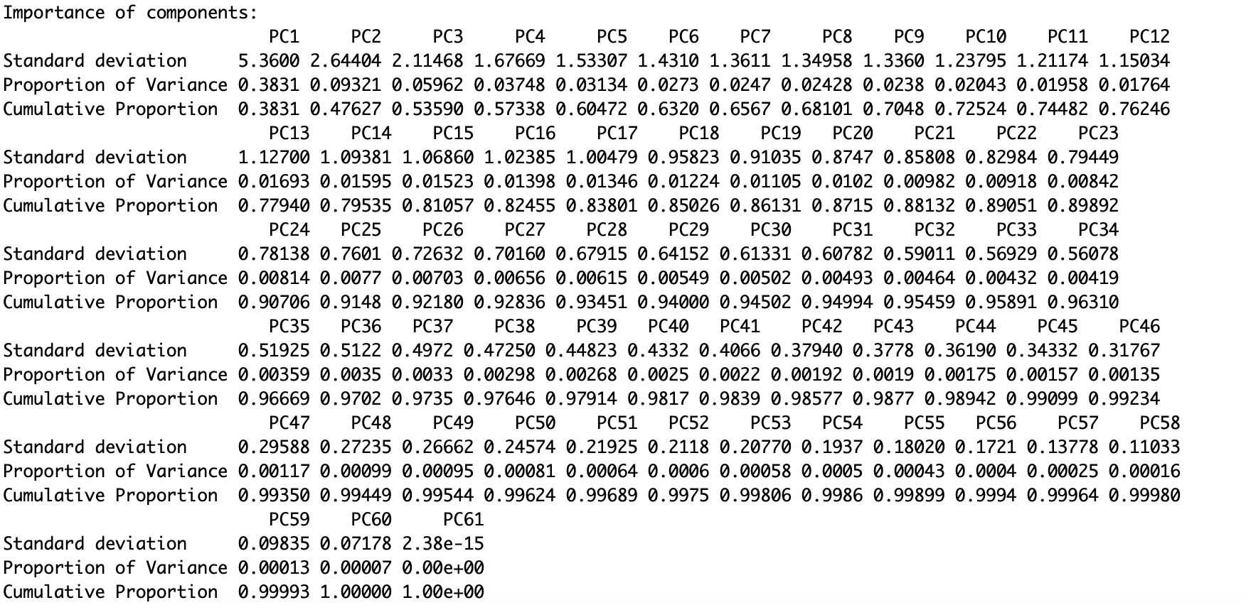
Source: Authors’ elaboration based on data

Linear Regression
The linear regression analysis presented in Figure 2 visualizes how different learning indicators—categorized into teacher, institution, and student factors—correlate with students' academic performance in mathematics. Also, shows clustered data points with some outliers, revealing atypical cases among the participants.
A closer look at the teacher-related factors shows a distinct, consistent trend line with minimal deviation, indicating a strong linear relationship between these factors and students' academic performance. This pattern suggests that variables such as teacher experience, use of technological tools, and communication skills and others, are highly predictive of student success in mathematics. The close fit of the data points to the trend line highlights the substantial influence of teachers on learning outcomes, establishing teacher-related indicators as reliable predictors in the model.
In contrast, the institutional and student-related factors exhibit greater variability, with data points more widely dispersed around the trend line. This dispersion implies a weaker linear correlation, suggesting that variables within these categories—such as institutional resources, curriculum design, and individual student characteristics (e.g., motivation, learning styles)— show weaker linear associations in predicting academic performance. The increased spread may reflect a range of external or unmeasured factors influencing these categories, such as variations in institutional resources or students' unique backgrounds, which contribute to the complexity and variability in the data.
Figure 2. Linear Regression of the data
Source: Authors’ elaboration based on data

Data Dispersion and Biplot
To obtain a more complete and detailed evaluation of the variability and relationships between the variables in the context of learning indicators in mathematics, a visual analysis was conducted using data scatter plots along with the biplot.
Figure 3 illustrates the grouping and dispersion of data points based on principal components (PC1 and PC2), helping to visualize the variability and relationships among the institution, teacher, and student categories.
In this plot, the teacher category is shown in green, the student category in yellow, and the institution category in blue. The teacher and student categories form relatively distinct clusters, meaning that data points within these categories share common characteristics and cluster closely together. This indicates that the variables related to teacher and student factors have more consistent patterns. However, each category also contains some outliers, or data points that deviate noticeably from the central grouping patterns.
The institution category, represented by blue data points, is more widely dispersed. This broader spread suggests that institutional factors vary more significantly within this dataset, possibly reflecting differences in resources, policies, and other structural aspects across institutions.
The distribution of data points within the teacher and student categories suggests that internal factors, such as teaching quality, the use of technological tools, and students’ emotional conditions, among other factors, contribute to variability within each category. This observed dispersion emphasizes the multi-dimensional nature of these factors and their influence on academic performance in mathematics, underscoring the complex interplay between various internal and external influences.

Figure 3. Data dispersion
Source: Authors’ elaboration based on data.
The biplot (see Figure 4) provides a richer visual representation, showing the projections of the original variables (indicators) onto the first two principal components (PC1 and PC2). The vectors from the origin represent the direction and magnitude of variable loadings to the principal components.
In this analysis, the length and orientation of the arrows suggest the correlation between the learning indicators and the factors. The variables associated with the teachers appear more aligned with the main dimensions, indicating that these variables have a greater influence in explaining variability in the data. The longer vectors pointing toward the students’ areas indicate that the indicators in this category also have significant influence, though their direction is more dispersed, suggesting greater complexity or variability in the factors affecting students.

Figure 4. Biplot of the data
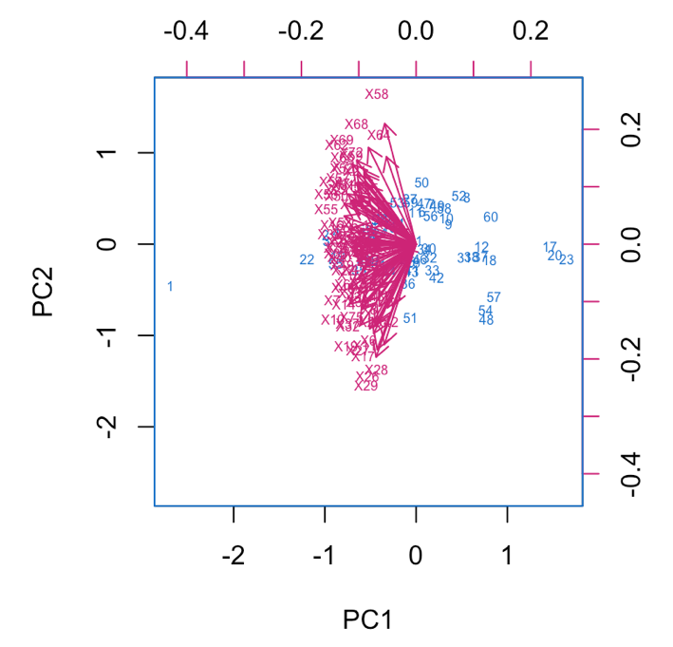
Source: Authors’ elaboration based on data.
The biplot also reveals that factors related to teachers tend to be more heavily loaded on the first principal components, reinforcing the hypothesis that teachers play a central role in explaining differences in academic performance in mathematics. The vectors for students, on the other hand, show greater dispersion, suggesting that the influences on student performance may be more heterogeneous and dependent on multiple factors.
Overall, the results from the data dispersion analysis and the biplot confirm that the teacher category plays a key role in the variation of outcomes, while the institution and student categories exhibit greater dispersion, indicating that multiple variables influence these areas. Representing the data in this format facilitates identifying underlying relationships and clarifies determining factors in mathematics learning.

VR visualization
The visual analysis concluded with the use of APP VR Math in a Virtual Reality environment, utilizing the first three principal components (PC1, PC2, and PC3) extracted from the PCA, offering a three-dimensional representation that allowed for a more intuitive visualization and understanding of the relationships and patterns among the studied variables. APP VR Math provided an interactive three-dimensional visualization of the first three principal components. This approach overcomes the limitations of traditional two-dimensional representations by facilitating the identification of groupings, outliers, and directions of influence that would be less evident in a flat graph.
Figure 5 shows the clustering of teacher-related data points, shown in green, is visually distinct and relatively uniform. This concentrated grouping indicates a more consistent pattern among teacher factors, reinforcing their clear predictive impact on student outcomes in mathematics. The homogeneity among these data points suggests that teachers who share characteristics such as using specific teaching tools or demonstrating high engagement show positive correlations with student performance.

Figure 5. VR Visualization
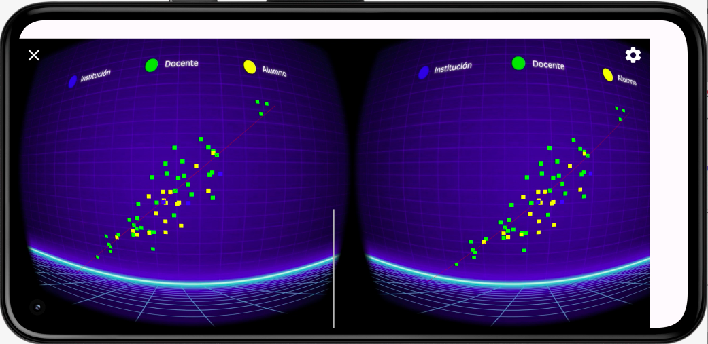
Source: Authors’ elaboration based on data.
In contrast, student-related factors (yellow points) are more dispersed across the three-dimensional space (see Figure 6), reflecting the diversity among student attributes such as emotions, study habits, and personal motivation. This greater variability suggests that student factors do not follow a consistent pattern, highlighting the challenges in predicting or uniformly influencing academic outcomes based on these characteristics alone. The distribution of institutional factors (blue points) also shows noticeable dispersion, although less so than student factors.

Figure 6. VR Visualization
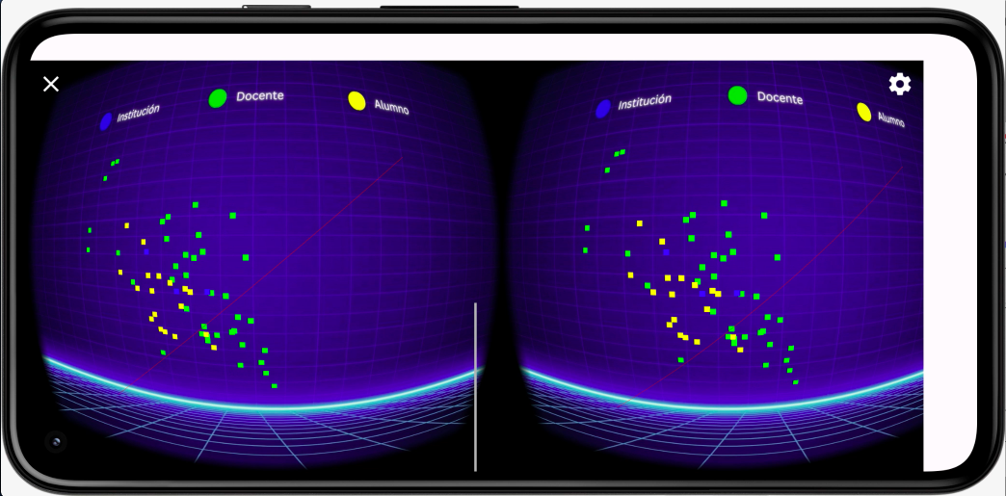
Source: Authors’ elaboration based on data.
The VR visualization also allowed observation of the direction of the vectors in space, providing a richer interpretation of how teaching factors indirectly affect students. For example, the directions of the vectors related to students largely aligned with the teaching vectors, suggesting that changes in teaching quality can directly translate into improvements in student outcomes.

Teachers Dimension Analysis
Finally, the analysis revealed that the variables that most influence academic performance in mathematics at the preparatory level, within the teachers’ dimension, are as follows:
- Professional Development: Continuous training for teachers, as well as their ability to stay updated on pedagogical and disciplinary innovations, plays a crucial role in improving student performance. An informed teacher can implement more effective teaching strategies tailored to the changing needs of students.
- Disinterest: Teacher disinterest in their educational role negatively affects student performance. Teacher apathy reduces the stimulation of the learning environment, reducing student engagement and interest in the subject.
- Vocational/Commitment: The vocation for teaching and the level of commitment to instruction are determining factors that influence the quality of teaching. Committed teachers who are passionate about their work often adopt more dynamic and effective pedagogical approaches, leading to higher academic performance among students.
- Technological Tools: Teachers who adequately integrate technological tools into their classes enable students to visualize and comprehend complex mathematical concepts more accessibly.
- Instructional Tools: The use of innovative methods and teaching materials, such as project-based learning or cooperative learning, facilitates understanding of mathematical content and promotes deeper, lasting learning. Teachers who master various teaching techniques tend to be more effective in the classroom.
- Assertiveness: Teachers' ability to communicate clearly and directly, establishing precise expectations and boundaries, significantly influences the learning environment. Assertiveness fosters greater discipline in the classroom and a more productive relationship between teachers and students, contributing to academic success.
- Empathy: Teacher empathy, understood as the ability to understand and emotionally connect with students' concerns and needs, fosters a supportive and trusting environment. Students who feel understood and supported tend to engage more in their learning, improving their performance in mathematics.

Discussion
This study allowed the identification and analysis the key factors influencing the academic performance of preparatory students in mathematics, with a special emphasis on the dimensions of teachers, students, and institutions. Through advanced techniques such as Principal Component Analysis, linear regression, and visualization in a Virtual Reality environment, provided a deeper understanding of how these factors interact has been achieved.
The analysis underscores the central role of teachers dimension in influencing students’ academic performance in mathematics. The findings align with existing literature (Hanushek & Rivkin, 2010) which emphasizes that teachers’ expertise, pedagogical strategies, and emotional support are essential for student success. In this study, variables such as professional development, the use of technological and instructional tools, assertiveness, and empathy were found to significantly influence student outcomes. This reinforces the theory that the quality of teaching, both in terms of content mastery and interpersonal relationships, directly shapes students’ academic experiences (Kyriakides et al., 2009).
Previous studies further revealed this finding, indicating the key role of teachers' pedagogical content knowledge and their ability to foster emotional connections with students. Research shows that high-quality teaching is one of the most significant predictors of student success (Darling-Hammond, 2015), which is consistent with the findings of this study.
The use of technological tools and innovative pedagogical methods, such as project-based learning, proved essential in enhancing students’ understanding of mathematical concepts. These results are consistent with the views of Tomlinson (2014), who suggests that differentiated instruction and the integration of technology allow teachers to address the diverse learning needs of students.
Although teacher-related factors were found to have a predominant impact on performance, student-related factors such as motivation, self-confidence, and emotional state also played a significant role, albeit with more variability. This finding corresponds with the work of Pajares & Graham (1999) and Ryan & Deci (2000), who highlight that intrinsic motivation and self-belief are critical to academic success. However, in this study, these factors exhibited a wider range of outcomes, suggesting that personal characteristics and emotional factors may be more heterogeneous and more difficult to predict than the more structured aspects of teaching quality.
Institutional factors, while important, showed less direct correlation with student performance in mathematics compared to teacher and student factors. Educational infrastructure, while facilitating learning, showed less consistent effects in its impact on performance, reflecting the complex and multifaceted nature of institutional influences discussed by Leithwood et al. (2010b). The variability within this category could stem from differences in the implementation of educational policies or the uneven distribution of resources across institutions.
The results from PCA and linear regression supported the theory that academic performance is a product of multiple interacting variables. The statistical models revealed a stronger, more coherent relationship between teaching-related variables and academic outcomes, aligning with previous studies that prioritize teacher effectiveness as the most influential factor in student achievement (Hanushek, 2011). The linear regression analysis confirmed that the predictors related to teaching were the most consistent, suggesting that efforts to improve teaching quality should be a primary focus in enhancing academic performance in mathematics.
The visualizations in the VR environment provided an innovative way to illustrate these relationships. By allowing for a three-dimensional representation of the factors, APP VR Math provided a more tangible representation of interactions, providing new insights into how teachers, students, and institutions interrelate. This approach aligns with the theoretical framework of data visualization and immersive technologies in education (Freina & Ott, 2015; Merchant et al., 2014), demonstrating how VR can be a powerful tool for understanding complex educational data and making it more accessible for decision-makers.
These findings have significant implications for educational practice. First, they reinforce the need for continuous professional development for teachers, particularly in terms of pedagogical strategies and technological integration. Investing in teachers’ capacity to integrate technologies and foster supportive relationships with students can have a profound impact on student success in mathematics. Furthermore, addressing the emotional and motivational needs of students should also be considered, as these factors also contribute to their academic performance, albeit with more individual variability.
The study also suggests that while institutional factors are important, targeted efforts to improve the quality of teaching may yield more immediate and measurable improvements in student performance. This aligns with the theory that teaching quality is one of the most consistent and direct predictors of academic success.

Conclusions
This study identified the key factors influencing academic performance in mathematics among high school students. Particular emphasis was placed on teacher-related variables. The research confirmed that teacher-related factors, including professional development, use of technological and instructional tools, assertiveness, empathy, and overall commitment, have the greatest impact on students' academic performance. These findings align with existing literature emphasizing the central role of teachers in shaping educational outcomes.
Student-related factors, such as motivation and self-confidence, were also recognized as significant, but the variability in their measured impact suggests that they are less predictable and more difficult to influence than teacher-related factors. Furthermore, while institutional factors contribute to the learning environment, their direct impact on student performance was found to be less consistent compared to teacher-related factors.
The APP VR Math application, leveraging Principal Component Analysis and linear regression in a Virtual Reality environment, provided an innovative approach to analysing complex relationships between variables. The immersive nature of VR not only facilitated a deeper understanding of how teacher, student, and institutional factors interrelate and highlighted the potential of virtual environments in educational research and decision-making.
In conclusion, the findings emphasize the need for targeted efforts to improve teaching quality as a primary strategy for enhancing student performance in mathematics. Continuous professional development for teachers, coupled with the integration of technology and the fostering of supportive teacher-student relationships, should be prioritized. By focusing on these areas, educational institutions can create a more effective and supportive learning environment, thereby improving academic outcomes.

Future lines of research
Based on the results, several areas emerged that, although not addressed in depth in this study, showed strong potential for future research. First, it would be relevant to analyze the longitudinal impact of teacher professional development. In particular, future studies could evaluate how different modalities of continuing education consistently influence pedagogical practice and student academic outcomes. Likewise, the study of teacher motivation and its evolution over time represents a promising line of research, as teacher engagement and disengagement have been shown to have significant effects on learning but requires more dynamic and contextualized exploration.
Another line of interest lies in a more detailed exploration of the use of technological and instructional tools. It would be valuable to investigate which specific types of educational technologies are most effective in teaching mathematics, especially in diverse educational contexts. Likewise, it would be pertinent to further analyze the impact of teacher empathy and assertiveness across diverse sociocultural and socioeconomic contexts, to determine the extent to which these interpersonal skills influence the classroom climate and students' academic performance.
Furthermore, the interaction between students' emotional factors and teaching strategies deserves special attention. Although these elements were identified as relevant, their relationship with pedagogical practice remain underexplored, so future research could examine how specific teaching styles enhance or constrain these factors.
Finally, although institutional variables did not show as consistent an influence as the teacher or student dimensions, a more detailed disaggregation of these variables is recommended, considering aspects such as principal leadership, organizational climate, and managerial autonomy. This would allow a more precise understanding of which structural elements of the school environment have a real impact on mathematics performance. Taken together, these future research lines open new possibilities for deepening our understanding of the educational phenomenon and designing more effective, sustainable, and contextualized interventions.

Acknowledgments
Funding: This research was funded by the Consejo Nacional de Humanidades, Ciencias y Tecnologías (CONAHCYT), Mexico.

References
Aboagye, E. A., & Mensah, C. (2016). Principal component analysis of students’ academic performance in mathematics and statistics. American Based Research Journal, 5(10). https://doi.org/10.5281/zenodo.3441775
Anthony, G. (2000). Factors influencing first-year students' success in mathematics. International Journal of Mathematical Education in Science and Technology, 31(1), 3-14. https://www.tandfonline.com/doi/abs/10.1080/002073900287336
Barrientos Maldonado, J. N., Parra-González, E. F., Zurita-Aguilar, K. A., & Avila-George, H. (2023). Assessing the impact of virtual reality on mathematics teaching in rural middle schools: A quasi-experimental approach. In CISETC 2023: International Congress on Education and Technology in Sciences. CEUR Workshop Proceedings. https://ceur-ws.org/Vol-3691/paper17.pdf
Brezavšček, A., Jerebic, J., Rus, G., & Žnidaršič, A. (2020). Factors Influencing Mathematics Achievement of University Students of Social Sciences. Mathematics, 8(12), 21-34. https://doi.org/10.3390/math8122134
Boqué, R., & Ferré, J. (2004). Análisis de componentes principales aplicado a la representación de datos multidimensionales. Técnicas de Laboratorio-Barcelona, 214-219, ISSN 0371-5728.
Carballo Aguilar, O. A. (2016). Cuáles son los principales factores en la reprobación en matemáticas, nivel bachillerato: Caso de Estudio en la Escuela Preparatoria Lázaro Cárdenas del Río, Municipio de las Margaritas, Chiapas. Revista Iberoamericana de Producción Académica y Gestión Educativa. https://www.pag.org.mx/index.php/PAG/article/view/637
Cárdenas, P., & Vicente-Villardón, J. (2007). Los métodos Biplot: evolución y aplicaciones. Revista Venezolana de Análisis de Coyuntura, 13(1), 279-303. http://www.redalyc.org/articulo.oa?id=36413113
Carrasquilla-Batista, A., Chacón-Rodríguez, A., Núñez-Montero, K.,Gómez-Espinoza, O., Valverde, J. & Guerrero- Barrantes, M. (2016). Regresión lineal simple y múltiple: aplicación en la predicción de variables naturales relacionadas con el crecimiento microalgal. Tecnología en Marcha, 29(8), 33-45. http://dx.doi.org/10.18845/tm.v29i8.2983
Clement, D. W. (1984). Factors contributing to mathematical problem-solving performance: An exploratory study. Educational Studies in Mathematics, 15(1), 50-64. https://link.springer.com/article/10.1007/BF00240987
Darling-Hammond, L. (2015). The flat world and education: How America's commitment to equity will determine our future. Teachers College Press.
Estepa Castro, A. (2008). Interpretación de los diagramas de dispersión por estudiantes de bachillerato. Enseñanza de las Ciencias: revista de investigación y experiencias didácticas, 26(2), 257-270. https://raco.cat/index.php/Ensenanza/article/view/118098.
Freina, L., & Ott, M. (2015). A literature review on immersive virtual reality in education: State of the art and perspectives. The International Scientific Conference eLearning and Software for Education, 1(133), 10-15. https://doi.org/10.12753/2066-026X-15-020
Gutiérrez-Guillén, E. S., Chaparro-Sanchez, R., & Soto-Bañuelos, E. (2023). Revisión Sistemática de las Matemáticas en el NMS y el Uso de la Tecnología para Mejora en los Índices de Reprobación. En N. Callaos, J. Horne, E. F. Ruiz-Ledesma, B. Sánchez, A. Tremante (Eds.), Memorias de la Décima Tercera Conferencia Iberoamericana de Complejidad, Informática y Cibernética: CICIC 2023 (pp. 61-65). International Institute of Informatics and Cybernetics. https://doi.org/10.54808/CICIC2023.01.61
Gutiérrez-Guillén, E. S., Chaparro-Sánchez, R., & Soto-Bañuelos, E. (2023). Propuesta de diseño de modelo paramétrico de indicadores de aprendizaje en matemáticas para estudiantes del Nivel Medio Superior. En A. Escudero-Nahón & R. Palacios-Díaz (Coords.), Horizontes de la transformación digital (pp. 293- 304). Editorial Transdigital. https://doi.org/10.56162/transdigitalb18
Hanushek, E. A., & Rivkin, S. G. (2010). Generalizations about using value-added measures of teacher quality. American Economic Review, 100(2), 267-271. https://doi.org/10.1257/aer.100.2.267
Hanushek, E. A (2011). Teacher quality. In E. A. Hanushek, S. Machin, & L. Woessmann (Eds.), Handbook of the Economics of Education (Vol. 3, pp. 1051-1078). Elsevier.
Hasanah, H., Farida, A., & Yoga, P. P. (2022). Implementation of simple linear regression for predicting of students' academic performance in mathematics. Jurnal Pendidikan Matematika (Kudus), 5(1), 38–52. https://doi.org/10.21043/jpmk.v5i1.14430
Instituto Nacional para la Evaluación de la Educación [INEE] (2019). Informe De Resultados Planea Ems 2017. El Aprendizaje De Los Alumnos De Educación Media Superior En México. Lenguaje Y Comunicación Y Matemáticas. Instituto Nacional para la Evaluación de la Educación, 1–196. https://www.inee.edu.mx/wp-content/uploads/2019/05/P1D320.pdf
Jolliffe, I., & Cadima, J. (2016). Principal component analysis: A review and recent developments. Philosophical Transactions of the Royal Society A: Mathematical, Physical and Engineering Sciences, 374(2065). https://doi.org/10.1098/rsta.2015.0202
Kyriakides, L., Creemers, B. P. M., & Antoniou, P. (2009). Teacher behaviour and student outcomes: Suggestions for research on teacher training and professional development. Teaching and Teacher Education, 25(1), 12-23. https://doi.org/10.1016/j.tate.2008.06.001
Leithwood, K., Day, C., Sammons, P., Harris, A., & Hopkins, D. (2010). The impact of leadership on student outcomes: An analysis of the differential effects of leadership types. Educational Administration Quarterly, 46(5), 665-704. https://doi.org/10.1177/0013161X10377347
Leithwood, K., Louis, K.S., Wahlstrom, K., Anderson, S., Mascall, B., Gordon, M. (2010). How Successful Leadership Influences Student Learning: The Second Installment of a Longer Story. In: Hargreaves, A., Lieberman, A., Fullan, M., Hopkins, D. (eds) Second International Handbook of Educational Change. Springer International Handbooks of Education, vol 23. Springer, Dordrecht. https://doi.org/10.1007/978-90-481-2660-6_35
Lozano Treviño, David Fernando, & Maldonado Maldonado, Lauro. (2021). Relación entre el desempeño del docente de matemáticas y el rendimiento académico: caso de estudio de un colegio militarizado. RIDE. Revista Iberoamericana para la Investigación y el Desarrollo Educativo, 12(23). https://doi.org/10.23913/ride.v12i23.1094
Merchant, Z., Goetz, E. T., Cifuentes, L., Keeney-Kennicutt, W., & Davis, T. J. (2014). Effectiveness of virtual reality-based instruction on students' learning outcomes in K-12 and higher education: A meta-analysis. Computers & Education, 70, 29-40. https://doi.org/10.1016/j.compedu.2013.07.033
Mishra, S., Sarkar, U., Taraphder, S.,Datta, S., Swain, D., Saikhom, R., Panda, S., & Laishram, M. (2017). Principal Component Analysis. International Journal of Livestock Research. 7(5), 60-78. https://www.researchgate.net/publication/316652806_Principal_Component_Analysis
Molero-Castillo, Guillermo, Maldonado-Hernández, Gabriel, Mezura-Godoy, Carmen, & Benítez-Guerrero, Edgard. (2018). Interactive System for the Analysis of Academic Achievement at the Upper-Middle Education in Mexico. Computación y Sistemas, 22(1), 223-233. https://doi.org/10.13053/cys-22-1-2773
Molina Roldán, S., Mello, R. & Padrós, M. (2022). Interactive Learning Environments: Fostering Learning, Development, and Relationships for Children with Special Needs. Frontiers in Education, 7, https://doi.org/10.3389/feduc.2022.975142
Montgomery, D. C., Peck, E. A., & Vining, G. G. (2012). Introduction to linear regression analysis (5th ed.). Wiley.
Mosia, M., Egara, F. O., Nannim, F. A., & Basitere, M. (2025). Factors Influencing Students’ Performance in University Mathematics Courses: A Structural Equation Modelling Approach. Education Sciences, 15(2), 188. https://doi.org/10.3390/educsci15020188
Organisation for Economic Co-operation and Development [OECD]. (2019). PISA 2018 results (Volume I): What students know and can do. OECD Publishing. https://doi.org/10.1787/5f07c754-en
Pajares, F., & Graham, L. (1999). Self-efficacy, motivation constructs, and mathematics performance of entering middle school students. Contemporary Educational Psychology, 24(2), 124-139. https://doi.org/10.1006/ceps.1998.0991
Pizon, M. G., & Ytoc, S. T. (2021). A Path Model to Infer Mathematics Performance: The Interrelated Impact of Motivation, Attitude, Learning Style and Teaching Strategies Variables. arXiv preprint arXiv:2105.05850. https://arxiv.org/abs/2105.05850
Ryan, R. M., & Deci, E. L. (2000). Self-determination theory and the facilitation of intrinsic motivation, social development, and well-being. American Psychologist, 55(1), 68–78. https://doi.org/10.1037/0003-066X.55.1.68
Tomlinson, C.A. (2014) The Differentiated Classroom: Responding to the Needs of All Learners (2nd ed.), ASCD, Alexandria.

Rol de Contribución | Author(s)
Conceptualización | Ricardo Chaparro-Sánchez and Efraín Soto-Bañuelos «igual»
Metodología | Elva Sinaí Gutiérrez-Guillén and Ricardo Chaparro-Sánchez «igual»
Software | Elva Sinaí Gutiérrez-Guillén
Validación | Elva Sinaí Gutiérrez-Guillén
Análisis Formal | Elva Sinaí Gutiérrez-Guillén
Investigación | Efraín Soto-Bañuelos
Recursos | Efraín Soto-Bañuelos
Curación de datos | Elva Sinaí Gutiérrez-Guillén
Escritura - Preparación del borrador original | Elva Sinaí Gutiérrez-Guillén
Escritura - Revisión y edición | Ricardo Chaparro-Sánchez
Visualización | Elva Sinaí Gutiérrez-Guillén and Efraín Soto-Bañuelos «igual»
Supervisión | Ricardo Chaparro-Sánchez
Administración de Proyectos | Elva Sinaí Gutiérrez-Guillén
Adquisición de fondos | Elva Sinaí Gutiérrez-Guillén

