https://doi.org/10.23913/ride.v16i32.2822
Scientific articles
Evaluación de huracanes en el sur de Guerrero (2013-2025) mediante la escala Saffir-Simpson: impactos y vulnerabilidad al cambio climático
Hurricane assessment in southern Guerrero (2013-2025) using the Saffir-Simpson scale: impacts and vulnerability to climate change
Avaliação de furacões no sul de Guerrero (2013-2025) usando a escala Saffir-Simpson: impactos e vulnerabilidade às mudanças climáticas

Francisco Hernández Herrera
Autonomous University of Guerrero, México
chopanhdezhe@gmail.com
https://orcid.org/0009-0009-3712-6997

Enrique Moreno Martìnez
Autonomous University of Guerrero, México
01762@uagro.mx
https://orcid.org/0009-0008-4986-8907

Enrique Moreno Mendoza
Autonomous University of Guerrero, México
08226185@uagro.mx
https://orcid.org/0009-0001-7137-6764

Marco Polo Calderón Arellanes
Autonomous University of Guerrero, México
15756@uagro.mx
https://orcid.org/0000-0002-7329-5925

Inti Leopoldo Calderon Arellanes*
Autonomous University of Guerrero, México
inticalderon777@gmail.com
https://orcid.org/0009-0007-8805-1644

Sirilo Suastegui Cruz*
Autonomous University of Guerrero, México
sirilo_sc@uagro.mx
https://orcid.org/0000-0001-6795-6312

* Corresponding authors

Resumen
Este estudio analizó los huracanes que impactaron al estado de Guerrero, al sur de México entre 2013 y 2025 mediante la aplicación de la escala Saffir-Simpson, con el propósito de evaluar sus niveles de intensidad, daños asociados y vulnerabilidad regional al cambio climático. La investigación se basó en datos oficiales de CONAGUA, SMN, SEDESOL, SEDATU y CONAFOR, así como literatura científica especializada. Se creó un registro comparativo de los fenómenos Ingrid y Manuel (2013), Max (2017), Otis (2023), John (2024) y Erick (2025), incorporando variables como velocidad del viento, categoría de impacto, impactos estructurales, sociales y ambientales. Los resultados muestran que incluso huracanes de categoría 1 causaron graves pérdidas humanas y materiales, como fue el caso de Ingrid y Manuel en La Pintada, mientras que Otis, clasificado como categoría 5, devastó la infraestructura de Acapulco y colapsó los servicios básicos. Se concluye que, si bien la escala Saffir-Simpson es una herramienta útil para clasificar huracanes, resulta insuficiente en contextos de alta vulnerabilidad social y geográfica. Por lo tanto, se propone complementarla con indicadores de precipitación, saturación del suelo y condiciones socioeconómicas, para fortalecer la gestión integral de riesgos y las estrategias de adaptación al cambio climático en Guerrero.
Palabras clave: cambio climático, huracanes, escala Saffir-Simpson, vulnerabilidad social, adaptación.

Abstract
This study analyzes the hurricanes that impacted the southern Mexican state of Guerrero between 2013 and 2025 using the Saffir-Simpson scale to evaluate intensity levels, damages, and regional vulnerability. The research draws on official data from CONAGUA, SMN, SEDESOL, SEDATU, and CONAFOR, alongside specialized literature. We constructed a comparative record of hurricanes Ingrid and Manuel (2013), Max (2017), Otis (2023), John (2024), and Erick (2025), assessing wind speed and structural, social, and environmental impacts. The results demonstrate that even Category 1 hurricanes caused severe losses -as seen with Ingrid and Manuel in La Pintada- while Category 5 Otis devastated Acapulco’s infrastructure. We conclude that while the Saffir-Simpson scale remains useful, it is insufficient for contexts of high social vulnerability. Therefore, we propose complementing it with precipitation and socioeconomic indicators to strengthen risk management strategies in Guerrero.
Keywords: climate change, hurricanes, Saffir-Simpson scale, social vulnerability, adaptation.

Resumo
Este estudo analisou os furacões que impactaram o estado de Guerrero, no sul do país, entre 2013 e 2025, aplicando a escala Saffir-Simpson, com o objetivo de avaliar seus níveis de intensidade, danos associados e vulnerabilidade regional às mudanças climáticas. A pesquisa foi baseada em dados oficiais da CONAGUA, SMN, SEDESOL, SEDATU e CONAFOR, bem como na literatura científica especializada. Foi criado um registro comparativo dos fenômenos Ingrid e Manuel (2013), Max (2017), Otis (2023), John (2024) e Erick (2025), incorporando variáveis ​​como velocidade do vento, categoria de impacto, impactos estruturais, sociais e ambientais. Os resultados mostram que mesmo os furacões de categoria 1 causaram graves perdas humanas e materiais, como foi o caso de Ingrid e Manuel em La Pintada, enquanto Otis, classificado como categoria 5, devastou a infraestrutura de Acapulco e colapsou os serviços básicos. Conclui-se que, embora a escala Saffir-Simpson seja uma ferramenta útil para a classificação de furacões, ela é insuficiente em contextos de alta vulnerabilidade social e geográfica. Portanto, propõe-se complementá-la com indicadores de precipitação, saturação do solo e condições socioeconômicas, a fim de fortalecer a gestão integral de riscos e as estratégias de adaptação às mudanças climáticas em Guerrero.
Palavras-chave: mudanças climáticas, furacões, escala Saffir-Simpson, vulnerabilidade social, adaptação.
Fecha Recepción: Octubre 2025 Fecha Aceptación: Enero 2026

Introduction
Climate change represents one of the most complex and challenging phenomena of this century; its consequences include an increase in both the frequency and severity of extreme hydrometeorological events (Intergovernmental Panel on Climate Change [IPCC], 2023). Among these hazards, hurricanes stand out as significant threats to coastal communities, particularly rural populations facing high levels of vulnerability (Bathi & Das, 2016; Marshall et al., 2020; Shaharier Alam & Hu, 2025; Yang et al., 2024). The combination of strong winds, torrential rainfall, rough seas, and storm surges causes material destruction, loss of human life, and significant environmental degradation (Lim & Foo, 2022; Mezősi, 2022). Several studies indicate that ocean warming and atmospheric variability associated with climate change have heightened the destructive potential of hurricanes globally (Behera, 2024; Robinson, 2021; Swain, 2022).
Due to its geographic location and climatic conditions, Mexico is situated in a region highly exposed to tropical cyclones originating from both the Pacific and Atlantic oceans (Castillo-Loeza et al., 2025; Martínez et al., 2025). In particular, the state of Guerrero exhibits notable vulnerability due to its extensive coastline, the complex topography of the Sierra Madre del Sur, and the presence of rural communities with limited infrastructure to cope with disaster risks (National Center for Disaster Prevention [CENAPRED], 2019). In recent years, southern Guerrero has experienced the impact of hurricanes of varying intensities, most notably Ingrid and Manuel (2013) (Toscana Aparicio & Villaseñor Franco, 2018), Max in 2017 (Bedolla Solano et al., 2021; Pitchaimani et al., 2025), Otis in 2023 (Bastien-Olvera et al., 2024; Moreno Mendoza et al., 2024), John in 2024 (Pitchaimani et al., 2025) and Erick in 2025 (Alvarez Montalvan et al., 2025). The repercussions of these events have highlighted critical shortcomings in prevention, mitigation, and community resilience systems (Bonfanti et al., 2023; Klasa et al., 2025). Beyond damage to housing, roads, and productive infrastructure, these hurricanes have generated severe social and economic impacts, undermining the safety and well-being of thousands of people (Koliyabandara et al., 2024; Mančić, 2025).
Furthermore, the orographic effect of the Sierra Madre del Sur acts as a natural barrier that traps moisture from Pacific cyclones, intensifying precipitation rates in coastal and mountain communities. This geographical interplay creates a 'risk multiplier' effect, where even low-intensity tropical depressions can generate catastrophic flash floods and landslides.
To characterize and evaluate these events, it is necessary to employ methodological tools that allow for the objective classification of hurricane magnitude and associated damage (Camacho Sanabria et al., 2019; Okolo et al., 2025). In this context, the Saffir-Simpson Hurricane Wind Scale (SSHWS) serves as the international standard, categorizing hurricanes into five levels based on sustained wind speed and destructive potential (Simpson & Riehl, 1981). Its application is essential for conducting comparative analyses of regional events, as well as for risk estimation and the planning of preventive actions. For Guerrero, implementing this methodology facilitates the compilation of available data on hurricanes that have impacted the southern region, providing a key resource for comprehensive risk management and climate change adaptation.
Therefore, this study aims to analyze the hurricanes that have affected southern Guerrero using the Saffir-Simpson scale. The specific objectives are to examine observed levels of intensity and damage, identify patterns of regional vulnerability, and provide technical data to strengthen decision-making in risk management and climate change adaptation policies.

Materials and methods
Rural communities in the state of Guerrero contend with significant limitations in telephone, television, and internet coverage, which exacerbates their vulnerability to the recurrent environmental hazards in the region. This lack of communication infrastructure diminishes their capacity for preparedness and response to hydrometeorological events such as hurricanes.
Over the past decade, several hurricanes have directly and indirectly impacted Guerrero, disproportionately affecting marginalized communities with high levels of exposure. In this context, it is essential to provide these populations with practical, standardized tools to evaluate the effects of such phenomena both pre- and post-disaster.

The Saffir-Simpson Hurricane Scale (SSHS) (Simpson & Riehl, 1981) as the reference methodology due to its international acceptance and utility in classifying tropical cyclone intensity. The classification is based on sustained wind speed (km/h), allowing for the anticipation of structural damage levels, as well as associated environmental and social impacts. Although primarily applied in the United States, its methodological framework is valid for regional studies in Mexico.
This study analyzes the impact of Hurricanes Ingrid and Manuel (2013), Max (2017), Otis (2023), John (2024), and Erick (2025), focusing on their environmental, social, and economic repercussions in Guerrero. We consulted data from official sources, including the National Water Commission (CONAGUA), the Ministry of Social Development (SEDESOL), the Ministry of Agrarian, Territorial and Urban Development (SEDATU), the National Forestry Commission (CONAFOR), and the National Meteorological Service (SMN), alongside specialized scientific literature.
The procedure involved compiling reported maximum wind speeds for each event and generating a comparative matrix containing the following variables: hurricane name, date of impact, geographic location at landfall, wind intensity, and SSHS category. We also incorporated qualitative data regarding precipitation and structural damage to illustrate the specific effects of each phenomenon. This methodological approach facilitates a clear, consistent communication of hurricane intensity while highlighting the need to transition toward comprehensive indicators that complement the scale’s one-dimensional perspective, particularly in highly vulnerable regions such as Guerrero’s Costa Chica.

Results
To organize the findings effectively, we classified the results into two groups based on the Saffir-Simpson scale: Category 1 hurricanes and Category 2-5 hurricanes. This distinction facilitates a differentiated analysis of low- versus high-intensity impacts in the state of Guerrero.
Table 1 compares the Category 1 hurricanes that affected the state between 2013 and 2025: Ingrid and Manuel (2013), Max (2017), and Erick (2025). Despite their lower classification, these events caused significant damage in rural and coastal communities, primarily driven by extreme rainfall and the structural vulnerability of housing.

Table 1. Saffir-Simpson Hurricane Wind Scale (SSHWS) classification.
Category | Wind speed (km/h) | Impact on structures | Environmental and social impact
1 | 119-153 | Minor damage to roofs, gutters, and siding. Windows and doors at risk in poorly constructed buildings. | Partial downed trees and large branches. Damage to power lines; short-term power outages.
2 | 154-177 | Considerable damage to homes, especially roofs and windows. Mobile and fragile homes are at severe risk. | Trees and vegetation widely affected. Widespread power outages lasting days to weeks. Damage to coastal roads.
3 (Major) | 178-208 | Devastating damage to unreinforced buildings.  Structural roofs severely damaged. | Numerous trees downed; communities isolated due to debris; prolonged loss of water and electricity (weeks).
4 (Major) | 209-251 | Catastrophic damage: extensive loss of roof and wall structures in homes. Severe damage to large buildings. | Most trees snapped or uprooted; power poles downed. Residential areas isolated; power outages lasting weeks to months.
5 (Major) | ≥252 | Total destruction of most structures, even reinforced ones. Massive damage to critical infrastructure. | Devastated environment: complete collapse of vegetation and basic services. Coastal and urban areas uninhabitable for months.
Source: Adapted from Simpson & Riehl (1981)
Hurricane Ingrid exerted indirect effects on the Northern and Costa Chica regions, triggering flooding and landslides that compromised precarious housing. Conversely, Hurricane Manuel proved particularly destructive, precipitating historic flooding and a massive landslide in the community of La Pintada (Atoyac de Álvarez), which resulted in severe human and social losses (Figure 1).

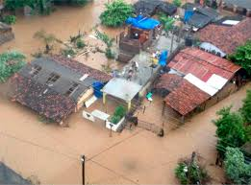
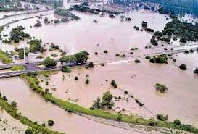
Figure 1. (a) (a) Flooding of a rural community and (b) impacts in coastal areas.
- (b)
Four years later, in 2017, Hurricane Max made a direct impact on the Costa Chica, causing damage to the roofs of homes, downed power lines, and damage to coastal roads (Figure 2)

Figure 2. Flooding and destruction of roofs in Guerrero.
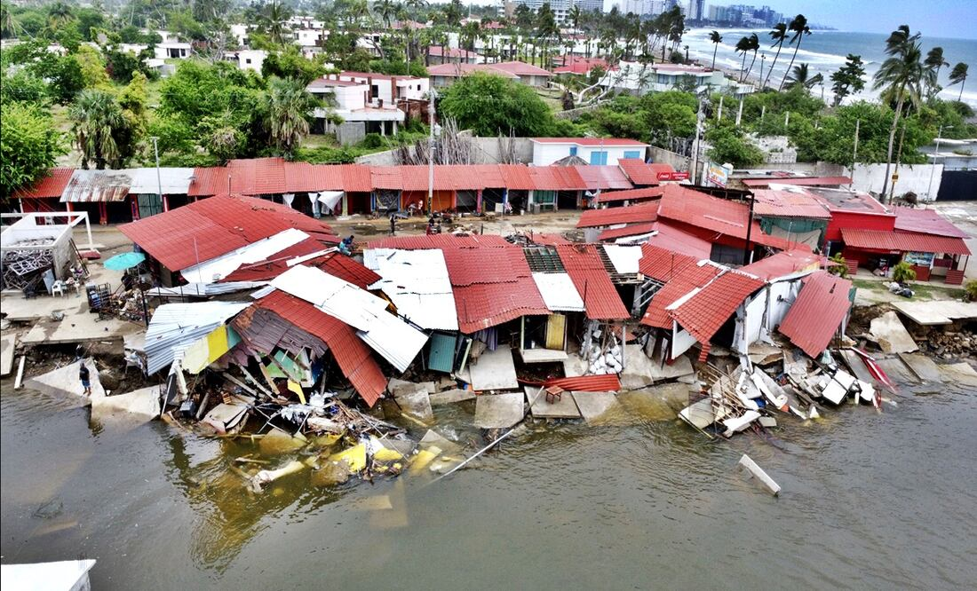

Most recently, Hurricane Erick (2025) -despite its lower intensity- resulted in significant losses to commercial agriculture, specifically affecting papaya and banana crops. The event also damaged rural road networks and caused temporary power outages (Figure 3).

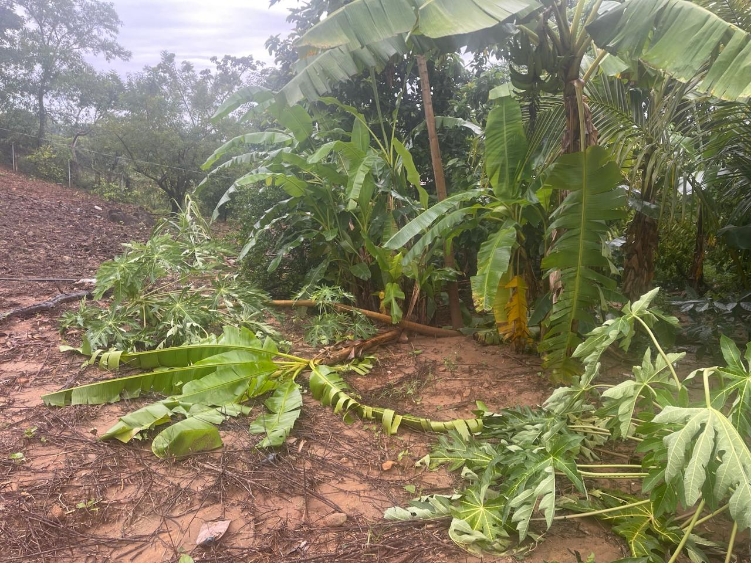
Figure 3. Loss of agricultural production (papaya and banana) in rural communities of Guerrero.

Table 2 summarizes data regarding the higher-intensity hurricanes (Categories 2 and 5): John (2024) and Otis (2023). These events illustrate how increased wind speeds result in extensive structural and social damage, generating lasting repercussions for communities and regional infrastructure.

Table 2. Category 2 and 5 Hurricanes in Guerrero (2023–2024).
Hurricane (Year) | Category | Wind speed (km/h) | Impact date | Geographical location of impact | Impact on structures | Environmental and social impact
John (2024) | 2 | 155-165 | September  2024 | Acapulco and Guerrero Coast | Costa Grande and Costa Chica | Considerable damage to homes, specifically roofs and windows.
Otis (2023) | 5 | ≥270 | October 25, 2023 | Acapulco and Guerrero Coast | Total destruction of homes and buildings; severe damage to hotels and hospitals. | Collapse of tourism infrastructure and basic services; environmental devastation; massive population displacement.
Source: Authors’ elaboration based on CONAGUA and SMN data.
Hurricane John, classified as a Category 2 storm, registered sustained winds ranging from 155 to 165 km/h (95–105 mph) upon impacting the Costa Grande and Costa Chica regions. The event resulted in considerable structural damage-particularly to roofs and windows-along with uprooted trees and prolonged power outages. Furthermore, the storm compromised coastal road networks, hindering access to several isolated communities (Figure 4).

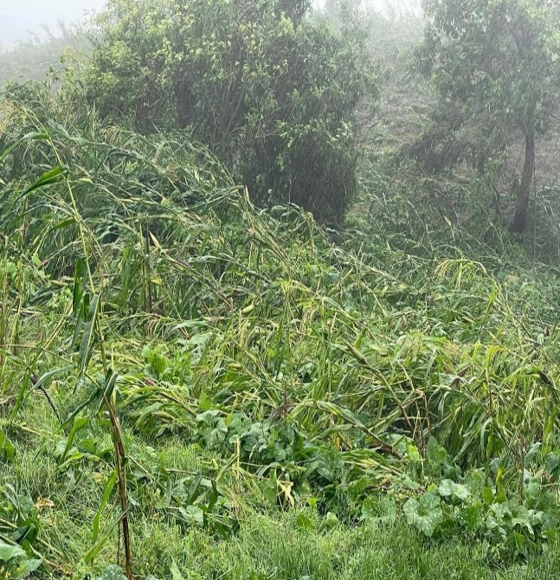
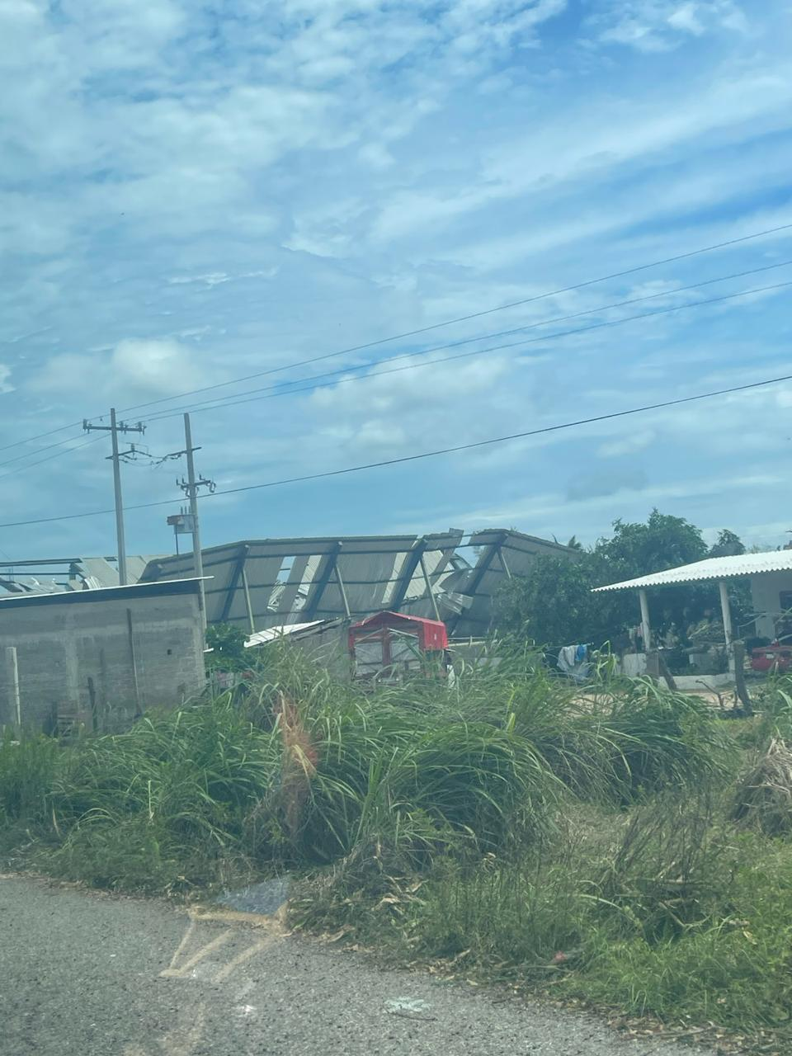
Figure 4. (a) Structural damage to residential roofing and (b) agricultural crop loss.
(a) (b)
The most devastating event was Hurricane Otis, classified as a Category 5 storm, which reached winds exceeding 270 km/h and represented an unprecedented event in Guerrero. Its direct impact on Acapulco and the coastal strip caused the total destruction of homes and large buildings, severe damage to hospitals and hotels, as well as the collapse of basic services and massive population displacement. Furthermore, large-scale environmental losses were recorded (Figure 5).

Figure 5. (a) Total destruction of homes in Acapulco and (b) impacts on agricultural production.
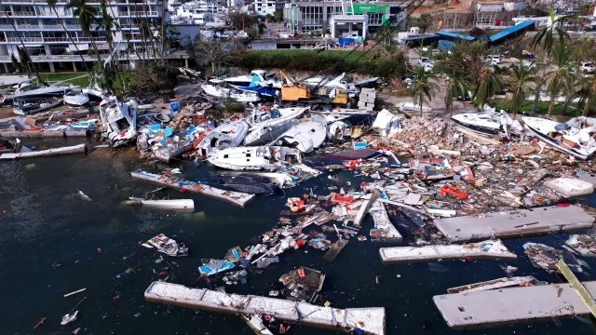
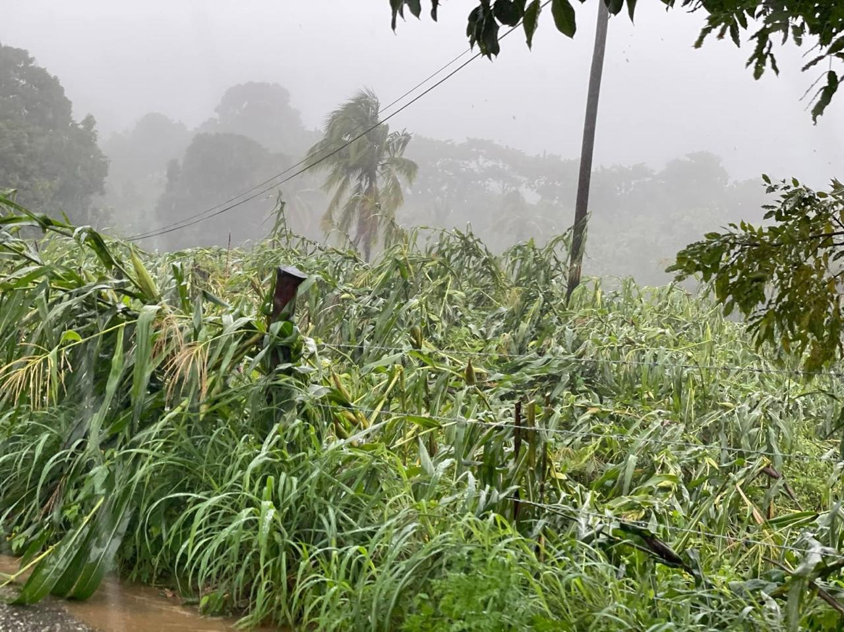
(a) (b)

Discussion
The findings of this analysis confirm that hurricanes exert considerable impacts across Guerrero, irrespective of their classification on the Saffir-Simpson scale (Ellis et al., 2020; Paxton et al., 2024). This observation aligns with Knutson (Knutson et al., 2020), who emphasize that the magnitude of tropical cyclone impacts depends not only on wind intensity but also on critical contextual factors, such as geography, population density, infrastructure quality, and community resilience (Ibe et al., 2025; Mitsova et al., 2019; Swain, 2022).
In this context, Hurricanes Ingrid, Manuel, Max, and Erick classified as Category 1 demonstrate that even low-level storms can produce significant social and economic repercussions due to intense rainfall and the structural vulnerability of rural housing (Castillo-Loeza et al., 2025; Jadhav et al., 2025). Hurricane Manuel provides a clear example: although it did not exceed Category 1, it triggered a landslide in the community of La Pintada, Atoyac de Álvarez, causing devastating losses in terms of human lives and material assets (Castillo-Loeza et al., 2025). This event illustrates the urgency of broadening the assessment framework of the Saffir-Simpson scale by incorporating additional indicators such as rainfall accumulation and soil saturation—factors that are critical in mountainous areas prone to landslides (Conforti & Ietto, 2019).
On the other hand, Hurricanes John (Category 2) and Otis (Category 5) highlight how stronger wind intensity leads to more severe structural damage and long-term consequence (Emrich et al., 2022; Ramírez-Herrera et al., 2025). John caused significant damage to roofs, windows, and coastal roads, affecting the connectivity of rural communities. In contrast, Otis represents a watershed event in Guerrero’s recent history: with winds exceeding 270 km/h, it reached Category 5 and caused unprecedented destruction in Acapulco and surrounding coastal areas (Morán-Rodríguez & Novelo-Casanova, 2018; Valderrama-Landeros et al., 2025). The total devastation of homes, hotels, hospitals, and basic services revealed the critical vulnerability of urban infrastructure to extreme events (Emanuel, 2017). These outcomes are consistent with the arguments of Emanuel (Emanuel, 2017) and the IPCC (IPCC, 2023), ho contend that climate change has increased the severity of hurricanes and exacerbated their socioeconomic repercussions.
The comparative analysis underscores two key aspects. The first concerns the limitations of the Saffir-Simpson scale: by focusing exclusively on wind speed, it overlooks other crucial factors such as rainfall intensity, storm surges, and socio-environmental vulnerability conditions (Bachmann, 2025; Wehner & Kossin, 2024). The second emphasizes the need to adopt an integrated risk management approach that combines physical indicators (winds, rainfall, sea levels) with social indicators (poverty, marginalization, access to preventive infrastructure) (Esteban et al., 2025).
Likewise, this study stresses the importance of strengthening public policies for climate change adaptation in Guerrero (Esteban et al., 2025). Priority actions include financing resilient infrastructure, establishing more efficient early warning systems, training communities in emergency protocols, and promoting environmental restoration strategies to reduce the risks of landslides and flooding. Furthermore, it is essential to reinforce inclusive territorial governance, where different levels of government work closely with local communities to design and implement prevention and post-disaster recovery strategies.

Conclusions
The analysis of hurricanes impacting southern Guerrero between 2013 and 2025 demonstrates that the magnitude of impacts depends not only on the Saffir-Simpson category but also on critical factors such as rainfall intensity, topography, and community social vulnerability. Even Category 1 events -namely Ingrid, Manuel, Max, and Erick- caused severe damage driven by extreme precipitation and the structural vulnerability of rural housing. The case of Hurricane Manuel in La Pintada exemplifies how lower-category storms can precipitate irreparable human and social disasters. Conversely, Hurricane Otis (Category 5) marked a turning point, devastating Acapulco and exposing the critical fragility of urban infrastructure against extreme weather events.
Crucially, the disproportionate damage caused by Category 1 storms in Guerrero is not solely a climatic anomaly but a direct consequence of structural informality. The prevalence of unregulated self-construction (autoconstrucción) in rural zones-often lacking adherence to building codes-amplifies the vulnerability of households to wind loads and saturation, transforming otherwise manageable meteorological events into social disasters.
These findings reaffirm the utility of the Saffir-Simpson scale as a reference tool while simultaneously revealing its limitations in highly vulnerable contexts. Consequently, this study advocates for complementing the scale with hydrometeorological and socioeconomic indicators to enable a more comprehensive risk assessment.
Consequently, this study advocates for a paradigm shift from hazard-based warnings (solely focused on physical parameters like wind speed) to impact-based forecasting models. This approach prioritizes the potential socioeconomic consequences of the event over its meteorological magnitude, ensuring that risk communication effectively reaches the most vulnerable populations.
Furthermore, the results emphasize the urgency of strengthening territorial governance, investing in resilient infrastructure, and promoting community-based educational strategies to advance effective climate change adaptation.

Future lines of research
Future research should prioritize the development of integrated assessment models that synthesize climatic, social, and territorial data. These models must incorporate precipitation patterns, soil saturation, housing conditions, and socioeconomic vulnerability, providing a multidimensional perspective that transcends the limitations of sole reliance on wind speed classification.
Parallel to this, environmental education should be established as a central pillar to guide public policy, strengthen local capacities, and bolster the resilience of Guerrero's coastal communities. Furthermore, fostering community participation and intercultural dialogue is essential to ensure that adaptation strategies remain context-specific, culturally sensitive, and sustainable in the long term.

References
Alvarez Montalvan, O. E., Memije Alarcón, N. Y., & Ventura Ramos, P. E. (2025). Crisis Climática y Vulnerabilidad Económica: Afectaciones por Fenómenos Naturales en el Estado de Guerrero (2020–2025). Ibero Ciencias - Revista Científica y Académica - ISSN 3072-7197, 4(3), 356-376. https://doi.org/10.63371/ic.v4.n3.a127
Bachmann, L. (2025). Integrating Social Vulnerability into Human Displacement Risk Models: An Event-Based Approach for Weather-Related Hazards [Application/pdf]. 48 p. https://doi.org/10.3929/ETHZ-B-000738124
Bastien-Olvera, B. A., Rivera, A., Gray, E., Mitchell, S., Favoretto, F., Ezcurra, E., & Aburto-Oropeza, O. (2024). Mangrove preservation could have significantly reduced damages from Hurricane Otis on the coast of Guerrero, Mexico. Science of The Total Environment, 957, 177822. https://doi.org/10.1016/j.scitotenv.2024.177822
Bathi, J., & Das, H. (2016). Vulnerability of Coastal Communities from Storm Surge and Flood Disasters. International Journal of Environmental Research and Public Health, 13(2), 239. https://doi.org/10.3390/ijerph13020239
Bedolla Solano, R., Miranda Esteban, A., Bedolla Solano, J. J., & Sánchez Adame, O. (2021). Análisis prospectivo-educativo del impacto del huracán Max en una comunidad de Guerrero. RIDE Revista Iberoamericana para la Investigación y el Desarrollo Educativo, 11(22). https://doi.org/10.23913/ride.v11i22.877
Behera, S. K. (2024). Understanding the impact of climate change on extreme events. Frontiers in Science, 2, 1433766. https://doi.org/10.3389/fsci.2024.1433766
Bonfanti, R. C., Oberti, B., Ravazzoli, E., Rinaldi, A., Ruggieri, S., & Schimmenti, A. (2023). The Role of Trust in Disaster Risk Reduction: A Critical Review. International Journal of Environmental Research and Public Health, 21(1), 29. https://doi.org/10.3390/ijerph21010029
Camacho Sanabria, J. M., Chávez Alvarado, R., & Velázquez Torres, D. (2019). Propuesta Metodológica para medir la Resiliencia Urbana ante Huracanes e Inundaciones en el Caribe Mexicano. Revista de Estudios Latinoamericanos sobre Reducción del Riesgo de Desastres REDER, 3(2), 28. https://doi.org/10.55467/reder.v3i2.30
Castillo-Loeza, D. E., Romero, D., & Quesada-Román, A. (2025). Tropical Cyclones in Mexico: A Comparative Analysis and a Composite Socioeconomic Damage Index. Economics of Disasters and Climate Change. https://doi.org/10.1007/s41885-025-00179-3
CENAPRED. (2019). Catálogo de inundaciones 2019. Mexico: Centro Nacional de Prevención de Desastres. Bing. https://www.bing.com/search?q=CENAPRED. Catálogo de inundaciones 2019. Mexico%3A Centro Nacional de Prevención de Desastres.&form=SWAUA2
Conforti, M., & Ietto, F. (2019). An integrated approach to investigate slope instability affecting infrastructures. Bulletin of Engineering Geology and the Environment, 78(4), 2355-2375. https://doi.org/10.1007/s10064-018-1311-9
Ellis, J. T., Harris, M. E., Román-Rivera, M. A., Ferguson, J. B., Tereszkiewicz, P. A., & McGill, S. P. (2020). Application of the Saffir-Simpson Hurricane Wind Scale to Assess Sand Dune Response to Tropical Storms. Journal of Marine Science and Engineering, 8(9), 670. https://doi.org/10.3390/jmse8090670
Emanuel, K. (2017). Will Global Warming Make Hurricane Forecasting More Difficult? Bulletin of the American Meteorological Society, 98(3), 495-501. https://doi.org/10.1175/BAMS-D-16-0134.1
Emrich, C. T., Zhou, Y., Aksha, S. K., & Longenecker, H. E. (2022). Creating a Nationwide Composite Hazard Index Using Empirically Based Threat Assessment Approaches Applied to Open Geospatial Data. Sustainability, 14(5), 2685. https://doi.org/10.3390/su14052685
Esteban, A. M., Solano, I. B., Solano, J. J. B., Adame, O. S., & Solano, R. B. (2025). Water situation in Las Vigas from a socioenvironmental perspective. Asian Journal of Water, Environment and Pollution, 0(0), 025220180. https://doi.org/10.36922/AJWEP025220180
Ibe, K. K., Chiweshe, O., Ola, M. I., & Kollur, S. P. (2025). Community vulnerability to cyclones: An empirical evidence from rural India to improve resilience. Journal of Safety Science and Resilience, 6(4), 100217. https://doi.org/10.1016/j.jnlssr.2025.100217
IPCC. (2023). Climate Change 2021 – The Physical Science Basis: Working Group I Contribution to the Sixth Assessment Report of the Intergovernmental Panel on Climate Change (1.a ed.). Cambridge University Press. https://doi.org/10.1017/9781009157896
Jadhav, J., Kamble, P., Sharma, D., Manglani, H., Panda, G. R., & Rajput, P. (2025). Socio-Economic Implications of Severe Storms in the Changing Climatic Scenarios: A Case of South Asia. En S. Das & W.-K. Tao (Eds.), Severe Storms (pp. 647-670). Springer Nature Singapore. https://doi.org/10.1007/978-981-97-7075-5_25
Klasa, K., Trump, B. D., Dulin, S., Smith, M., Jarman, H., & Linkov, I. (2025). A Resilience-Augmented Approach to Compound Threats and Risk Governance: A Systems Perspective on Navigating Complex Crises. Environments, 12(2), 64. https://doi.org/10.3390/environments12020064
Knutson, T., Camargo, S. J., Chan, J. C. L., Emanuel, K., Ho, C.-H., Kossin, J., Mohapatra, M., Satoh, M., Sugi, M., Walsh, K., & Wu, L. (2020). Tropical Cyclones and Climate Change Assessment: Part II: Projected Response to Anthropogenic Warming. Bulletin of the American Meteorological Society, 101(3), E303-E322. https://doi.org/10.1175/BAMS-D-18-0194.1
Koliyabandara, P. A., Preethika, D. D. P., Cooray, A. T., Liyanage, S. S., Siriwardana, C., & Vithanage, M. (2024). The Environmental Pressure by Open Dumpsites and Way Forward. En A. Anouzla & S. Souabi (Eds.), Technical Landfills and Waste Management (pp. 171-204). Springer Nature Switzerland. https://doi.org/10.1007/978-3-031-52633-6_7
Lim, K. Y., & Foo, K. Y. (2022). A State-of-the-Art Review on the Unique Characteristics, Key Driving Causes and Mitigation Measures of the World Catastrophic Flood Disasters. En C. Ghosh & S. Kolathayar (Eds.), A System Engineering Approach to Disaster Resilience (Vol. 205, pp. 229-246). Springer Nature Singapore. https://doi.org/10.1007/978-981-16-7397-9_17
Mančić, T. (2025). Climate Change as a Security Challenge, Risk and Threat of the 21st Century and Its Consequences on Critical Infrastructure. International Journal of Contemporary Security Studies, 1(1), 191-203. https://doi.org/10.18485/fb_ijcss.2025.1.1.14
Marshall, J., Wiltshire, J., Delva, J., Bello, T., & Masys, A. J. (2020). Natural and Manmade Disasters: Vulnerable Populations. En A. J. Masys, R. Izurieta, & M. Reina Ortiz (Eds.), Global Health Security (pp. 143-161). Springer International Publishing. https://doi.org/10.1007/978-3-030-23491-1_7
Martínez, M. L., Silva, R., Chávez, V., López-Portillo, J., Salgado, K., Marín-Coria, E., Pérez-Maqueo, O., Maximiliano-Cordova, C., Landgrave, R., & De La Cruz, V. (2025). The challenges of climate change and human impacts faced by Mexican coasts: A comprehensive evaluation. PLOS ONE, 20(4), e0320087. https://doi.org/10.1371/journal.pone.0320087
Mezősi, G. (2022). Meteorological Hazards. En G. Mezősi, Natural Hazards and the Mitigation of their Impact (pp. 97-136). Springer International Publishing. https://doi.org/10.1007/978-3-031-07226-0_3
Mitsova, D., Escaleras, M., Sapat, A., Esnard, A.-M., & Lamadrid, A. J. (2019). The Effects of Infrastructure Service Disruptions and Socio-Economic Vulnerability on Hurricane Recovery. Sustainability, 11(2), 516. https://doi.org/10.3390/su11020516
Morán-Rodríguez, S., & Novelo-Casanova, D. A. (2018). A methodology to estimate seismic vulnerability of health facilities. Case study: Mexico City, Mexico. Natural Hazards, 90(3), 1349-1375. https://doi.org/10.1007/s11069-017-3101-2
Moreno Mendoza, E., Calderón Arellanes, M. P., & Suastegui Cruz, S. (2024). Percepción socioambiental de los productores de maíz, debido al paso del huracán Otis en el estado de Guerrero, México. RIDE Revista Iberoamericana para la Investigación y el Desarrollo Educativo, 15(29). https://doi.org/10.23913/ride.v15i29.2037
Okolo, E. C., Landaverde, R., Doerfert, D., Piñeiro, J. M., Hudson, D., Elbert, C., & Opat, K. (2025). Preparedness, Response, and Communication Preferences of Dairy Farmers During Extreme Weather Events: A Phenomenological Case Study. Climate, 13(2), 29. https://doi.org/10.3390/cli13020029
Paxton, L. D., Collins, J., & Myers, L. (2024). Reconsidering the Saffir-Simpson Scale: A Qualitative Investigation of Public Understanding and Alternative Frameworks. En J. Collins, J. Done, Y.-J. Zhu, & P. Wilson (Eds.), Advances in Hurricane Risk in a Changing Climate (Vol. 3, pp. 241-279). Springer Nature Switzerland. https://doi.org/10.1007/978-3-031-63186-3_10
Pitchaimani, G. P., Santhanakrishnan, S., Rodríguez, S. P., Ibarra, M. A. M., Torres, M. A. G., & Ponniah, J. M. (2025). Eco-environmental impact of hurricane John (September 24, 2024) along the coastal municipalities of Acapulco, Guerrero, Mexico. Environmental Monitoring and Assessment, 197(8), 903. https://doi.org/10.1007/s10661-025-14274-1
Ramírez-Herrera, M. T., Coca, O., Gaidzik, K., & Vargas Espinosa, V. H. (2025). Hurricane Otis: Category 5 storm effects and cascading hazards in Acapulco Bay, Mexico. Global and Earth Surface Processes Change, 3, 100004. https://doi.org/10.1016/j.gespch.2025.100004
Robinson, W. A. (2021). Climate change and extreme weather: A review focusing on the continental United States. Journal of the Air & Waste Management Association, 71(10), 1186-1209. https://doi.org/10.1080/10962247.2021.1942319
Shaharier Alam, Md., & Hu, Y. (2025). Mobility disruption and recovery in southwest Florida’s elderly-dense communities during Hurricane Ian. Transportation Research Part D: Transport and Environment, 141, 104648. https://doi.org/10.1016/j.trd.2025.104648
Simpson, R. H., & Riehl, H. (1981). The hurricane and its impact. (No Title). https://cir.nii.ac.jp/crid/1130000794772982144
Swain, D. (2022). Tropical Cyclones and Coastal Vulnerability: Assessment and Mitigation. En A. Pandey, V. M. Chowdary, M. D. Behera, & V. P. Singh (Eds.), Geospatial Technologies for Land and Water Resources Management (Vol. 103, pp. 587-621). Springer International Publishing. https://doi.org/10.1007/978-3-030-90479-1_30
Toscana Aparicio, A., & Villaseñor Franco, A. (2018). Las tormentas Ingrid y Manuel en La Montaña de Guerrero, 2013. La atención de la emergencia. Sociedad y ambiente, 16, 59-89.
Valderrama-Landeros, L., Pérez-Espinosa, I., Villeda-Chávez, E., Alarcón-Medina, R., & Flores-de-Santiago, F. (2025). Shoreline Response to Hurricane Otis and Flooding Impact from Hurricane John in Acapulco, Mexico. Coasts, 5(3), 28. https://doi.org/10.3390/coasts5030028
Wehner, M. F., & Kossin, J. P. (2024). The growing inadequacy of an open-ended Saffir–Simpson hurricane wind scale in a warming world. Proceedings of the National Academy of Sciences, 121(7), e2308901121. https://doi.org/10.1073/pnas.2308901121
Yang, Y., Tilman, D., Jin, Z., Smith, P., Barrett, C. B., Zhu, Y.-G., Burney, J., D’Odorico, P., Fantke, P., Fargione, J., Finlay, J. C., Rulli, M. C., Sloat, L., Jan Van Groenigen, K., West, P. C., Ziska, L., Michalak, A. M., the Clim-Ag Team, Lobell, D. B., … Zhuang, M. (2024). Climate change exacerbates the environmental impacts of agriculture. Science, 385(6713), eadn3747. https://doi.org/10.1126/science.adn3747

Rol de Contribución | Autor (es)
Conceptualización | Francisco (Principal), Inti Leopoldo (Apoyo), Sirilo (Principal)
Metodología | Francisco (Principal), Marco Polo (Igual), Enrique (Apoya)
Software | NO APLICA
Validación | Francisco (Principal), Inti Leopoldo (Igual), Sirilo (Igual)
Análisis Formal | Francisco (Principal), Sirilo (Igual)
Investigación | Francisco (Principal), Enrique (Igual), Inti Leopoldo (Igual), Marco Polo (Igual)
Recursos | Enrique (Principal), Marco Polo (Igual)
Curación de datos | NO APLICA
Escritura - Preparación del borrador original | Sirilo (Principal), Inti Leopoldo (Apoyo), Marco Polo (Apoyo)
Escritura - Revisión y edición | Enrique (Apoyo), Francisco (Principal), Marco Polo (Apoyo), Sirilo (Principal)
Visualización | Enrique (Principal)
Supervisión | Sirilo (Principal)
Administración de Proyectos | Francisco (Principal)
Adquisición de fondos | Enrique (Principal), Marco Polo (Apoyo)

